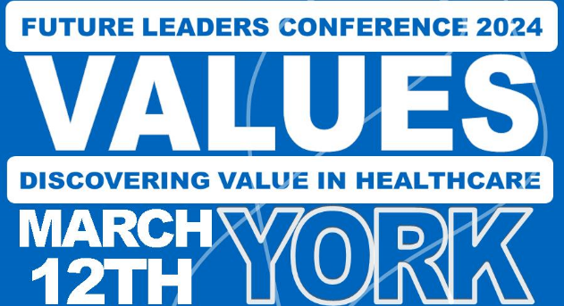

Abstract Submission Guidelines

Submission Timeline
Call for Abstracts Opens: 15th January 2024
Call for Abstracts Closes: 2nd February 2024 at 5pm (late submissions will not be accepted)
Outcome Emails Issued: 9th February 2024 (to the submitting Author)

Submission requirements
Submissions are invited to showcase innovative projects conducted by healthcare professionals within the UK and in consideration of the conference theme “Discovering Value in Healthcare”.

For each submitted abstract, authors will be asked to identify the most relevant theme for their submission from the following list:

- Sustainability
- Workforce
- Community engagement
- Ethical leadership
- Authenticity
N.B. up to 2 themes can be selected per submission

Abstract Format
Abstracts are restricted to a maximum of 500 words, which does not include the title of the abstract or any references an author may choose to list.

Submission Process
Abstracts should be submitted via a single word document and emailed to: England.FLPconference.yh@nhs.net with “FLP Conference Abstract” as the subject line.
Please indicate in your email which theme(s) your submission fits under.

Outcome Notification Emails
The submitting Author will receive an email notifying the outcome of each abstract submission no later than 9th February 2024.
By submitting an abstract you are agreeing to submit a poster for presentation at the FLP conference.

Certificates will be provided for all presenters. The top 5 scoring posters will be invited to give a 5-minute oral presentation and to answer questions about their work on the day of the conference. Prizes will be given to the top 3 scoring presentations on the day.
If you do not want your work to be considered for oral presentation or a prize, please indicate this in your abstract submission email.

Submission Rules:
- All abstract content and material will be final upon submission and corrections will not be possible.
- Submission of an abstract constitutes a formal commitment by the author(s) to present the work if accepted.
- The submitter hereby affirms that the work submitted is original, except for extracts from copyrighted works fully authorised by the copyright holders, and that all statements declared as facts are based on thorough examination and investigation for accurateness.
- No identifiable patient information should be present in the abstract or presentations. [The exception to this would be non-identifiable appropriate images, with evidence of informed consent from the patient and/or parents for their use. You do not need to attach the informed consent to your submission.]
- Please provide evidence of ethical approval and informed consent upon request.
- The submitter signs for all co-authors.

- The abstracts will be judged anonymously, any conflicts of interest will be highlighted to the judges.
- The abstracts will be judged fairly and with a transparent judging process.
- Every author has the right to challenge the judging process and have their submission re-marked once for clarification.
- Any disputes regarding the judging process will be referred to Susy Stirling (Associate Dean, Coaching Lead, HEE Y&H)
- If you wish to withdraw a submitted abstract, please notify us at England.FLPconference.yh@nhs.net. Withdrawals are still accepted after the submission deadline.

