A brief guide to recording a Microsoft Powerpoint presentation for conversion into a video

1. Create your Powerpoint presentation as normal. Save it under a suitable title e.g. “Presentation for website”. Then make a duplicate copy which specifies it has audio e.g. “Presentation for website WITH AUDIO”. You should use the latter presentation for the recording. The original will be kept in case you want to do it live again in the future.

2. Next, go to the “Slideshow” tab at the top of the screen:

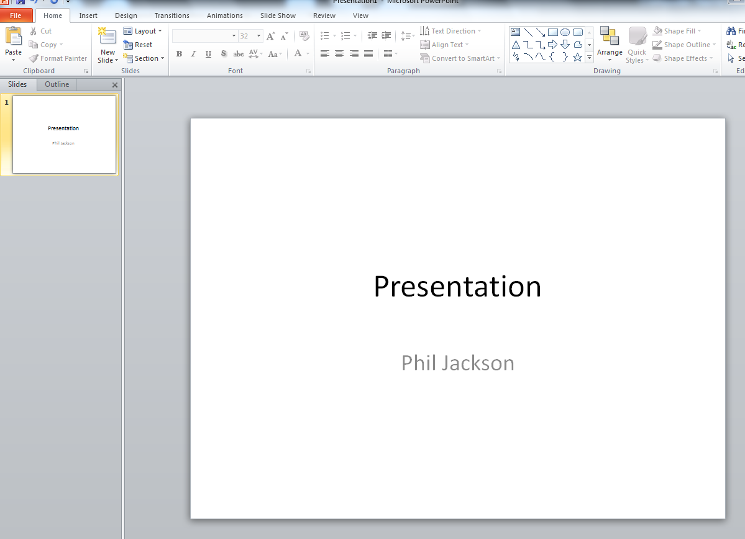

This is magnified here:
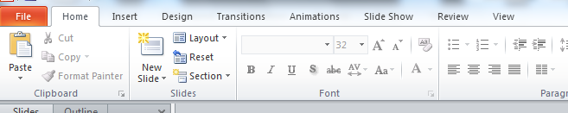

3. Once you have clicked the Slide Show tab, select the “Record Slide Show” box as illustrated below:
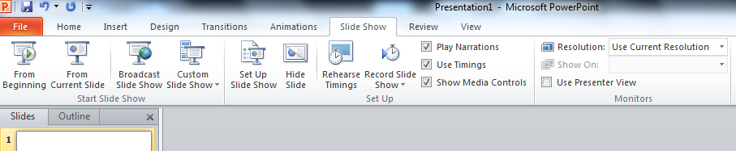

4. Click on the “Start Recording” box in the box out that appears. Make sure you have a computer that has a microphone (unlike in the picture below)
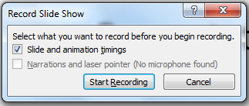

You may be presented with a submenu first, especially if you have clicked on the little arrow rather than the box. Just click on “Start Recording from the Beginning…” then click on the “Start Recording” box.

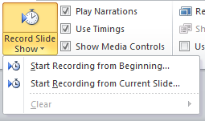

5. The view will then change to the normal “Slide Show” view, but with a small recording box in one corner:

Record you slide show as normal, giving your presentation into the microphone of your computer. You can use the cursor keys or the mouse to cycle through the slides just like you normally would.

A few points to remember:
- It won’t record the mouse/cursor so don’t use this to highlight parts of the slide
- It stops recording the vocal when it cycles between slides so try not to do any “voice over” when moving between slides
- It will record continuously until the end of the presentation, therefore it is helpful to have a script to read from as mistakes may require starting all over again
- It will record outside sounds so don’t have your phone nearby
- If you do make a mistake you can stop the recording with the escape button (“Esc”) and then start recording again from the current slide.

6. If you make a mistake on your first run through:
- You can stop the recording with the escape button. The view will return to the overview and the recording will stop. You will still be on the slide you have reached.
- When you are ready to start recording again highlight the “Start recording from Current Slide” option under the “Record Slide show” box.
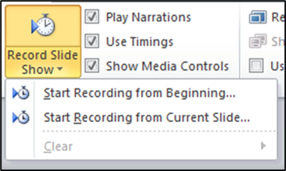

7. If you notice a mistake AFTER you have finished the recording you can go back and edit individual slides:
- Go to the slide that you want to edit on the overview screen
- Select the “Slide Show” tab (blue circle), and click the little down arrow at the bottom of the “Record Slide Show” tab (green arrow and circle)

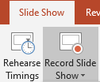

- This will produce a drop-down menu, at the bottom of which is a row entitled “Clear” (blue circle) with a little arrow on the right (green circle and arrow). Click the arrow to bring out a further drop-down menu (yellow box).

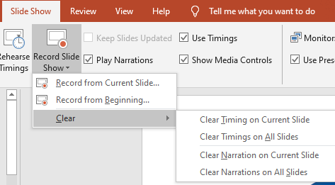

- From this new drop-down menu select both “Clear timing on Current Slide” and “Clear Narration on Current Slide”. You can then click “Record from Current Slide” on the previous menu box.
- The “Record Slide show” box (below) will appear again. Click “Start Recording” and it should present you with the slide show view but with the required slide up rather than the beginning slide.

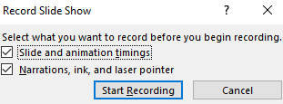

- When you have finished recording the voice-over for that slide DO NOT MOVE TO THE NEXT SLIDE otherwise you will have to re-record that one too. Instead, press the little “x” on the recording box in the top right corner of the screen (see below) or press escape to stop recording.

8. Once you have got to the end of the slide show the following box will appear:

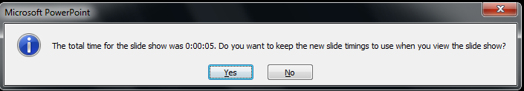

Click “Yes”.

You will now have a version of the Powerpoint presentation with audio. You can check it by going back to the “Slide Show” tab and clicking on the “From Beginning” icon on the left. This will play through the slide show with the vocal over the top.

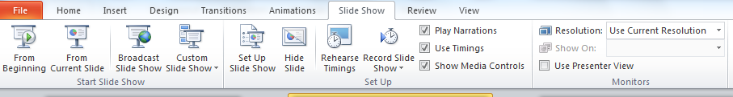

You can now send me the file with audio and I will convert it to a video if you like.

Alternatively, if you want to know how to convert it then read on.

9. Click on the “File” tab at the top left

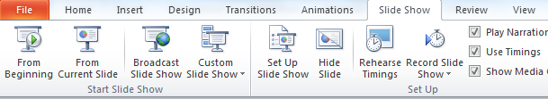

Click on the “EXPORT” heading on the list below (red circle), which should then change the details on the right. Some of the older versions do not have export, but have “Save & Send” instead.

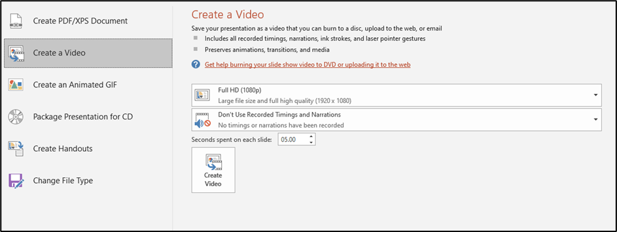
Then, highlight the “Create a Video” Icon on the left (blue circle), followed by the “Create Video” box that appears in the middle (green circle):

Finally, save it as an MP4 file if you can, or a Windows Media Video (.wmv) file if you can’t. Please be aware that it will take a LONG time to convert the file, and the results are very large.

