Yorkshire & Humber Trainee Wider Forum

Minutes of Meeting
traineeforum.yh@hee.nhs.uk

Date: 31/08/2022
Venue: Online – MS Teams
Time: 1300-1600

Attendees invited from TEF (attended ):
Emma Howe (EH) (Chair) ☐Pete Webster (PW) (Academic Lead)
Sara Page (SP) (Vice Chair) ☐Stuart Stokes (StS) (South Locality Lead)
☐Maria Crouch (MC) (Secretary) Sanah Sajawal (SS) (West Locality Lead)
☐Lucy McCabe (LM) (Quality Lead) Lauren Harkin (LH) (LTFT Lead)

Wider forum members present:
Chitrangi Johari, Moaz Ahmad, Anita Jacob, Sarah Martell, Mohammed Toorani, Nima Farah, Sangram Patil, Christian Perkins, Raykal Sim, Sarishka Singh, Luke Thompson, Catherine Turner
Brenda Van Beek, Shivani Rae

HEE present:
Jon Cooper (Postgraduate Dean), Jon Hossain (Deputy Postgraduate Dean), Julie Platts (Senior quality lead for NE and Yorkshire), David White (Quality intelligence manager NE and Yorkshire), Becky Travis (Senior business manager for YH), Joanne Hall (Quality Co-ordinator)

GMC Education Quality Analysts: Laura Curtis and Kimberley Archer

Apologies: LM, MC,

Acronyms:
PGDiT = Postgraduate doctors/ dentists in training

Trainee representatives CLOSED SECTION of meeting
Introductions, apologies

Closed section for trainee representatives only. Open forum, any discussion welcomed including feedback from trainee reps, training concerns, ideas, ongoing projects for advertisement or discussion.

First item raised: NHS Car Lease scheme
- PGDiTs who have change in employer with change in rotation, do not have access to NHS benefits including car lease scheme. Unfair in view of relative long-term training within a region.
- Highlighted that those with Lead employer may have access to the scheme. And updated that at recent DMT meeting, single lead employer for YH is being re-explored and a suitable hosting administrative support is being sought.
- Single lead employer may allow access to Car Lease scheme for more trainees.

Second item raised: Study budgets and rejected study leave applications
- PGDiTs in a particular region/ school were advised that each trainee had an allocated study budget. And yet, when PGDiTs submitted study leave requests to have courses funded, these have been declined as ‘too expensive’ despite not having requested funding before and ‘budget’ not yet utilised.
- Unfortunately, this is an out-dated way of describing study budget allocation, each trainee does not have individual access to a study fund ‘pot of money’. The new study leave guidance for YH is supporting equity of access to study leave funding and now has guidance for costs up to £500 to be funded for educational and training, costs above this would need to be self-funded. ACCENT study leave manager will be able to record if study leave funding is being denied, and why, and should highlight gaps in education and training being provided by schools/ colleges.

Action point: EH will update the Trainee Forum with news regarding single lead employer across YH. Benefits will also include easier transfer of information such as occupational health records.
HEE YH and GMC representatives join the meeting OPEN SECTION of meeting

ITEM: Educational Focus: Leadership stories; Jon Cooper
- Explanation of possible career pathways and progression from PGDiT, to Director of Medical Education to Postgraduate Dean
- JC highlighted challenges faced, perspective he brought to the region and the importance of compassionate leadership.
- Doing the right thing vs doing what is right.
- Top pieces of advice: 'be yourself', 'learn from those who are doing well' and 'don't be afraid to challenge what is not right'.

Action point: EH will collaborate with inspirational leaders from the YH region and request their attendance at future WF meetings to deliver the educational focus. (Susy Sterling will present at the WF in November).

ITEM: GMC National Training Survey results
- EH introduced GMC Survey and explored quality function from PGDiT’s perspective
- Purpose of this discussion was to demystify quality function, highlight key results from 2022 GMC NTS survey, outline improvement action plan for 2022-2023 and open discussion for Q&A from PGDiT
- Quality aim to deliver high quality education and training and ensure a safe and inclusive learning environment via then national quality framework with 6 domains
- ‘Monitoring learning environment meetings’ one type of quality visit – setting action plans and timelines. Raising and monitoring concerns is categorised from 1 (minor concerns, local level)-4 (placements suspended, reported nationally).

*Poll taken – all PGDiTs present at meeting aware of GMC National training survey*

- Information about GMC NTS survey – largest annual survey of doctors in the UK, ran from March to May this year, results used to identify issues and to drive improvement. DW emphasised that “Your feedback matters”
- Overall satisfaction with training across local education providers (trusts) – only 1 red outlier (NLAG, has been identified and quality is working with the trust to drive improvements). The results in YH are reassuring, positive message in the face of NHS pressures and challenges
- Satisfaction by training programme reviewed. 4 red outliers for YH – gastro, (gastro has been flagged as a UK-wide issue this last year), neuro, plastic surgery and cardiology. High scoring programmes in YH e.g. forensic psychiatry, sports medicine, old age psych, public health. Usually, programmes score higher where less workload issues are present.
- YH is performing well across its wide region, >90% programmes score well comparative to other regions/ national average. Overall, 82% of PGDiTs said they have a very good or good experience in YH
- When YH compared to national mean – there is not a lot variation – positive! The biggest gaps in YH to national highlight key issues are:
  - difficulty obtaining study leave
  - don’t have access to good out of hours facilities
  - lose training opportunities to rota gaps
  - don’t get to regularly attend high quality teaching
- Deanery action plan explored
  - Improved access to study leave – the roll out of ACCENT LEAVE MANAGER will remove the need for paper forms, but also improve the transparency of study leave applications. It can highlight areas where study leave is being rejected and explore the underlying reasons as to why. If PGDiT are requesting study leave for the same courses, can also explore if there is a curriculum gap.
  - Regional teaching – Blackboard was introduced to improve the access of regional teaching to PGDiT. Where popular courses are being delivered in other reasons, HEE YH hope to learn from these examples and look to improve ‘in-house’ courses to keep teaching nearby.
  - Local teaching – connection between HEE YH and directors of medical education and medical educators’ team important, keep sharing best practice and ideas
  - Rota design – it is the local educational provider’s responsibility. But HEE YH has GOSW links, holds forum with employers every few months. HEE YH don’t write the rotas, but recognise there is work that can be done to improve PGDiTs experience in rotas
- Other actions ongoing
  - Improvements to ARCP process and communication
  - Open door policy for PGDiTs to raise issues directly with HEE YH – Trainee Exec forum members present at monthly deanery management meetings, PGDiT opinion always explored
  - Supporting IMGS – future leader fellowships dedicated to review and develop resources, commissioned support such as social prescribing pilot (support for visas, childcare, schools, housing, mental health, finances) and identifying ‘New to NHS’ start date – avoid PGDiTs on night shift after changeover if new to NHS

*Poll to PGDiT in meeting – what is your priority?*
https://jamboard.google.com/d/1HHDdUfmfL_p6OS5ZkaGxwTo2KosvZ31hCKJ94-UkSYQ/edit?usp=sharing

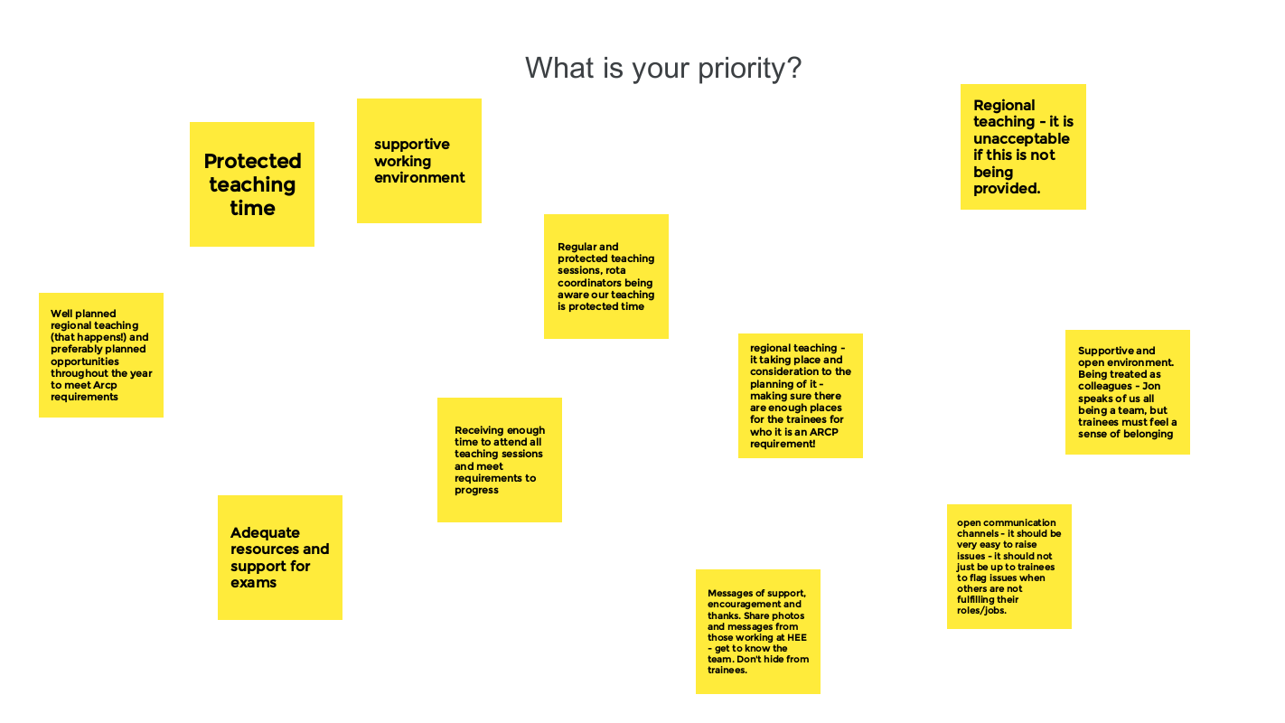

- Forum opened to Q&A
  - PGDiT: Regional teaching – [51%] of regional teaching occurred. This is something of concern. Most PGDiTs feel that HEE YH is there to provide training, it is important to get this right. Even when blackboard there, regional training hasn’t occurred. Who is accountable for these teaching schedules? PGDiTs are proactively organising teaching themselves to fellow colleagues to compensate
  - JH: Regional teaching is the responsibility of the Schools. HEE YH are pushing back to Schools to deliver. School is to report back on what is being delivered. ‘Self-assessment’ tool, asking Schools to set SMART objectives. Ethos in YH is to try and deliver teaching ‘in house’ but if not high quality teaching in YH then outsourcing e.g. to London is necessary to support education. Jon Hossain would like to see more face to face training, with Hybrid option and recognise different preferences for different schools.

If your regional teaching doesn’t happen, please fill in exception reports – MISSED EDUCATIONAL OPPORTUNITIES. HEE YH meets with GOSW on quarterly basis, HEE YH want to know if it isn’t happening

- The trainee forum has an important role to promote exception reporting. Loss of training time needs to be highlighted and escalated. The trainee forum newsletter in Aug 2021 and again in the upcoming Sept 2022 edition outlines the exception reporting process (when and how to exception report), pathway (what happens next) and outcomes from exception reporting (time back in lieu, paid monies, review of placements or services).
- If any free text comments raise bullying or patient safety, it gets escalated directly to Jon Hossain and this is taken very seriously and then raised with trusts. Other free text comments can be very insightful and directive.

*Opened ideas from PGDiTs to suggest their ideas for improvement:*
https://jamboard.google.com/d/1LH0wiQv4lGPIgzS3kbUSLBAm7te2f7AL4Rx1xrTfT1M/edit?usp=sharing

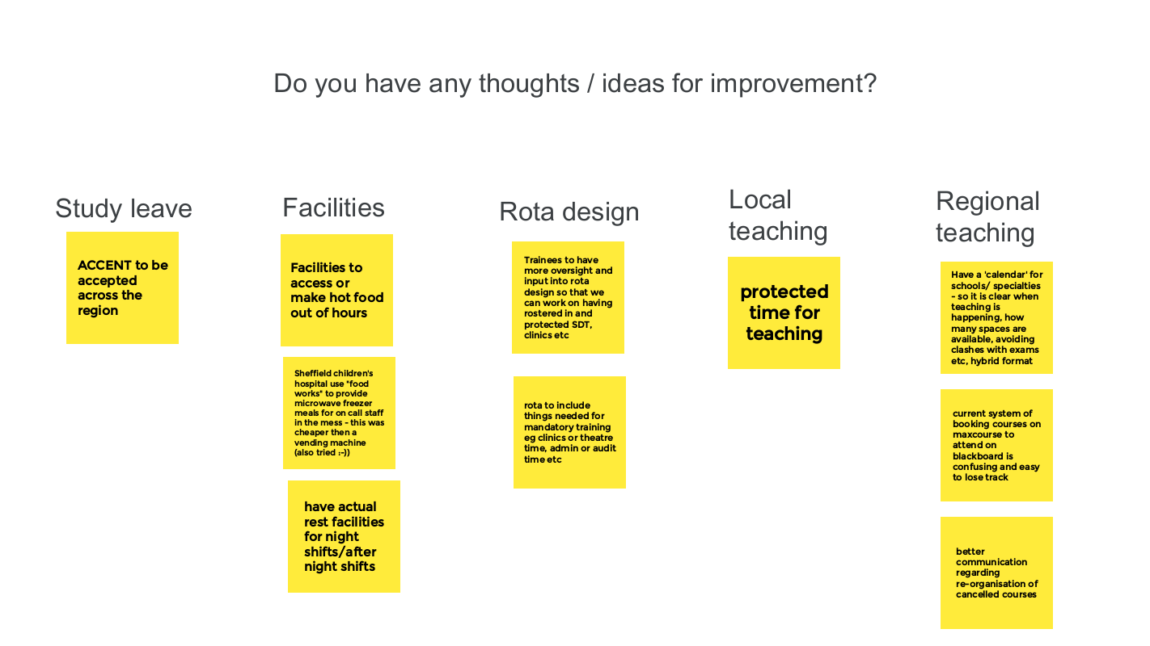

Action point: EH to monitor Jamboard responses and feedback priorities and ideas to quality team. Trainee Forum to promote exception reporting campaign – added to TEF Sept agenda.

ITEM: Less than full time training

- LTFT brought to the agenda as flexibility is a key initiative in NHS long term plan, significant changes recently (category 3 rollout), questions have been raised by PGDiTs across the region, great opportunity to have Jon Hossain who is a great advocate for flexibility in training present the update and answer Q&A.
- LTFT has been recognised nationally as important:
  - People want to work flexibly
  - People want to do things outside of medicine
  - Allows people to train in medicine who otherwise would not be able to train – children, family, health
- LTFT training protects the training element of jobs by avoiding hours reduction reflected in loss of teaching days only
- Key regional priorities:
  - Improve access
  - Reduce barriers
  - Standardise - same thing everywhere, across all deaneries. LTFT will be funded the same across all offices in England (Wales and Scotland vary)
- £1000 pay premium – every LTFT PGDiT entitled to £1000 pay premium annually, should just appear in payslip. Note – PGDiT on old contract may not be able to access this
- Utilise BMA rota checker to make sure hours are correct. BMA also has estimated wage calculator to assist with decision making in LTFT.
- “Any % you want to work is on the table!” any percentage over 50 should aim to be supported where possible in each trust.
- All doctors, full time and LTFT PGDiT are supported to pick up additional hours. If extra work requested when LTFT for health reasons – meeting may be required, to ensure adequately support and health prioritised.
  - During COVID LTFT PGDiT increased hours and picked up shifts to support the system. If wish to pick up extra hours to support gaps in rotas, this is supported by the deanery
- Now in the Gold guide – there are no categories for LTFT. Applications for LTFT will be reviewed as requested. If you feel your reason for application has a priority then writing a narrative on your application is preferable and will support application.
- There are concerns being raised that Deanery is supporting LTFT, but trusts are not supporting this. Evidence is being collected to review this concern and an operating procedure being developed.
- “Less than full time” terminology – some say change it, some say keep it!
- Every trust has a funded role of a LTFT champion – is a useful go-to person, such as for rota issues. Can then be managed locally at trust level.
- Q&A
  - PGDiT: Challenges re-surface with each rotation and change in placement
  - JH: Can lengthen placements if wish, it is recognised that renegotiating childcare every 6 months is challenging. Flexibly is key and negotiation between PGDiT and employer/ school is important.
  - PGDiT: Can duration of training change according to competencies
  - JH: default position is if go LTFT then duration of training will be extended pro rata. Minimum training times were EU directive, now with Brexit, no longer minimum training time. But each College, when re-writing the curriculum decided what the normal or expected training time should be. Assessments aren’t just WBAs – there is a holistic general confidence aspect, need to feel ready. It would be detrimental to the number of doctors supported in training posts if everyone shortened training, as the ‘need’ for doctrs would appear less. We need more!
  - PGDiT: LTFT coming in on non-working days, this can affect other PGDiTs
  - JH: Be cautious, make sure covered with indemnity and it is your choice. Should not be expected to come in to achieve competencies – take time back in lieu. Be supportive of colleagues and share opportunities where possible.
  - PGDiT: Overseas doctors cannot work less than 80% to meet minimum wage requirements for visa.
  - JH: This has been raised from HEE to Minister level and this point has repeatedly tried to be made. Unfortunately, there is no change currently from Department of health or Border Agency to change this.
  - PGDiT: Challenges faced by doctors on working visas. Need to find a job months before end of a training programme to ensure can remain in the country. Some PGDiTs go LTFT to navigate this.
  - JH: I am ‘lobbying on your behalf’, but no improvements in the system. Some PGDiTs leave the UK after completion of training programmes because they are not permitted to remain, and this is not what we want to see. Issues with department of help and border agency, feels disturbing in a shortage occupation, no accommodations being supported currently.

- IMG networks in North Manchester signposted to, as large number of IMGS in training and as trainers there.
- Enhancing Junior Doctors’ working lives (EJDWLs) report – to be brought to the Nov wider forum meeting to explore HEE’s vision for improving flexibility and the current opportunities for flexibility in training and. Can see the report outlined in September’s TEF newsletter

Action point: EH to access list of LTFT Champions and advertised this via the Trainee Forum. LH will create summary for key points from today’s LTFT segment and this shall be made available with the minutes and via the TF webpage.

ITEM: Wider Forum engagement

- EH described the vision of the Trainee Forum and the roles of the Executive Forum and Wider Forum as part of that. Also explored how the two arms should aim to collaborate effectively with each whilst also fulfilling different responsibilities
- Key aspects of development moving forward
  - Supporting wider forum members to engage with PGDiTs from across the region to gather different opinions/ ideas/ perspectives and effectively represent these
  - Improve the communication between TEF and TWF to share ongoing projects, opportunities to get involved,
  - Being more visible to PGDiTs across the region and improving promotion and publicising of the forum.
  - Creating effective links between PGDiTs and reps including making it easier to find out who is the rep for each region/ school/ specialty/ IMGs/ LTFT/ LGBTQI+ / BMA and more

- SS asked how to link with IMT trainees in the region. Recommendations of asking TPD or MEMs (managers of medical education), for access to IMT PGDiT list. IMT TPD contacts can be found here. AJ provided contact details of Chair of Hull JDF – Professor Labani

Action point: EH to collaborate with SS and support connection with IMT trainees. EH to allocate the job of collecting details for trainee reps to members of TEF and TWF from different regions, trusts and schools, to include specialty reps, JDF reps, LTFT and more. EH to collate list of MEM, DME, GOSW for each trust.

Upcoming meetings
- November 30th 9-12pm
- February 22nd 9-12pm

Any other Business – Trainee Executive Forum role vacancies

Trainee forum 8 vacancies
- Wider forum lead
- Communications and engagement lead
- EDI lead x 2
- South locality
- East locality
- Employers lead
- Wellbeing and support Lead

Find out more on website HERE
Applications opened 19/8/22 and close 16/9/22.

ACTIONS SUMMARY

- EH will update the Trainee Forum with news regarding single lead employer across YH. Benefits will also include easier transfer of information such as occupational health records.
- EH will collaborate with inspirational leaders from the YH region and request their attendance at future WF meetings to deliver the educational focus. (Susy Sterling will present at the WF in November).
- EH to monitor Jamboard responses and feedback priorities and ideas to quality team.
- Trainee Forum to promote exception reporting campaign – EH added to TEF Sept agenda.
- EH to access list of LTFT Champions and advertised this via the Trainee Forum.
- LH will create summary for key points from today’s LTFT segment and this shall be made available with the minutes and via the TF webpage.
- EH to collaborate with SS and support connection with IMT trainees.
- EH to allocate the job of collecting details for trainee reps to members of TEF and TWF from different regions, trusts and schools, to include specialty reps, JDF reps, LTFT and more.
- EH to collate list of MEM, DME, GOSW for each trust.

Find out more about the Trainee Forum HERE
Catch up with Minutes of previous meetings HERE

