Clinical Fellow for Interface
Harrogate Foundation Trust
Job Description

Context –
Harrogate District Foundation Trust (HDFT) embraces collaborative working with system partners. We are looking to appoint a Leadership Fellow to work with the trust team as part of the :
Yorkshire and Humber Future Leaders Scheme
Information can be found at:
Yorksandhumberdeanery.nhs.uk/education/future_leaders_programme

Purpose –

The Clinical Fellow for Interface role at Harrogate and District Foundation Trust ( HDFT) is an opportunity for a medical or pharmacy trainee to take a year's leadership post to work alongside the medical directorate team. The post offers opportunity, as a team member, to address challenges that impede quality patient care that have been identified by primary or secondary care colleagues. Fundamental to achieving this is communication and building collaborative relationships between the Primary Care Communities and Trust teams.
One project would be developing safe collaborative care processes for patients during the 28 days after acute hospital discharge. This includes reviewing research and guidance from medical colleges, observing practices in other trusts and establishing clear clinical governance for follow-up investigations and prescribing.
The Fellow have opportunity to engage with trust clinical colleagues, operational managers, Executives and Primary Care teams and would be encouraged to develop communication and leadership skills throughout the placement. The Fellow would be part of multidisciplinary meetings, developing patient pathways and communicating these new processes. Outcomes would be to reduce risk and clarify safer care pathways across local organisations.

Title: | Clinical Fellow for Interface
Location: | Based a Harrogate and District Foundation Trust
New or Replacement Post: | New fixed term post
Prime responsibility: | Interface Clinical Fellow work
Accountable to: | Associate Medical Director for Primary care
Reports to: | Associate medical Director Primary Care
Works with: | Medical Directorate team

Remuneration and skill-set -

The role will be paid on a per-annum basis as full time (37.5 hours per week). The skills required for the post are summarised in the attached job description. This is a fixed term post for one years, with the prospect of renewal by mutual agreement.

Salary is aligned to the applicant’s baseline salary in their training role (subject to confirmation)
Study leave costs will be covered by NHS England up to a maximum of £3,700 for each Future Leader (subject to agreement)
The clinical leadership post is supported by the Yorkshire and the Humber training programme and full attendance at Leadership training sessions provided by the Yorkshire and Humber training programme is mandated as part of this post.

Person Specification- Clinical Leadership Fellow
Area | Specification | Essential / Desirable
Education | GMC registration  MBChB / MBBS qualification
Experience | - Medical Specialty Trainees (ST5+/GPST2+)  - or for Radiology Registrars (ST4+)  - Dental Specialty Trainees (ST2+)  - Public Health Registrars (ST4+)  Registered pharmacy staff with 3 or more years post registration experience and working at Bands 6-8a with agreement from their current employer to undertake a secondment.  Full GMC, GDC or UKPHR registration as applicable and current licence  Have a satisfactory ARCP outcome  Have Head of School approval for a year Out of Programme  Must not have existing experience in a senior / significant leadership role
Knowledge | Can identify the opportunities arising from improved IT in healthcare, especially at the interface of primary and secondary care  Understands the requirements of good organisational and clinical governance.  Understands and is committed to key trust initiatives
Skills and Abilities | High-level communication skills – written and verbal.  Has demonstrated membership of a clinical team  Can demonstrate that they have taken an active interest in developing leadership
Personal Qualities | Work collaboratively, showing mutual respect for others skills and abilities.  Demonstrates enthusiasm for change and is passionate about improving patient care.  Demonstrates alignment with Harrogate foundation trusts vision and mission

SECTION 4: About HDFT

Harrogate and District NHS Foundation Trust (HDFT) was founded under the Health and Social Care (Community Health and Standards) Act 2003 and authorised as an NHS Foundation Trust from 1 January 2005.
HDFT is the principal provider of hospital services to the population of Harrogate and the surrounding district, and also provides services to North and West Leeds. In total this covers a catchment population for the acute hospital of approximately 316,000 people. In addition, the Trust provides some community services across North Yorkshire (with a population of 621,000 people) and provides Children’s and Young People’s Public Health Services between birth and 19 (or in some cases 25) years of age in North Yorkshire, County Durham, Darlington, Middlesbrough, Stockton-On-Tees, Sunderland, Gateshead, Northumberland and Wakefield. The Trust’s Children’s Public Health Services look after almost 600,000 children across these localities.

Our Acute Services
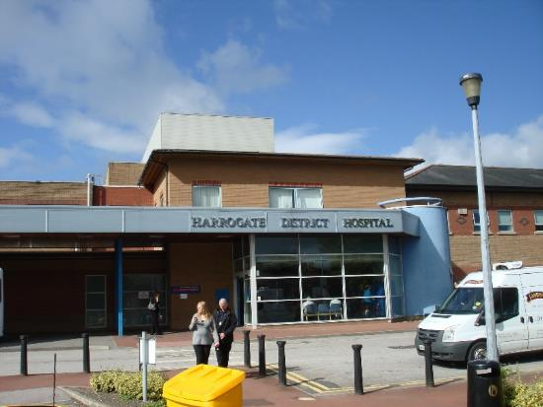
Harrogate District Hospital has:
an Emergency Department
extensive outpatient facilities
an Intensive Therapy Unit and a High Dependency Unit
a Coronary Care Unit
five main theatres and a Day Surgery Unit with three further theatres
The Hospital provides emergency, urgent, outpatients, day case and inpatient services across a comprehensive range medical and surgical specialties
The Sir Robert Ogden Macmillan Centre (SROMC) provides assessment, diagnosis and treatment for patients with cancer
Dedicated purpose-built facilities are also provided on site for Cardiology, Endoscopy, Pathology, Pharmacy, Imaging and Therapy Services, as well as a Child Development Centre, Stroke Ward and Women’s Unit

The Trust provides Maternity Services with an Antenatal Unit, Central Delivery Suite, Special Care Baby Unit (SCBU) and Post Natal ward, together with an Early Pregnancy Assessment Unit


Ripon Community Hospital has:
an inpatient rehabilitation ward
minor injuries unit
diagnostics and offers a range of outpatient services to Ripon and the surrounding area
It also provides a base for the integrated health and social care Community Care Team and community midwifery services in the Leon Smallwood unit

HDFT also acts as the first contact for access to more specialist services through alliance-based working with neighbouring hospitals. These extended services are provided by visiting consultants, or alternatively by the patient travelling to hospitals in York or Leeds.
The range of hospital services that are provided in partnership with York and Scarborough Teaching Hospital NHS Foundation Trust (YSTHFT) include Breast and Cervical Screening, Dermatology, Ear Nose and Throat (ENT), Neurophysiology, Non-Surgical Oncology, Ophthalmology, Oral and Maxillofacial Surgery, Orthodontics, Renal Medicine, Rheumatology, Urology, and Vascular. An outpatient renal dialysis unit is provided at a facility on the Harrogate District Hospital site, managed by YSTHFT.

In addition, HDFT has a number of established clinical links with the Leeds Teaching Hospitals NHS Trust (LTHT). These include care for Coronary Heart Disease, Plastic Surgery, Specialist Paediatrics, visiting consultants providing additional support to HDFT’s own Neurology service and access to specialist Cancer Services. Links have also been strengthened with commissioners in Leeds, providing further services in Orthopaedics and General Surgery and an outpatient clinic for ENT services at Chapeltown Health Centre.
Additional outpatient outreach clinics are held at:
Wetherby Primary Care Centre and Yeadon Health Centre for the specialities of Dermatology, Gastroenterology, General Surgery, Gynaecology, Maternity, Neurology, Paediatrics, Respiratory, Rheumatology, Urology, and Vascular clinics.
Alwoodley Medical Centre which includes clinics for the specialties of Endocrinology, Audiology, ENT, General Surgery, Gynaecology, Orthopaedics, Rheumatology and Urology.
There is also a dedicated Radiology service providing plain film x-ray and ultrasound services to support the clinics listed above, as well as providing GP Direct Access for the surrounding practices.
Patient choice is an important part of the NHS Constitution and patients from surrounding areas frequently choose HDFT for their care. HDFT will continue working in partnership with the local Integrated Care Systems (ICSs) to expand secondary care services and meet this demand.

Our Community Services

HDFT also provides a range of community services in Harrogate and the local area as well as across North Yorkshire. Our dedicated and experienced staff, who are based in the communities they serve, offer expertise across a variety of disciplines and work closely with primary care, acute hospitals, social care, mental health and voluntary sector providers.

Services include:

Community Podiatry Services

District and Community Nursing
Community Therapy Services
GP Out of Hours Services
Infection Prevention and Control/Tuberculosis Liaison Services
Minor Injury Units
Older People and Vulnerable Adults Services
Safeguarding Children Services
Community Dental Services
Specialist Community Services

Our Children’s and Young People’s Services
HDFT is the largest provider of Children’s and Young People’s Public Health Services (also known as 0-19 or 0-25 services) in England. We support almost 600,000 children and their families in County Durham, Sunderland, Darlington, Middleborough, Stockton, Gateshead, Northumberland, North Yorkshire and Wakefield. These are universal services which are delivered by multi-disciplinary teams led by Specialist Children’s Public Health Nurses, both as Health Visitors (for children up to 5 years old) and School Nurses (for children from 5 years old).

The needs and voices of children, young people and families are at the core of the service which is designed to identify and address their needs at the earliest opportunity, as well as to recognise and build on the strengths that are within individuals. This enables them to be part of the solution to overcome challenges and identify and develop resources within communities so that children, young people and families have access to support when and where they need it.

We work closely with other trusts, local authorities and other organisations to be a strong partner. We are part of the local governance and system working for children’s services and we tailor our services to the strengths and challenges of the local population. Many of these services are now delivered through partnership agreements with local authorities and this is a strategy we are keen to replicate in other areas because it enables long term investment and development of the services.

Our Subsidiary Company

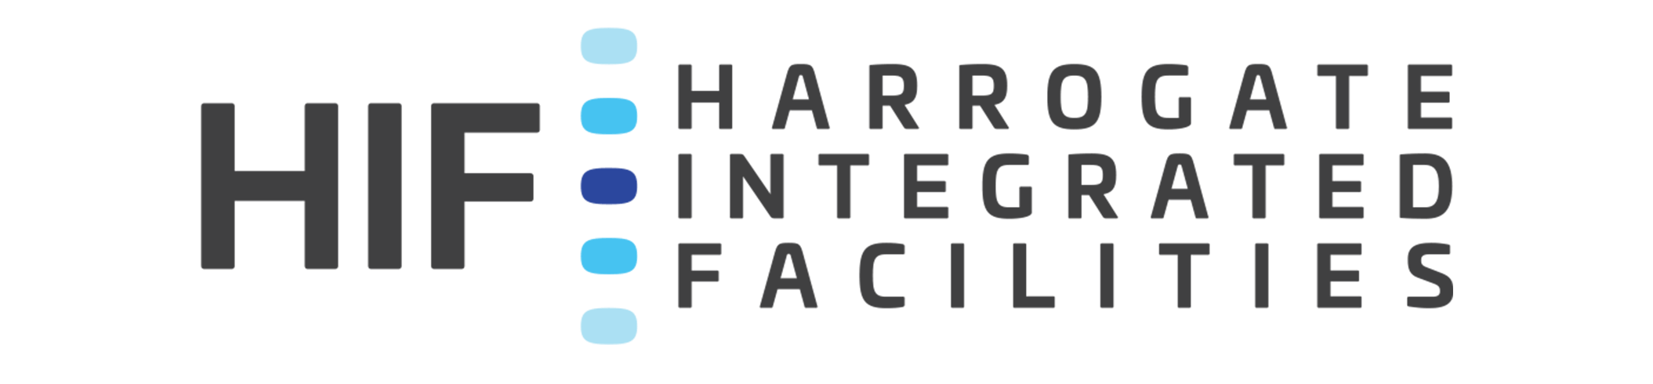

In 2018, HDFT established a wholly owned subsidiary company, Harrogate Healthcare Facilities Management Ltd to provide it with estates and facilities services. The company currently trades as Harrogate Integrated Facilities (HIF) and, while the vast majority of its activity directly supports the Trust to deliver its services, the company has begun to offer services to external organisations such as the Duchy Hospital and a number of dental surgeries.

HDFT in numbers
3  INTEGRATED CARE SYSTEMS | OVER  5,000  COLLEAGUES |  | 21,000  VIRTUAL OUTPATIENT ATTENDANCES
118,000  HOME VISITS | HOSPITAL CATCHMENT AREA  c316,000 |  | £350M  TURNOVER
LOOKING AFTER OVER 600,000 CHILDREN | COMMUNITY SERVICES POPULATION c621,000 |  | LARGEST EMPLOYER  IN HARROGATE AND DISTRICT
55,000 EMERGENCY DEPARTMENT ATTENDANCES |  | OVER 2,000 CANCER TREATMENTS

Our Strategy – 2022 and Beyond


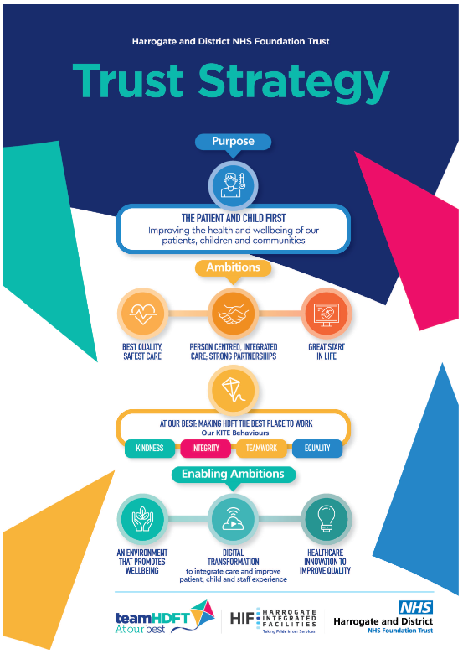

The aim of our Strategy is to establish shared understanding and clarity for our workforce, Board of Directors and partners about the Trust’s purpose, ambitions and priorities. It provides a framework to align our endeavours and mobilise our resources and workforce. Our Strategy is for everyone in the Trust, in every role and every function. It drives our activities as a Trust, as Directorates, Services and individually.
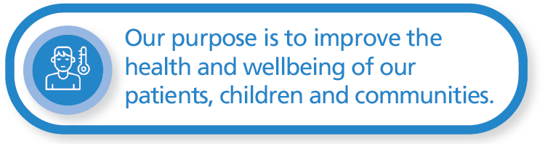
We exist to serve two groups:
the patients who we care for in our hospitals and community services in Harrogate and District, including wider North Yorkshire
the children and young people who we support through our Children’s and Young People’s Public Health Services across large parts of the North East and Yorkshire
Our Strategy makes it clear that our patients and children always come first.
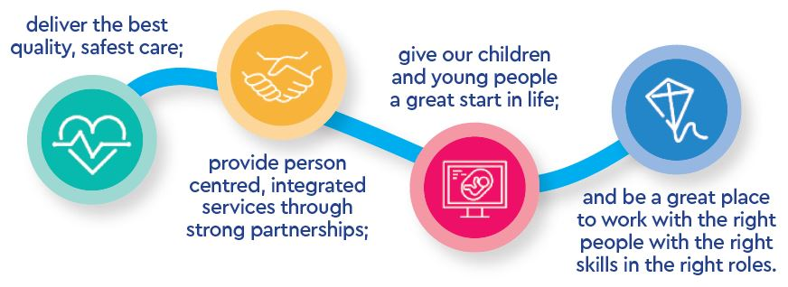
Our purpose is to improve the health and wellbeing of our patients, children and communities. As well as caring for patients when they are unwell, we can also help improve people’s health and contribute to the wellbeing of our communities through our services and how we use our resources.


Our Strategy guides our decision-making about today’s priorities, ensuring they support our purpose and long-term ambitions. Annually, we set clear, specific priorities and objectives for each ambition and goal, and track their delivery through the Board Assurance Framework and our governance and management processes.
Our strategic objectives for 2022-23 were:

Best Quality, Safest Care
Improve theatres’ safety
Reduce pressure ulcers and falls
Implementing the learning from clinical investigations
Reduce medication errors
Improve patient communications
Person Centred, Integrated Care; Strong Partnerships
Increase elective capacity through theatre productivity and outpatient transformation to ensure no patients wait over two years for treatment
Initiate projects to build additional theatre capacity at Wharfedale and Harrogate Hospitals
Reduce waiting times in the Emergency Department by improving the environment and implementing an Urgent Treatment Centre model
Improve patient flow through the hospital, including out of hospital services to support discharge
Great Start in Life
Develop a Children’s Public Health Services Strategy and operating model
Re-start implementation of Hopes for Healthcare, our principles for supporting children and young people in our services
Deliver the actions from the Ockenden Report into our own Maternity Services
At Our Best: making HDFT the best place to work
Look after our people
Embed a culture of belonging
Embrace new ways of working
Growing for the future

These objectives were supported by our enabling ambitions:
An environment that promotes wellbeing: Deliver the 2022-23 estates programme including: Emergency Department reconfiguration; multiple wellbeing projects; the SALIX carbon reduction programme
Digital transformation to integrate care and improve experience: Start the process to replace our Electronic Patient Record; Deliver the 2022-23 digital programme including: Luna - Referral To Treatment (RTT) tracking, eRostering, Datix Cloud, Maternity Electronic Patient Record, Somerset (Cancer Tracking), Yorkshire & Humber Care Record
Healthcare innovation to improve quality: Establish a Harrogate Innovation Hub; Deliver our National Institute for Health and Care Research (NIHR) Portfolio research activity; Start to develop research into Children’s Public Health Services
Our Values

Over values are a key component of what makes HDFT the organisation it is today. Our values are:





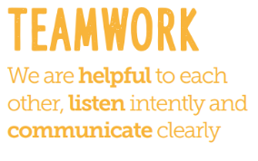
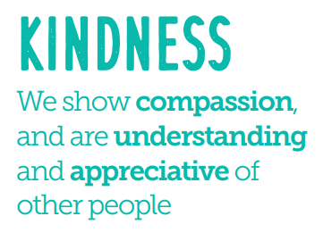


The Locality

Harrogate is surrounded by the beautiful countryside of the Yorkshire Dales but the cities of Leeds and York are also conveniently close by. Knaresborough and Ripon are the market towns which surround Harrogate. Originally, a spa town in the Victorian era, Harrogate is now famous for its shops and many festivals. It has also developed a new role as a national and international conference centre, but retains much of its older charm.

Leisure/Recreation

There are excellent facilities in the area for most sports and outdoor activities. Harrogate also has its own Turkish Baths and Health Spa, and for the enthusiastic spectator, Harrogate Rugby Union Football Club and Harrogate Town Football Club are located near to the hospital site.

Harrogate boasts excellent shopping facilities including department stores, boutiques and high street favourites.

The town is also a gold medal winner of Europe in Bloom and offers recreational facilities including parks, gardens and nature trails.

Housing/Education

There is a very good choice of housing in a variety of town and country settings. The range of state and public schools is wide, including a number of special schools, and standards are high. There are also universities in Leeds and York.

Transport

Harrogate is equidistant from London and Edinburgh and there are frequent connections by intercity rail links in addition to good motorway access. The Leeds/Bradford Airport for national and international connections is easily accessible.

SECTION 6 General Conditions of Appointment

6.1 General Conditions of Appointment

The appointee will enjoy terms based on the nationally agreed Terms and Conditions of Service for Consultants (England) 2003.

i. The successful candidate will be required to live within 15 miles of their base hospital,

iii. The Trust requires the successful candidate to have and maintain full registration with the General Medical and to fulfil the duties and responsibilities of a doctor as set down by the General Medical Council.

iv. All appointments are subject to satisfactory Occupational Health Clearance being obtained.

v. The appointment is exempt from the provisions of Section 4(2) of the Rehabilitation of Offenders Act 1974 by virtue of the Rehabilitation Act 1974 (Exemptions) Order 1975. Applicants are not entitled therefore to withhold information about convictions which for other purposes are "spent" under the provision of the Act, and in the event of employing any failure to disclose such convictions could result in dismissal or disciplinary action by the Trust. Any information given will be completely confidential and will be considered in relation to an application for positions to which the Order applies.

This post falls within the scope of the Rehabilitation of Offenders Act 1974 (Exceptions) (Amendment) (England and Wales) Order 2007 and Section 115 of the Police Act 1997. In accordance with these pieces of legislation the Trust is obliged to check the background of all candidates appointed to medical posts with the Criminal Records Bureau. Accordingly, you will be expected to undertake a 'disclosure' check.

Study leave is granted in accordance with the Medical and Dental terms and conditions of service, currently equivalent to 10 days per year (or 30 days over 3 years). Preference will be given to courses which are organized locally within the region.

In accordance with the Trust’s Removal Expenses policy in appropriate cases assistance may be given in respect of removal costs

All medical staff employed at the Trust should ensure they are familiar with, and apply, the agreed procedure for reporting concerns, quickly and confidentially, relating to the conduct, performance or health of medical colleagues.

x. HDFT takes its responsibility to safeguard and protect the welfare of both adults and children very seriously. During the annual appraisal process appraisers will use the appropriate documents to work with post holders to identify the relevant competencies necessary for this role and ensure the post holder is competent to undertake any appropriate duties or requirements to safeguard adults and children.
For child safeguarding issues the relevant documents are the HDFT Child Protection Training Strategy and the Intercollegiate Document “Safeguarding Children: the Roles and Competencies of Health Professionals.” For adult safeguarding issues the relevant documents are the HDFT Safeguarding Adults policy, particularly the Training Needs Analysis.
Safeguarding also means ensuring that fundamental aspects of care, such as appropriate nutrition, preventing falls and minimising the risk of pressure ulcer formation, is provided for each patient in our care.

