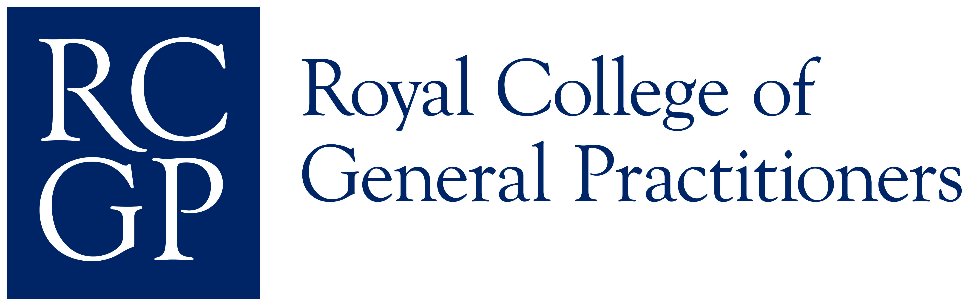

Introduction to Clinical Examination and Procedural Skills Assessment

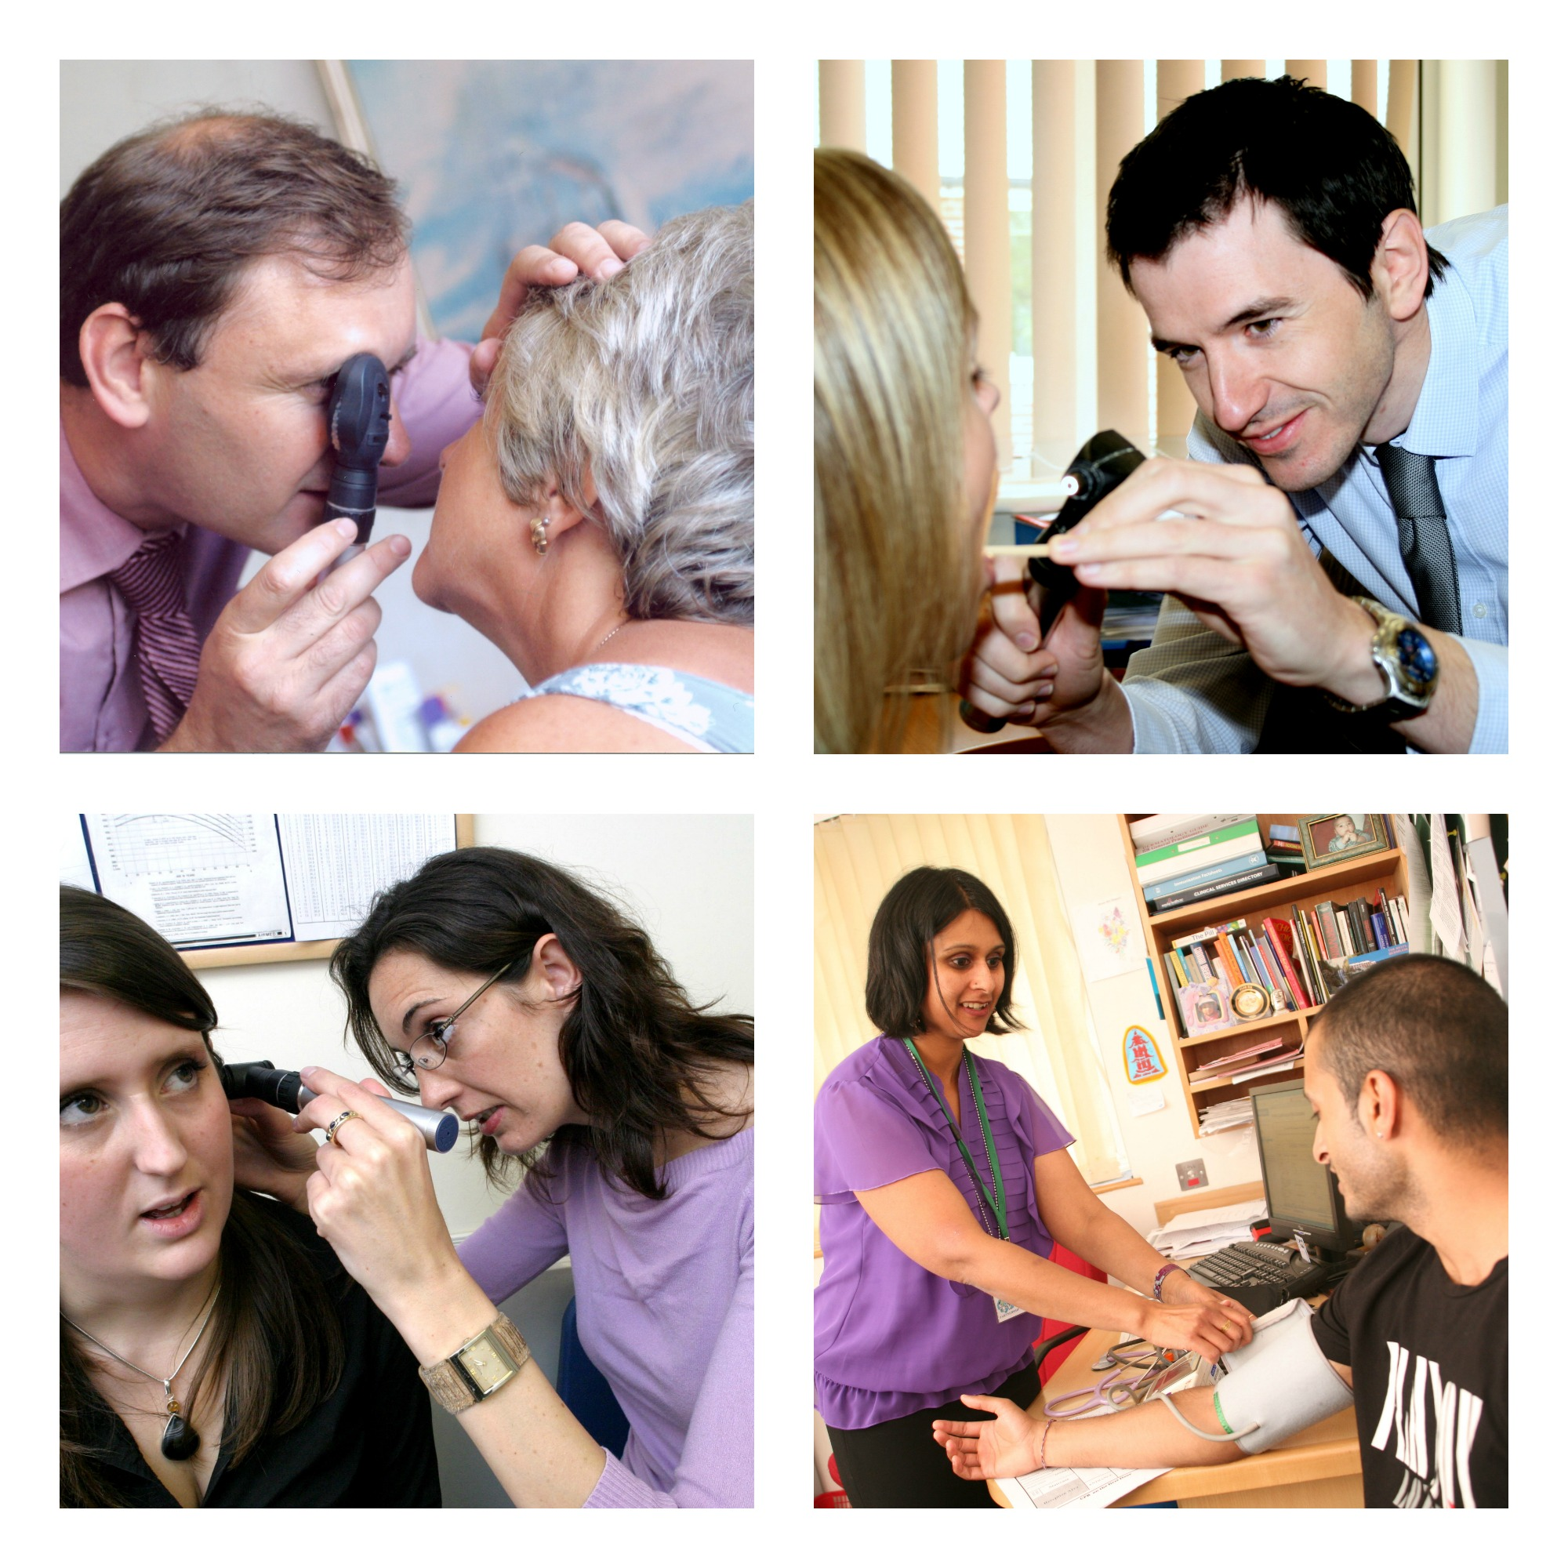

RCGP WPBA core group
December 2015

Contents

Introduction 3

Summary of the key changes 4

Step-by-step guide for Trainees 6

Step-by-step guide for Educational Supervisors 9

Step-by step guide for Secondary Care Supervisors 12

Appendix A: Word pictures and Indicators of Potential Underperformance 13

Appendix B: Clinical Examination and Procedural Skills descriptors 15

Appendix C: Learning log entry 18

Appendix D: Clinical Examination and Procedural Skills evidence form 20

Appendix E: Changes to COT criteria and MSF 21

Appendix F: ESR questions to be completed during each review on CEPS 22

Introduction to Clinical Examination and Procedural Skills

The assessment of clinical examination and procedural skills is an important part of GP training. Competence in these skills is integral to the provision of good clinical practice. As a trainee, you will have a range of clinical skills at the time of recruitment to the GP training programme, but there will also be new skills that you need to acquire, and it will be important to learn how to apply all of your clinical skills in the context of modern general medical practice. You are expected to demonstrate progress in applying these skills in the GP workplace during your training. When you complete training, you must be competent to apply your skills unsupervised.

Clinical examination and procedural skills need to be interpreted broadly, including the range of skills that any competent General Practitioner should be confident in using. There are some particular examinations that need to be specifically included. These are breast examinations, rectal and prostate examinations, and the examinations of male and female genitalia. Any examination can be considered intimate by some patients, for instance a competent examination of the eye with an ophthalmoscope, but the examinations listed are those that, due to their particularly intrusive nature, need to be specifically commented on and reflected on during your training.

There is no minimum number of assessments to be recorded. Instead, you will be expected to discuss your learning needs during placement planning meetings and to record your plans in the learning log and PDP. The range of examinations and procedures and the number of observations will depend on your particular needs and the professional judgement of your Clinical and Educational Supervisors.

It is your responsibility, with the help of, and in negotiation with, your clinical and educational supervisors, to plan and demonstrate your learning with regard to these important skills.

We wish you the best of luck with your training!

The Workplace Based Assessment Team

Summary of the key ways to collect evidence of progression in CEPS

Clinical Examination and Procedural skills (CEPS) is a competence closely aligned to Data Gathering, which needs to be completed by trainees in their ePortfolios and supervisors in the Educational Supervisor's review. It should be treated in the same way as the other 12 competencies in terms of providing evidence of progression from a range of sources. When reflecting on CEPS, it is helpful to relate the reflections to the word descriptors. Appendix A, describes these and the various grades for this competence. The Indicators of Potential Underperformance are listed below the word pictures.

Clinical Examination and Procedural Skills are intricately linked to many of the existing competences and detailed descriptors of how these fit into the existing competences are explained in Appendix B.

Where is the evidence?

There is a type of log entry available to help trainees record their learning and skill acquisition related to Clinical Examination and Procedural Skills, (Appendix C). It will remain the responsibility of the trainee to gather evidence for this competence as it is with the original 12.

A CEPS form appears within the “Evidence” category in the ePortfolio and for observed CEPS the form should be completed by the assessor. This is available to ESs/CSs through their own log-in and to other clinicians through a ticket code generated by the trainee, (Appendix D).

The wording of the COT and the MSF were adapted in 2015 and encourage reference to Clinical Examination and Procedural skills, (Appendix E).

The CSR has a question that specifically requires the rating of the trainee’s ability to elicit important clinical signs and interpret them appropriately. A Clinical Supervisor’s Report (CSR) is mandatory at the end of each secondary care placement and encouraged at the end of all primary care placements. The comments should relate to the clinical examinations and procedural skills undertaken in that post.

In addition the ES is asked to rate progress in this area both generally and in relation to intimate examinations (breast examinations, rectal examinations, examination of the prostate and the full range of male and female genital examinations), (Appendix F).

What type of learning events can be used as evidence for this competence area?
- Joint surgeries
- CEPS forms when examinations or procedural skills are directly observed
- COT / miniCEX
- Videos (where observation of examination technique is appropriate)
- Referrals analysis including correspondence back from secondary care
- MSF
- Case based discussions
- Random case review
- Surgery debriefs
- Simulation stations

None of these in isolation will provide sufficient evidence and this is not an exhaustive list of evidence that can be used.

There may be occasional circumstances, for example certain disabilities, where a trainee is unable to perform a Clinical Examination or Procedural Skill himself or herself. In these situations the trainee will be assessed in their competence in being able to identify the examination required, recognising and reflecting in their learning log that they are unable to do this and ensuring the patient has timely access to another competent health professional to undertake the procedure.

Trainees who have completed any of the previous mandatory Direct Observation Procedures (DOPS) will not have wasted any effort as these completed mandatory DOPS can be used to contribute to supporting their overall competence in Clinical Examination and Procedural Skills.

Step-by-step guide for Trainees
Trainees should provide evidence for Clinical Examination and Procedural Skills as opportunities arise during training. Evidence for this will occur regularly during consultations and joint surgeries. It is expected that supervisors will also observe trainees performing Clinical Examination and Procedural Skills and these can be documented on the CEPS form, which can be found in the evidence section of the ePortfolio, (Appendix D).
It is the responsibility of trainees and their supervisors to ensure that there is sufficient evidence of competence recorded in the ePortfolio.

How to record evidence of Clinical Examination and Procedural Skills within the trainee ePortfolio
Learning Logs
- There is a learning log (Appendix C) that allows the trainee to record learning and skill acquisition relating to Clinical Examination and Procedural Skills (CEPS).

- The trainee is advised to use the word pictures, (Appendix A) for the CEPS competence to describe learning in this area.

- As with all log entries these will need to be linked to the relevant curriculum headings and will need to include a range of entries from specific areas, for example cardiovascular / respiratory / children / the elderly and patients with mental health problems.

- It is essential that the trainee includes entries on breast examinations, rectal examinations, prostate examinations and the full range of female and male genital examinations, as these are required by the GMC.

- Log entries will require the trainee to reflect on any communication, cultural or ethical difficulties encountered.

- The issue of consent for examinations needs to be specifically addressed and also the appropriate use of chaperones.

- The trainee needs to think imaginatively about ways to demonstrate their competence, for example, if they referred a patient to secondary care and mentioned specific findings on examination, they should look for the reply and reflect on whether they were agreed or not.

- Significant event analyses can also be a time for a trainee to reflect on their Clinical Examination and Procedural Skills.

Educational (or Clinical) Supervisors can validate log entries against the curriculum and competence areas once the trainee has shared their log entries with them.

CEPS evidence forms
- Observation and assessment of CEPS may be made by the Educational and Clinical supervisor and/or other colleagues, (including senior nurses and trainees more senior than ST4). If the supervisor is linked to the trainee’s eportfolio, the assessment form can be accessed from the evidence section of the ePortfolio. If the supervisor is not linked to the trainees ePortfolio it can be downloaded from the ePortfolio, or the trainee can produce a ticket code for the assessor to access the form.
- The Educational Supervisor during every review is asked to comment on the progression of breast, rectal, prostate, and male and female genital examinations. If these have been observed this decision can be supported with a completed evidence form.
MSF

- The MSF specifically requests feedback on Clinical Examination and Procedural Skills in the clinical assessment section.

COT

- COTS can be carried out on both recorded and live consultations. Assessment and feedback on CEPS can be provided on most live COT assessments and some recorded ones. Best practice is for COT assessments to be done on both recorded and live consultations. Live consultations give more opportunities for feedback on CEPS and recorded consultations give the best opportunities for formative feedback on general communication and consultation skills.

PDP

- The trainee should consider including specific PDP entries to meet specific learning needs in Clinical Examination and Procedural Skills as well as other learning needs.

- When starting a new placement the trainee needs to think about which skills might be most appropriately acquired during that placement and make a specific PDP entry to that effect.

ESR preparation and self-rating

- The trainee needs to provide enough evidence for them and their ES to link to the CEPS competence just as the trainee does with the other competences.

- Using the word pictures for CEPS, the trainee needs to state how the evidence they have provided supports their personal assessment of this competence.

- A range of attributes is required for the trainee to demonstrate progress in this competence as detailed in the word pictures.

- The trainee can use a variety of sources of evidence (log entries, MSF, COTs and CEPS evidence forms).

- The ES will be asked the following three questions so the trainee needs to ensure their evidence sufficiently covers these;

- For all trainees: Has the trainee demonstrated progression in their Clinical Examination and Procedural Skills, commensurate with their stage of training, during the period under assessment? Please comment specifically on breast, rectal, prostate and male and female genital examinations.
- Are there any concerns about the trainees’ clinical examination or procedural skills? If the answer is ‘yes’, please expand on the concerns and give an outline of the plan the trainee needs to follow for these to be improved.
- For those at the end of training: Is the trainee competent in breast, rectal, prostate and male and female genital examinations? Please refer to specific evidence including Learning Log entries, CEPS, COTs and CBDs etc.

Step-by-step guide for Educational Supervisors

Learning logs

A specific type of learning log (Appendix C) allows the trainee to record their learning and skill acquisition in Clinical Examination and Procedural Skills (CEPS). As with learning logs, the ES can comment on these entries and validate them against the competences.

- The ES uses the word pictures (Appendix A) for the new competence to decide if the log shows learning in this area and, if it does, validate it by linking to the CEPS competence heading. Other competences may also be relevant for example, Ethics, Clinical Management.

- The ES uses the comments box to provide constructive feedback on the trainee’s achievements and to make suggestions for further development.

- If the ES does not feel the entry should be validated than an explanation as to why and the additional evidence required would be appropriate.

- Trainees should be encouraged to carry out and record in their CEPS learning logs a referrals review. In this case the review should focus on whether their referrals had involved examinations which they completed and where the hospital team had reviewed their findings.

Other sources of evidence

The MSF specifically requests feedback on examination and procedural skills in the clinical assessment section.

COTs allow feedback on examination and any procedural skills observed when the assessment is performed on directly observed, rather than recorded, consultations.

Specific CEPS Evidence forms are available to permit feedback on observed examinations and procedures. (Appendix D).

The CSR contains questions specifically relating to clinical and procedural skills.

PDPs (and initial placement planning learning logs) will regularly be places that trainees identify CEPS that will be demonstrated in the course of each placement.

ESR - Rating the competences

The ES approaches the CEPS competence in the same way as the other competences.
- The ES reads, evaluates and makes a judgement on all of the available evidence relating to this competence from the MSF, CSR, COTS, CEPS evidence forms and learning logs in the same way as the other competences.

- In the “Agreed actions” section, the ES describes how the trainee could develop in this area before the next review.

ESR – Skills log

In addition the ES, will be asked to comment on three questions relating to Clinical Examination and Procedural Skills:

- For all trainees: Has the trainee demonstrated progression in their Clinical Examination and Procedural Skills, commensurate with their stage of training, during the period under assessment? Please comment specifically on breast, rectal, prostate and male and female genital examinations.
- Are there any concerns about the trainee’s clinical examination or procedural skills? If the answer is ‘yes’, please expand on the concerns and give an outline of the plan the trainee needs to follow for these to be improved.
- For those at the end of training: Is the trainee competent in breast, rectal, prostate and male and female genital examinations? Please refer to specific evidence including Learning Log entries, CEPS, COTs and CBDs for example.

Step-by-step guide for Clinical Supervisors

When GP trainees are working in a secondary care placement, they value the feedback that they receive during these placements. One important part of this is feedback on their Clinical Examination and Procedural Skills (CEPS).

There are four very straightforward ways of providing feedback on CEPS in a form that can be recorded in the trainees’ ePortfolio so that they can demonstrate evidence of progression in these areas:

Mini-CEX

These assessment instruments are very flexible and most secondary care supervisors are familiar with them. At times it might be appropriate to concentrate on the assessment of a trainee’s physical examination skills when performing a mini-CEX.

Clinical Examination and Procedural Skills (CEPS) forms

There are specific CEPS forms for the purpose of recording an observed examination or procedural skill. These work in a very similar fashion to the Direct Observation of Procedural Skills that CSs have filled in in the past. They are simple to use and the GP trainee can send the CS a ticket code for these to be completed. The completed form will then be available for the trainee to access in their ePortfolio. It is important to note that these forms should only be completed by other Specialist Trainees if they are at ST4 level or above.

Multisource Feedback (MSF)

The MSF for GP trainees has just two questions and the second of these relates to their clinical performance. It is helpful to consider the trainee’s examination skills as demonstrated during the placement if these are being done during the trainee’s hospital post.

Clinical Supervisor’s Report (CSR)

At the end of each placement in a secondary care post the Clinical Supervisor is required to complete a report. There is a specific question that relates to examination skills and the types of examination observed during the post.

Finally, thank you for taking the time to provide our trainees, and their Educational Supervisors, with feedback on their performance. This feedback is a vital element of the overall evidence of their progression in training.
Appendices

A Word pictures for Clinical Examination and Procedural Skills competence.

B Examples of Examination and Procedural skills descriptors within the other competency domains.

C Learning log and trainee guidance to completing log.

D Clinical Examination and Procedural skills evidence form for assessors

E Evidence to be gathered from the COT, mini-CEX and MSF

F ESR questions to be completed during each review on CEPS

Appendix A

Word pictures and IPUs for clinical examination and procedural skills

Clinical Examination and Procedural Skills
This competence is about clinical examination and procedural skills and by the end of training, the trainee must have demonstrated competence in breast, rectal, prostate and in the full range of male and female genital examinations
Insufficient Evidence | Needs Further Development | Competent | Excellent
From the available evidence, the doctor’s performance cannot be placed on a higher point of this developmental scale | Chooses examinations broadly in line with the patient’s problem(s) | Chooses examinations appropriately targeted to the patient’s problem(s) | Proficiently identifies and performs the scope of examination necessary to investigate the patient’s problem(s)
 | Identifies abnormal signs but fails to recognise their significance | Has a systematic approach to clinical examination and able to interpret physical signs accurately | Uses an incremental approach to examination, basing further examinations on what is known already and is later discovered
 | Suggests appropriate procedures related to the patient’s problem(s) | Varies options of procedures according to circumstances and the preferences of the patient | Demonstrates a wide range of procedural skills to a high standard
 | Demonstrates limited fine motor skills when carrying out simple procedures | Refers on appropriately when a procedure is outside their level of skill | Actively promotes safe practice with regard to examination and procedural skills
 | Observes the professional codes of practice including the use of chaperones | Identifies and discusses ethical issues with regard to examination and procedural skills | Engages with audit quality improvement initiatives with regard to examination and procedural skills
 | Performs procedures and examinations with the patient’s consent and with a clinically justifiable reason to do so | Shows awareness of the medico-legal background to informed consent, mental capacity and the best interests of the patient | Helps to develop systems that reduce risk in clinical examination and procedural skills
 | The intimate examination is conducted in a way that does not allow a full assessment by inspection or palpation. The doctor proceeds without due attention to the patient’s perspective and feelings | Ensures that the patient understands the purpose of an intimate examination, describes what will happen and explains the role of the chaperone. Arranges the place of examination to give the patient privacy and to respect their dignity.  Inspection and palpation is appropriate and clinically effective. | Recognises the verbal and non-verbal clues that the patient is not comfortable with an intrusion into their personal space especially the prospect or conduct of intimate examinations. Is able to help the patient to accept and feel safe during the examination.

Indicators of potential underperformance (IPU):
- Fails to examine when the history suggests conditions that might be confirmed or excluded by examination
- Patient appears unnecessarily upset by the examination
- Inappropriate over - examination
- Fails to obtain informed consent for the procedure
- Patient shows no understanding as to the purpose of examination.

Appendix B

Clinical and Examination and Procedural Skills descriptors

These descriptors are for the guidance of Trainees and their Clinical and Educational Supervisors. They may be read in conjunction with the descriptors for rating the assessment of competence.

Communication and consultation skills
- Explores the patient’s previous experience of the examination/procedure should they have any.
- Explains the process, and purpose for the examination/procedure in language that is easily understood by the patient.
- Ensures that the process, and purpose for the examination/procedure is understood and gains consent to proceed.
- Offers the attendance of a chaperone when this is appropriate for either doctor or patient.
- Doctor is sensitive to the patient’s situation and perspective and seeks throughout to ensure the patient is happy for them to continue.
- Communicates effectively throughout the procedure putting the patient at ease.
- Ensures any discomfort is kept to the minimum. Checks with the patient that they are happy for them to continue, should any discomfort occur.
- Explains the findings to the patient in appropriate manner after completing the procedure. Maintains the dignity of the patient and incorporates the patient’s beliefs when appropriate.
- Responds to verbal and non-verbal cues from the patient.
- Seeks to confirm the patient’s understanding of the findings or consequences of the examination or procedure.
- Explains when results of such procedure will be available and arranges appropriate follow up.

Practising holistically
- Demonstrates an understanding of the patient’s wishes in relation to their cultural or religious background relevant to the examination or procedure. Takes appropriate steps to adhere to any adjustments that are feasible.

Data gathering and interpretation
- Chooses examinations and procedures appropriately which are relevant to the patient’s presenting complaint or situation.
- Identifies abnormalities when they are present and finds examination normal when they are absent.
- Recognises the implications of examination findings.
- Extends the examination or procedure when the findings dictate.

Making a diagnosis
- Interprets findings to aid diagnosis using patterns of recognition.
- Works out the meaning of findings when there is not a recognised pattern
- Revising hypotheses in the light of additional information.

Clinical management
- Refers on appropriately when the procedure is outside their level of skill and experience or when the examination findings indicate the need for referral.

Managing medical complexity
- Interprets the effect of long standing findings related to pre-existing conditions and differentiates these from findings related to an acute problem.
- Is able to tolerate uncertainty resulting from the findings or outcome of the examination or procedure.
- Communicates the risk of the procedure to the patient and involves them in the decision making.
- Monitors the patient’s progress for any adverse outcomes and minimises risk by appropriate safety netting.

Organisation Management and Leadership
- Records accurately their examination findings in the primary care IMT system, including the patient’s consent in a manner that is coherent and comprehensible.
- May audit an aspect of procedural skills using the computer records.

Working with colleagues and in teams
- When a procedure or examination involves other members of the team, works co-operatively with the other member and uses their skills appropriately.
- Communicates effectively with the team member to enhance patient care.

Community orientation
- Optimises the use of limited resources through cost effective use of all necessary equipment and other resources.

Maintaining performance learning and teaching
- Shows a commitment to professional development through reflection on performance of procedural skills and the identification of and attention to learning needs.
- Evaluates the process of learning to make future learning cycles more effective.
- Participates in audit where appropriate and uses audit activity on procedural skills to evaluate and suggest improvements in personal and practice performance.
- Identifies learning objectives related to procedural skills and uses teaching methods appropriate to these.
- Assists in making assessments of learners’ procedural skills when their own level of experience makes shared assessment appropriate.

Maintaining an ethical approach
- Is aware of their own limitations and does not attempt procedures for which they are not qualified.
- Seeks helps when needed.
- Does not perform procedures without the patient’s consent or without a clinically justifiable reason to do so.

Fitness to practice
- Observes the accepted codes of practice in order ensure patient safety. This includes clear documentation of the patient’s consent, the offer of a chaperone and the appropriateness of the procedure related to the patient’s complaint.

Appendix C

Learning log entry

Type: Clinical Examination and Procedural skills

Date: *…………………………..

Curriculum linkage:…………….

Clinical Examination or Procedural Skill performed,
(Please be specific, for example prostate examination not just rectal examination or cranial nerve examination not just neurological examination)

If observed, state name of observer and position

Observer………….
Position ………….

Reason for physical examination, procedure performed and physical signs elicited (to include whether this was the expected finding)

Reflect on any communication or cultural factors

Reflect on any ethical factors (to include consent)

Self assessment of performance (to include overall ability and confidence in this type of examination or procedure)

Learning needs identified

How and when these learning needs will be addressed

Trainee Guidance for completing the learning log ‘clinical examination and procedural skills’

Include entries to demonstrate your ability to perform clinical examinations and procedures against the curriculum areas.

Suitable examinations will include cardiovascular, respiratory, neurological, abdominal, musculoskeletal and mental state examinations.

Cases should also include examinations of different patient groups, i.e. elderly and paediatric patients

Ensure you have linked the entry to the relevant curriculum area.

It is essential within your learning log to include evidence of competence in breast examination and in the full range of male and female genital examinations, as there is concern that these may otherwise not be done. Your Educational or Clinical Supervisor can complete a Clinical examination and Procedural Skills evidence form if they/you feel this is necessary.

When completing the log entry you need to consider any communication, ethical or cultural issues, for example the use of chaperones or when it was felt to be inappropriate to examine and why.

When appropriate your ES will then be able to validate this entry against the competence for clinical examination and procedural skills. They may make a comment in the usual way which highlights any areas of concern, or areas of particular strengths, etc.

Appendix D

Clinical Examination and Procedural Skills evidence form

Trainees name to be automatically populated
Assessor
Drs Surname

Drs Forename

GMC number

Free text

Clinical examination / Procedural skill observed

What was performed well? To consider:
- Communication with patient
- Awareness of cultural and ethical factors
- Ability to perform clinical examination or procedural skill
- Consideration of patient and professionalism demonstrated

Areas for further development

Appendix E

COT criteria 6

This competence is about both the appropriate choice of examination, and performance of examination when directly observed. A mental state examination would be appropriate in a number of cases. Intimate examination should not be recorded (on video), but directly observed.

Multisource feedback (MSF)

Part 2 of the MSF asks the assessor to make a comment on the your overall clinical performance.
The prompts given in this section, which help the assessor reach their decision, are:
‘You may wish to comment on the doctor’s ability to:
- Conduct a thorough history
- Identify a patients’ problems
- Make a diagnosis
- Perform a range of clinical, procedural and technical skills effectively
- Manage patients
- Learn from their clinical experience
- Manage time appropriately

Appendix F

ESR questions on Clinical Examination and Procedural Skills

Three questions to be completed on CEPS during the ES review:

- For all trainees: Has the trainee demonstrated progression in their Clinical Examination and Procedural Skills, commensurate with their stage of training, during the period under assessment? Please comment specifically on breast, rectal, prostate and male and female genital examinations.
- Are there any concerns about the trainees’ clinical examination or procedural skills? If the answer is ‘yes’, please expand on the concerns and give an outline of the plan the trainee needs to follow for these to be rectified.
- For those at the end of training: Is the trainee competent in breast, rectal, prostate, and male and female genital examinations? Please refer to specific evidence including Learning Log entries, CEPS, COTs and CBDs etc.

