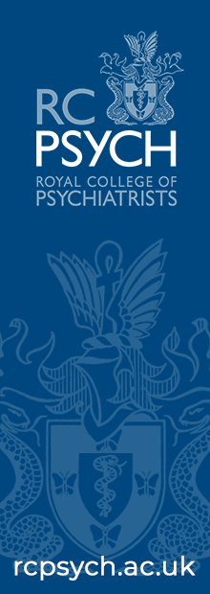

|  |
| --- |
| [Type the document subtitle] | William Wright |

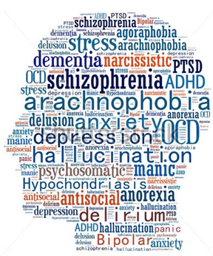

2020/2021

|  |
| --- |
| HANDBOOK |

**C**ore

**P**sychiatry

**T**raining

**C**ourse

Basic Neurosciences

Behavioural Science & Socio-Cultural Psychiatry

Human Development

Clinical Psychopharmacology

Old Age Psychiatry

Organisation & Delivery of Psychiatric Services

Classification & Assessment in Psychiatry

General Adult Psychiatry

Child & Adolescent Psychiatry

Psychotherapy

# Contents

Contents 1

Introduction 2

Meet the Team 2

Portfolio Competency Framework 3

Course Outline 3

Course Days and Locations of Teaching 5

Attendance 5

Feedback Forms 6

Mock CASC (CT2 and CT3) 7

FACS 1 (CT1) and FACS 2 (CT2) 7

Exam and Private Study Leave 7

Support and Resources 8

# Introduction

Welcome to the Core Psychiatry Training Course. We hope that you enjoy your time with us and that you find the course rewarding and fulfilling. This handbook gives a basic overview of the course and how it works, who’s who in the Core Psychiatry Training Course team and resources and support available to you.

The Core Psychiatry Training Course is a taught course, for all Core Trainees who have a National Training Number in Yorkshire and the Humber. The course is delivered to core trainees in psychiatry over 3 years, jointly by the University of Leeds and Sheffield Health and Social Care NHS Foundation Trust, across Yorkshire and Humberside.

Please do not hesitate to contact us for any further information you may require. Our contact details can be found in section below.

# Meet the Team

### Dr Joy Owens

Consultant Psychiatrist

Core Psychiatry Training Programme Director, South Yorkshire Rotation

### Dr Alex Pavlovic

Consultant Psychotherapist and Course Lead

Email: [Alex.Pavlovic@shsc.nhs.uk](mailto:Alex.Pavlovic@shsc.nhs.uk)

### Mrs Jo Wilson

Medical Education & Staffing Manager and Course Manager

Email: [Jo.Wilson@shsc.nhs.uk](mailto:Jo.Wilson@shsc.nhs.uk)

### Bethany May

Core Psychiatry Training Course Coordinator

Tel:  0114 2711481

Email: the CPTC generic inbox: [cptc@shsc.nhs.uk](mailto:cptc@shsc.nhs.uk)

### Dr William Gann

Co-Associate Course Organiser

Specialty Registrar

**Dr Dasal Abayaratne**

Co-Associate Course Organiser

Specialty Registrar

**Dr Zoe Kwan**

Co-Associate Course Organiser

Specialty Registrar

# Portfolio Competency Framework

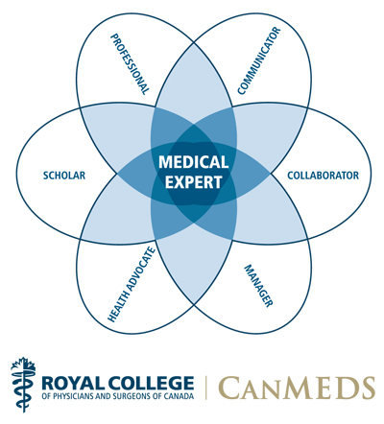

# Course Outline

Teaching takes place on one day per fortnight over two semesters each year. The format of the course includes lectures, workshops, interaction with simulated patients and self-directed study. Most teaching is face-to-face and maps closely onto the MRCPsych syllabus. Additionally, some specialist teaching is delivered in joint sessions which trainees from both Leeds and Sheffield attend and via live video-linked lectures.

In each year of the course there is teaching on communication skills with formative assessments of communication skills (FACS) at the end of years 1 and 2, to help trainees’ development in this important area.

The course aims to provide learning opportunities relating to the knowledge, skills, attitudes and behaviours underpinning core training in psychiatry, as outlined in the core training curriculum of the Royal College of Psychiatrists and to facilitate preparation for MRCPsych examinations, based on the MRCPsych examination syllabus which can be accessed here - <http://www.rcpsych.ac.uk/traininpsychiatry/corespecialtytraining/curricula.aspx>

<http://www.rcpsych.ac.uk/traininpsychiatry/examinations.aspx>

*By the end of the course, trainees should be able to:*

* understand the sciences basic to psychiatry
* *understand the clinical aspects of the psychiatric specialties*
* *demonstrate communication and clinical interviewing skills at a level appropriate to core training*
* principles of research methodology and ability to critically appraise relevant research
* develop non-clinical skills (leadership, management etc)

New trainees may enter the course either in September (Semester 1) or February (Semester 2). For each academic year of the course, you must complete two semesters; this means that September starters finish in the following June, whilst February starters do not finish until the following December.

Trainees may enrol in the course year that is most suitable for their training requirements, agreed with their TPD.

The course runs over the three years of your core training programme.

Year One (CT1): This focuses on foundation sciences and psychological processes, including human development and ageing; psychopharmacology and the historical and cultural aspects of psychiatry, mapping on to the syllabus for Paper A. Additionally, FACS 1 (introductory communications skills) is incorporated into the timetable.

Year Two (CT2): This focuses on clinical learning, with specifics of general adult and specialist psychiatry, mapping on to the syllabus for Paper B. There is a strong focus on principles of research methodology and developing ability to critically appraise relevant research as well as, clinical and communication skills, with plenty of preparation for the CASC exam included. Additionally, FACS 2 (communications skills training) is incorporated into the timetable

Year three (CT3): Advanced communication and clinical skills are the focus of the final year, with ongoing relevance of the learning events to day-to-day clinical practice; additionally, non-clinical educational events are included to help prepare you for the next stage of your career e.g. building your CV, interview practice, understanding the changing clinical workforce.

# Course Days and Locations of Teaching

The days on which the Course runs are:

* CT1 - Fridays 09:30 – 16:30
* CT2 - Tuesdays 09:30 – 16:30
* CT3 - Wednesday afternoons 13:30 – 16:30

Locations of teaching:

Most of face to face teaching takes place on the Fulwood House site in Sheffield, the exact room location will be listed in the timetable.

Teaching also occasionally takes place in Leeds and some may be held via video conferencing.

The timetables give details of teaching/events including subjects, lecturers, dates, times and locations. They are emailed by us when they are updated and will be available on the HEE website, details of which can be found in the support and resources section of this handbook.

# Attendance

You are expected to attend at least 75% of teaching provided on the Core Psychiatry Training Course timetable (pro rata for Less Than Full Time Trainees).

The course is a key component of the training scheme and is included as part of your study time to support your preparation for exams and is therefore protected time that must be included in your work schedules. There is a strong correlation between attendance and passing the exams. The course also helps to equip you for your career in psychiatry.

To monitor attendance, there is an attendance register for each lecture.

**Absence**

Please email the CPTC inbox ([cptc@shsc.nhs.uk](mailto:cptc@shsc.nhs.uk)) if you know you cannot attend the course, preferably in advance of your absence. If we are not notified of non-attendance we send a standard email to you. If there is no response within two weeks the Course Lead will contact your Clinical Supervisor and, if the absence is unauthorised, he will also contact the Training Programme Director. We have a duty of care to you and if you are having problems attending we need to know so that we can help you.

Authorised reasons for absence

* Prearranged Annual Leave – However should a pattern of non-attendance on teaching days occur it is subject to review by the Training Programme Director and Course lead
* Sick Leave
* Rest days / zero days
* Pre-approved study leave for exams
* Carer Leave/Compassionate Leave
* Emergency Leave
* Maternity Leave
* Paternity Leave
* Partner/Paternity leave
* Adoption Leave
* Attendance at the Coroner’s Court
* Jury Service

Trainees are only excused from attendance at the course for reasons other than those stated above, with the advance approval of their Training Programme Director. This will normally only be given if the trainee has the opportunity of an exceptional clinical experience which is only rarely encountered during training (e.g. observing court proceedings).

Absence on the course for any reason other than those stated above will be treated as unauthorised. Recurrent absence will result in a meeting with the course lead and addressed at ARCP.

# Feedback Forms

Feedback forms are distributed at the end of each teaching session. We ask that you complete them at that time. They are your chance to tell us anonymously what you think. We do take account of feedback and use it to improve the course.

# Mock CASC (CT2 and CT3)

The Mock Clinical Assessment of Skills and Competences (CASC) exam is a half-day event, run twice a year, around three months before the exams in September and January. We have ten places available to practice nine stations, under real examination conditions. We use simulated patients and consultant examiners (many of whom are examiners for the CASC exam) in order to provide you with the most realistic experience of the exam. Feedback on your performance is provided individually, verbally and in a written format. Feedback from previous candidates has always been excellent and we strive to continue to provide you with a valuable experience. You will receive an email inviting you to apply for a place approximately two to three weeks before the Mock CASC.

# FACS 1 (CT1) and FACS 2 (CT2)

**Formative Assessment of Communication Skills 1**

The aim of FACS 1 is to further develop your communication skills when dealing with patients who are undergoing distressing and difficult times which would be a common presentation as you start your journey in psychiatry. The key point of FACS 1 is that it is a formative assessment whereby both your strengths and areas of improvement can be highlighted in a relaxed, casual environment. The 1:1 feedback process and recording of the session would hopefully encourage further reflection in your everyday practice. It is also a stepping stone in preparing for the CASC where your communication skills would be put to the test.

There will be 2 stations. You will get a chance to read the scenario before entering the room. Each station is 15 minutes long; 10 minutes to complete the task and 5 minutes feedback from the facilitators. There will be two facilitators in each station.  Your sessions will be recorded and you will be provided with the video files after the day. This will provide you with the opportunity to reflect on your performance on the day.

**Formative Assessment of Communication Skills 2**

FACS2 will consist of 2 clinical scenarios each lasting a total of 30 minutes; 15 minutes to work through the scenario and 15 minutes with the assessors giving written and verbal feedback. The scenarios will focus on exploring psychopathology and delivering a collaborative care plan. Together with the assessors you will agree a Personal Development Plan on developing your clinical interview skills. Your PDP will enable you to reflect on and progress these skills with your educational and clinical supervisors. The FACS does not have a pass or fail mark.

# Exam and Private Study Leave

Please see the Curriculum Delivery Procedure for Junior Doctors distributed with this handbook.

# Support and Resources

Presentations and teaching materials will be uploaded onto the CPTC website when received or, if the lecturer wishes, after the teaching. However sometimes materials are not made available, although they are always requested.

The CPTC website is located on the HEE website and can be accessed here <https://www.yorksandhumberdeanery.nhs.uk/psychiatry/cptc>

We will automatically arrange access to the login area for you when you start the course, however please could us if you have any problems accessing this area.

## Trainees Online TrOn (RCPsych)

### Trainees Online (TrOn) is an online learning resource for trainees, produced by the Royal College of Psychiatrists.

TrOn offers:

* A free teaching resource to aid your learning and revision for the MRCPsych exams.
* eLearning to fit around your timetable at work, at home, or on the go.
* Use of a credible online study resource to record in your ARCP portfolio.
* A more interesting learning experience with dynamic diagrams and responsive illustrations.
* 'My TrOn' tracks your progress so you can return to unfinished modules later.
* Measure your understanding with interactive activities and tests.
* Signposts for further study with references and links to other related journal articles.

### Accessibility

All College members (all categories including: PMPTs, Affiliates, Special Associates, Members, Fellows and International Associates) can gain free access to Trainees Online - your user name and password will automatically be the same as for the College website's secure members' area.

## eBrain

eBrain is an online e-learning resource with a focus on training in the clinical neurosciences. It features a wide variety of resources including e-learning modules, virtual patients, webinars question banks, as well as formative tests/examinations.



## CPD Online (RCPsych)

CPD Online is an online resource offering access to RCPsych e-learning modules and publications. It offers access to various free modules but more modules are available through a subscription.

Many modules are free to access without any login being required. However, access to more content requires a paid subscription which can be arranged by contacting:

**Customer Services**

Turpin Distribution

Pegasus Drive

Stratton Business Park,

Biggleswade

SG18 8TQ

Tel: 01767 604 951

Fax: 01767 601 640

Email: [custserv@turpin-distribution.com](mailto:custserv@turpin-distribution.com)

**Contact us:**

**Core Psychiatry Training Course**

Medical Education Department

Fulwood House

Old Fulwood Road

Fulwood

Sheffield

South Yorkshire

S10 3TH

🕿: (0114) 226 1585

🖂: [CPTC@shsc.nhs.uk](mailto:CPTC@shsc.nhs.uk)

© Sheffield Health & Social Care NHS Foundation Trust 2018 Publication