Please use the below link or QR code to register your attendance at all Dental Specialty Training Study Days

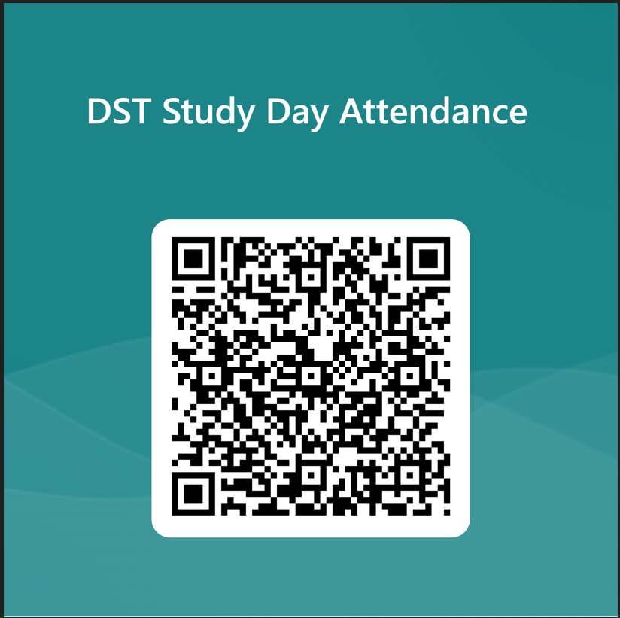

https://forms.office.com/e/sBu5f0aNgm

