Foundation Training Job Description

Grade | F1
Placement | Endocrinology & Diabetes
Department | The Department is located in the Allam Diabetes Centre on the Hull Royal Infirmary site. There are 9 consultants in the department (not all appear in this photograph!). The department has an active research team led by the R+D lead for the Trust, Professor Sathyaplan, assisted by Senior Lecturer, Dr Harshal Deshmukh. Dr Kamrudeen Mohammed is Assistant Clinical Dean for Hull York Medical School. Dr Shiva Mongolu is IMT Training Programme Director, Dr Rehmat Karim is Clinical Governance Lead, and Dr Belinda Allan is Clinical Lead. Dr Chris Walton is the Chair of the Strategic Clinical Network for Diabetes in Yorkshire and the Humber.  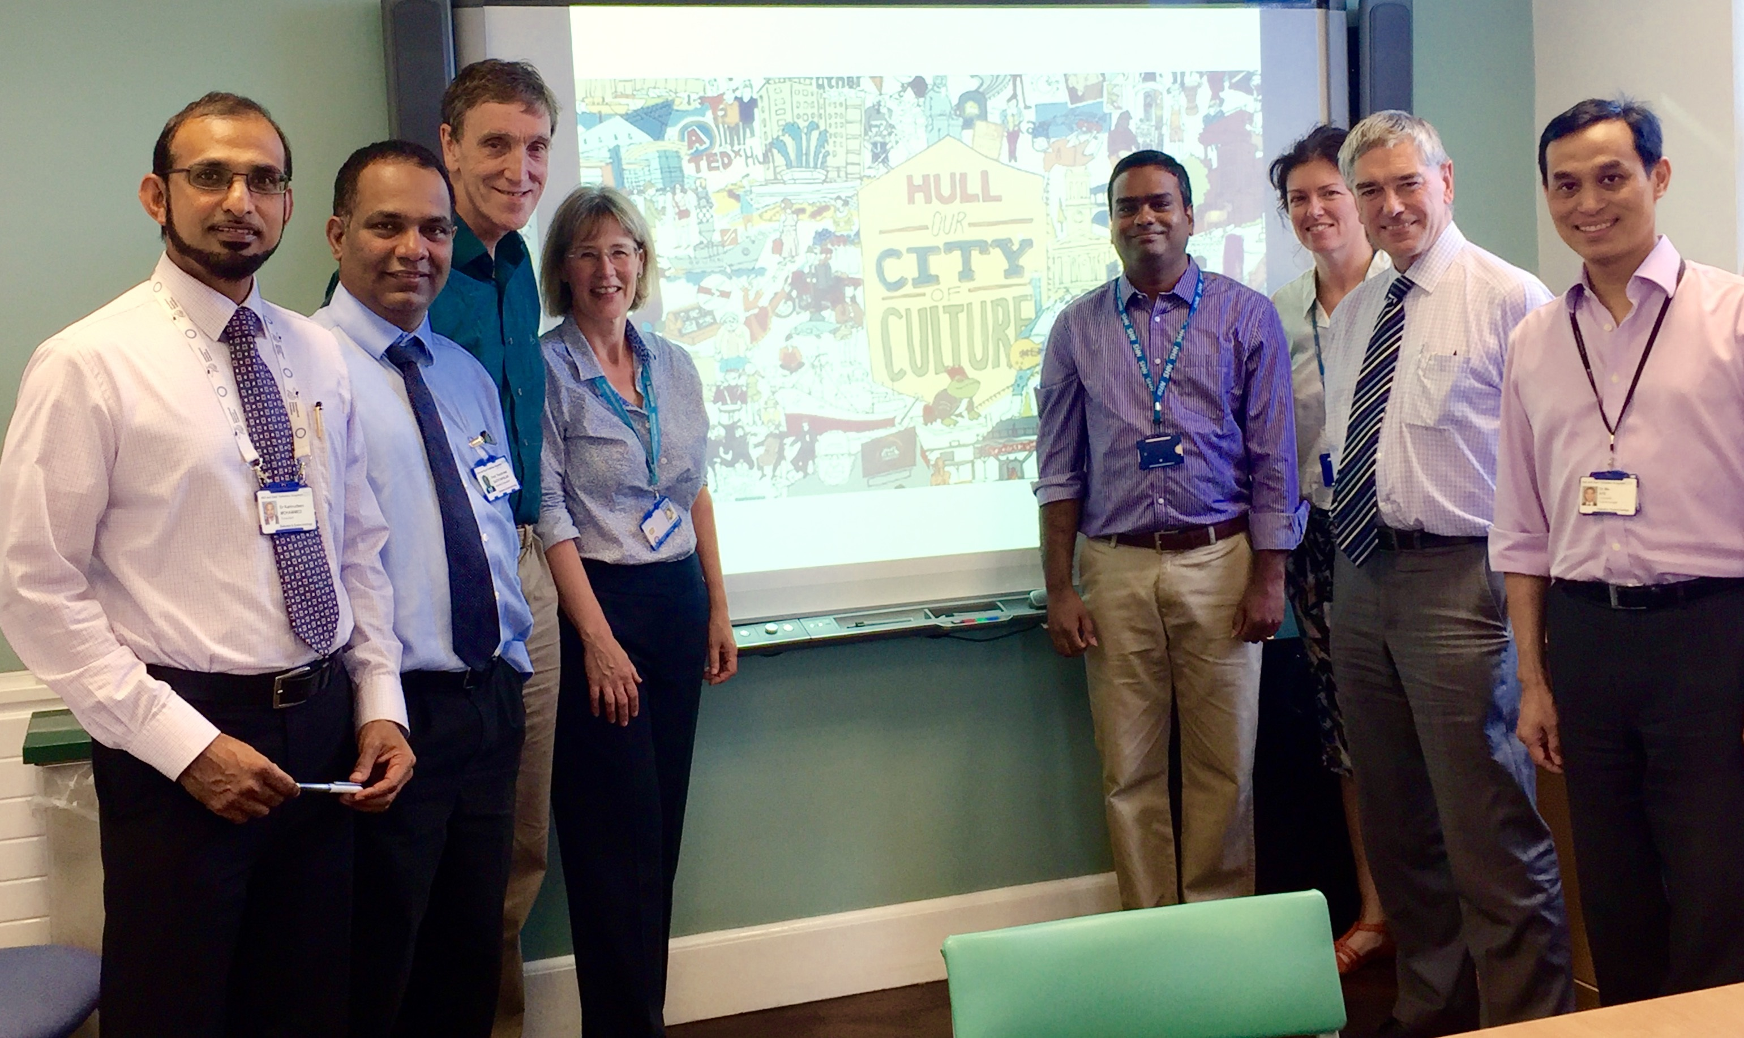
The type of work to expect and learning opportunities | - To gain experience in diabetes and endocrinology history taking and examination  - To improve communication skills and develop team work  - To master basic medical techniques  - To learn about common endocrinology emergencies and their management  - To build upon undergraduate education and FY1 experience  - To gain experience and familiarity in dealing with a wide variety of medical conditions  - To develop the skills of history taking, physical examination, appropriate investigation and rational prescribing  - To master several basic medical techniques  - To improve communication skills with patients, relatives and colleagues  - To develop skills in managing time and conflicting priorities  At the end of the four month period the FY1 will have obtained experience in the following:  - Diagnosing a wide range of common medical conditions  - Treatment of a wide range of common conditions including managing some diabetic emergencies  - Management of a wide range of common acute medical conditions  After 4 months you should have had sufficient experience to be able to complete the required DOPS, CBD, Mini-CEX.
Where the placement is based | Diabetes and Endocrine Ward, H10, Hull Royal Infirmary and the Acute Medical Unit, Hull Royal Infirmary
Educational and Clinical Supervisor(s) for the placement | Will be allocated when you join the training programme.
Main duties of the placement | Ward work.
Typical working pattern in this placement | Out of hours work could be in any other specialty and will be reflected in your work schedule with adequate notice  Ward round each morning, ward jobs and discharges in the afternoon, clerking admissions in the acute medical unit and reviewing those patients transferred to the ward. You will be allocated self-directed study time to keep your e portfolio up to date.
Employer | Hull University Teaching Hospitals NHS Trust

It is important to note that this description is a typical example of your placement and may be subject to change.

