Enhanced Communication and Engagement
27 October 2020
Oakwell Centre, Dewsbury & District Hospital
09:00-17:00

Enhanced Communication and Engagement – a motivational workshop
Learning objectives/outcomes:
By the end of the one day workshop, delegates will be able to:
- Understand and communicate compellingly to different thinking styles
- Enrich your understanding and perspective of a situation by experiencing it from multiple points of view
- Create and maintain genuine rapport
- Explore how enhanced communication skill supports the revalidation process
- Understand how the appraisal for revalidation process benefits individuals, patients and teamwork
Outline Programme:
Workshop:
First principles – the key principles of NLP.
Our past – understanding the effect of our beliefs and past experiences on communication.
Building rapport – techniques to build rapport including facts about body language.
Our senses – understanding how to incorporate all of the senses in communication.
The brain – demonstrating what happens in our brain to influence understanding and thinking patterns.
The mind – how the unconscious mind works.
Language – understanding how we communicate through language patterns.
Communication – highlighting the use of different patterns and styles used in communication.
Persuasion – how to influence and persuade others positively.
Link to appraisal & medical leadership
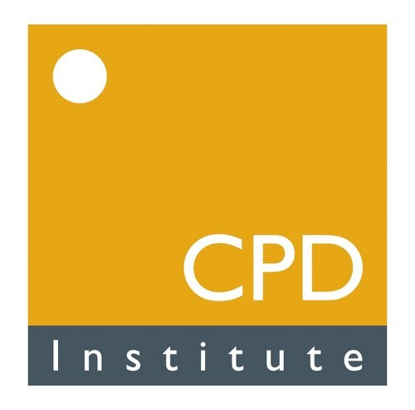

6 guided learning hours
6 CPD Points

