Trainee Wider Forum

8th February 2022

Executive forum members present:  Emma Howe (chair)  Sara Page  Lauren Harkin  Alex Damazer  Lucy McCabe  Opeoluwa Adeniran  Peter Webster  Hussain Sarwar  Maria Crouch  Sanah Sajawal | Wider forum:  Catherine Turner  Sangram Patil  Haoyu Wang  Khaled Habib (exception reporting presentation)  Mousindha Arjunan (FLP on update on EDI development)

Jam boards completed

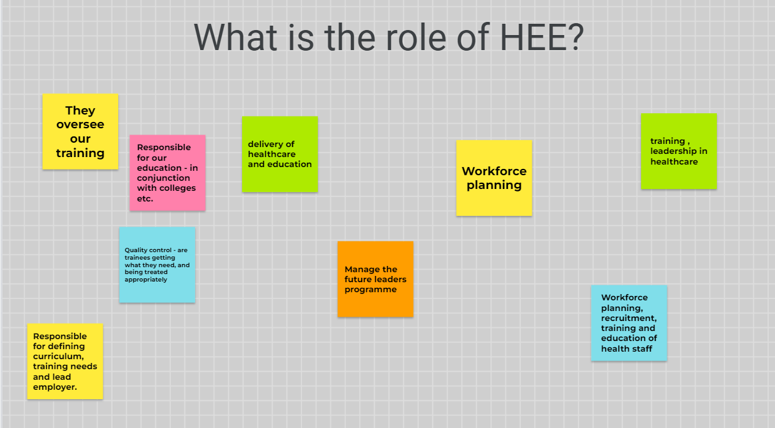
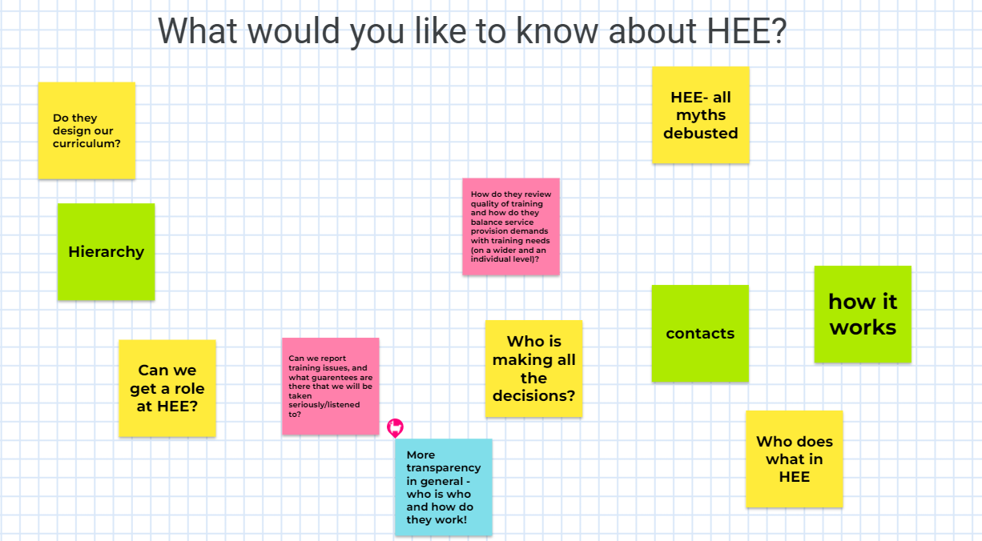

Podcast HEE communication project:
Discussed pending project to improve communication and roles within HEE to trainees specifically exploring roles and the tasks of HEE
Podcast Suggestions:
- ARCP process explained and changes that have occurred.
- What in training is HEE in charge of and what aspects are school/colleges in charge of? The differences in these roles.
- “How to fail” style podcast: HEE mini podcasts open and transparency about some mistakes in decisions and learning points. What projects have worked and what hasn’t and learning points from HEE.
- Opportunities for trainees to be involved in HEE and explanation of HEE roles that we might benefit in the future.
- Top tips from heads of schools and TPDs: common areas in which trainees have issues with for ARCP/training etc.
Concerns expressed around changes in IMT and paediatric curriculum and cut offs deadlines meaning some close to CCT are having to go on to the new curriculum. Discussed school decision and whether HEE can support individual trainees regarding these decisions.

LTFT update by Lauren:
- Webinars over last few months about LTFT hosted by John Hussain and HEE LTFT leads.
- HEE support widening access to LTFT and all trainees should have flexibility for ltft.
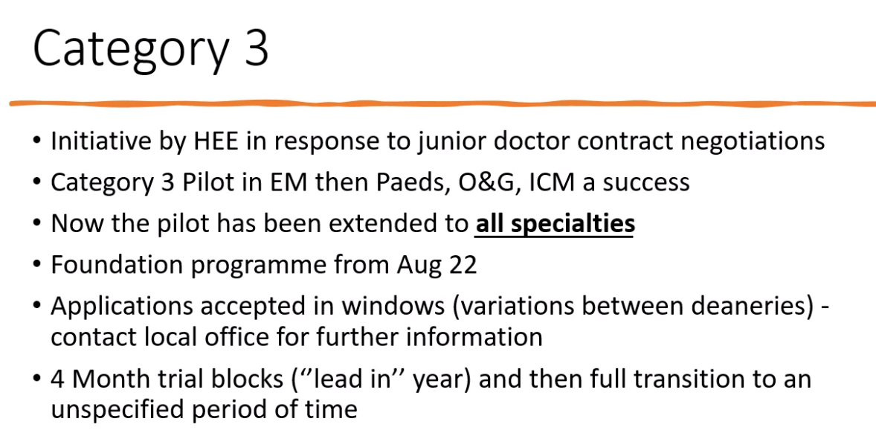
- Category 3 new criteria now being expanded to all specialties with window deadlines for applications for LTFT.
- Foundation should be offered category 3 form August.
- Category 1 and 2 LTFT can apply at any time.
- Applications take 12-16 weeks but fast track applications can be considered on individual situation
- Positive impact on evaluation of category 3 outcomes
- Concerns expressed regarding LTFT colleagues attending on days off to gain training. Discussed contracts not protecting this and also impacting other trainees training.
- LTFT should not be used to allow time to come in to focus on catching up in training. Should not be used as reason

Emma Diggle COVID recovery update:
- Trainees to contact head of schools if needing any specific COVID recovery measures.
- Some comms coming out regarding the suggested COVID recovery projects/bids
- Those trainees having back bid money to support training has been closed and should contact head of school/TPD and supervisors to support these measures within rota etc.
- COVID recovery money has come from the treasury and needs governmental approval.
- COVID recovery information included in the TEF newsletters.

Jon Cooper: Ask the Dean

What is your position on accelerated training in LTFT trainees who have completed the minimal number of years in training?
- Trainees should be supported if they have met the training needs earlier within the minimum years if they show competence completed.
- If having issues with TPD or unsure who this is escalated to then contact head of school and then the associate deans leading those schools.
- These discussions should be done prior to ARCP deadlines.
What are your priorities for education and training in 2022?
- Trying to get back to “normal”
- Jon feels he has not been able to focus on the role of dean due to COVID. Wellbeing focus to support trainees.
- Wellbeing and diversity is focus
- Supporting trainees and making ease of job and rotations for doctors in training eg; centralised employers within the region which links in to centralised training support and wellbeing.

When will we go back to face 2 face teaching?
- Training balance of virtual and face 2 face is needed but often decision at trust local level to keep staff safe.
- Training will change from lessons learnt from COVID and gain insight into training needs.
- HEE are encouraging face 2 face training where appropriate by hybrid models are important.
- Maria expressed that as part of FLP blackboard TEL team development a survey has been sent to explore trainees views on virtual versus face 2 face training to feedback to HEE/schools to review the balance in training.

Study budget and process discussed:
- Online study leave approval system being trialled.
- Escalate study budget concerns to ask TPD or head of schools to see whether certain courses can be allowed/funded
- Private study varies across schools but this should be addressed with the new study leave approval process
- Study budget awareness is controlled within head of schools and differs between schools.
- Increase transparency about funding for curriculum budget and study leave.
- Jon Cooper expressed wanting to focus on faculty development and TPDs in 2023 and curriculum delivery and finances.
- No isolated budget for individual trainees but overall school curriculum budget therefore if trainee needs more funded study budget this should be supported through TPD.
Training recovery suggestions:
- Can we have staff grade locums to fill in service provision “back fill” to allow trainees to cover theatre. Written to DMEs to ask where support is needed and where independent sector. These resources are available.
- Trainees need to contact ES/CS to identify training
- Portability agreement and contracts approved to access training lists in private sectors and other hospitals.

EXCEPTION REPORTING THE POSITIVE STORIES:
- Khaled Habib IMT doctors in Grimsby
- 18months as trust grade prior to training programme
- Need to encourage the more junior trainees to get used to the process.
- Study done in future health care workforce journal about the barriers to exception reporting and Khaled explored these barriers in relation to his experience of exception reporting.
- Afraid/reluctant to exception report as they thought they had to meet a consultant
- Khaled done 11 exception reports in 4 months not had to meet a consultant for any of these.
- Concern about appearing inefficient if working out of hours. Should consider that it is the unexpected workload rather than capability of trainee. Exception reporting is not a sign of inefficiency. He experienced no judgement
- Lengthy process and complicated: Khaled uses allocate app and explained that this method of reporting is very easy.
- Delayed response or payment: Khaled in 80% of cases had response within the expected 7 day window. He also had the option to challenge the outcome time back versus money and was listened to.
- In the report pressures from seniors not to exception report: Khaled has had no issues with this from seniors.
- Exception reported lack of support for duties (staff shortage only 1 doctor covering a 2 doctor rota gap). Also lack of time for audit or attending teaching reported as well.
- Khaled wants to develop a QIP for local education and awareness of exception reporting.
EDI/MG support update from Ope and Sindhu
- IMG induction - trainees not always supported to attend and working on improving induction process. Working on developing a handbook for IMG trainees.
- HEE website being updated with useful forms and videos to help support IMGs
- Mentoring scheme; peer and reverse mentoring being developed by Sindhu FLP trainee. Working to increase awareness about this and increase uptake in the scheme.

ACTION POINTS
- submit outstanding questions and queries regarding redeployment to Jon cooper to get written reply
- use information from jam board and mentimeter to guide work regarding comms updates and podcast project
- get written account and update of QI project from Khaled and add to newsletter

