Fellows Induction Pack 2026-2027

NHSE Yorkshire and the Humber
Future Leaders Programme

Contents
Fellows Induction Pack 2026-2027 1
Foreword 4
Introduction 4
The Future Leaders Programme 5
Programme Aims and Structure 5
Expectations of Fellows 6
Self-directed learning 8
Additional points and tips 8
Fellowship Activities 9
Leadership Project 9
Postgraduate Certificate (PGCert) 9
FLP Courses 10
FLP Bimonthly Meetings 12
FLP Annual Conference 12
Supervision 13
Reflection 13
Coaching 15
360 Feedback 15
Fellows’ Networks 16
Equality, Diversity, and Inclusion (EDI) 17
Support for Fellows 18
Remote Working 18
Support for fellows with disabilities, neurodivergence, or long-term health conditions and accessing additional support 19
Administration 19
Terms of Employment 19
Study Leave & Expenses 20
Less Than Full Time (LTFT) Working 21
Sickness and Extensions 21
Parental Leave 22
Research Approval for your Leadership Project 22
Indemnity 23
NHSE Organisational Structure 23
NHSE Offices 23
NHS.net Account 24
NHSE Branding 24
Key Contacts & Web Links 25
FLP Steering Group 26
Resources 26
Organisations & Events 26
Podcasts (External & Alumni) 28
Appendix 1: FLP Curriculum Map 31
Appendix 2: FLP Learning Charter 34
Appendix 3. EDI Summary for Fellows 35

Foreword
Good leadership is essential for patient safety, and for improved patient experience and outcome. It does not come about because of some happy accident; good leadership needs to be grown and developed. NHS England has chosen to invest in the next generation of leaders by creating these Fellowship opportunities. This is an investment in future patient outcomes and quality of care.
Susy Stirling
Associate Dean & Future Leaders Programme Lead

Introduction
Hello and welcome to your new post as a Future Leaders Fellow. We hope that this guide is a useful introduction to the structure of the programme and your new post – which is likely to be quite different to anything you’ve done before!

Background
The Yorkshire and the Humber PGMDE (Post Graduate Medical and Dental Education) Committee agreed in September 2009 to establish a fixed term Leadership ‘out of programme’ (or OOP) training opportunity within Yorkshire and the Humber. The ‘out of programme’ is in reference to how medical, dental, and public health specialty registrars complete their training, and initially the programme was only available to medical and public heath registrars. The decision to establish the training opportunity was in response to both a national drive to improve the leadership skills and knowledge of doctors in training and other professional groups, and recommendations from the GMC, following their visit in March 2009. During this visit, they determined that the Yorkshire and Humber Deanery had a gap in its provision of clinical leadership opportunities. In 2016, the programme was opened to other clinical professionals, including trainee dentists, nurses & midwives, allied health professionals, pharmacists, health care scientists, and SAS doctors and dentists.

Current Position
NHS England (NHSE) therefore funds the Yorkshire and Humber Future Leaders Programme (FLP) and is led by Associate Dean Dr Susy Stirling. The FLP hosts Fellows from various specialties & settings. The settings include primary care, secondary care, a variety of schools within NHSE, primary care networks, Improvement academies, public health, local authorities, and the voluntary sector.
For the 2026/27 cohort we are unable to extend recruitment to professional groups beyond those that are in a Deanery funded programme, this means recruitment will be restricted to doctors, dentists, public health registrars and pharmacy professionals.
Each post is individually applied for by a supervisor bidding to host a 12-month post. Each post is a stand-alone experience: posts are not continued once the 12 months is completed
Cohort Information – Induction Dates
Save the dates:
- Wednesday 5th August 2026, Crowne Plaza Hotel Sheffield, 9am, and
- Wednesday 12th August 2026, The Met Hotel, Leeds, 10am
All fellows are expected to attend both days of induction. This is a great opportunity to meet the FLP team and network with other fellows. These days will provide you with essential information you need for starting the year. You will receive an email from the FLP inbox with further details, and the agenda, in due course. If you require any reasonable adjustments or accessibility support, please email your request to england.futureleaders.yh@nhs.net and we will do our best to accommodate your needs.
All the information about the programme is on the FLP webpage Information for Fellows, so please familiarise yourself with this – you will find the answers to most questions there.

The Future Leaders Programme

Programme Aims and Structure
The aims of the leadership posts are to allow health professionals:
- To develop and enhance skills and competencies that are essential for future leaders, including the nine domains built into the Healthcare Leadership Model
- To experience practical and academic experience in leadership from local experts in the field and via completion of an accredited academic leadership qualification (such as a PGCert or equivalent)
- To build a network of contacts with local, regional, and national health and social care leaders
- To develop skills in critical thinking, problem solving and reflection, and understand how to create a leadership culture where these skills can flourish, and robust decision making can occur

Programme Structure
The aims are usually achieved by undertaking:
- A leadership project(s)
- A Postgraduate Certificate (or alternative academic course) with a healthcare leadership component
- Attendance at courses offered by NHSE or other relevant organisations, such as the Leadership Academy or Improvement Academy
- Engagement with FLP activities such as attendance at the Fellows’ bimonthly meetings, contribution to the FLP conference organisation
There are a wide range of formal, informal, and self-directed learning opportunities available to fellows over the course of year. These are mapped to the ‘Healthcare Leadership Model’. How these opportunities map to the model can be found in the curriculum map (appendix 1). There is typically a split between the project work and supplementary learning through academic study and personal reflective development, with approximately a third of your time spent on each.

Expectations of Fellows

General Expectations
We expect the behaviour of all fellows to reflect the values of the programme and the organisation. The FLP Learning Charter (appendix 2) was drawn up by the 2021-22 cohort to outline the behaviours and attitudes expected of fellows.
- The Future Leaders Programme (FLP) is a regional fellowship programme. All fellows are expected to remain resident and working within the Yorkshire and Humber region throughout the fellowship year.
- Working patterns: You will need to discuss with your educational supervisor either before or within the first few weeks of commencing in post the expectations with regards to in-person/hybrid/remote working and flexible/asynchronous hours.
- The ethos of the FLP is self-directed learning and fellows are responsible for identifying their own learning needs and managing their own diaries. Make sure you are building in enough time for personal development activities as well as project-specific work.
- Fellows are required to sign a learner agreement at the beginning of the programme which affirms their commitment to the expected contributions and behaviours during the FLP.
- Attendance at the FLP bimonthly meetings. Dates of these meetings will be given in August/September and fellows should do their utmost to attend.
- Attendance at and engagement with the bespoke courses funded by the FLP to meet the FLP curriculum.
- Contributing to and attending the FLP conference: all fellows must submit a poster of work. Some fellows may also present on the day, or speak as part of a panel, depending on the conference structure – this is at the discretion of the conference organising committee, but every fellow is expected to submit a poster on some aspect of leadership. The conference is usually held in February / March – details will follow nearer the time. All supervisors are invited to attend.
- If for any reason you are unable to attend planned FLP activities, apologies must be submitted via email to Susy Stirling and the FLP inbox. Less formal activities such as journal club, coffee and catch-up etc are not mandatory but can be a great way to build connections, share ideas and learn from each other.
- Pay it forward: all fellows are expected to contribute to a social contract with their colleagues, i.e. to share benefits of learning eg across team, unit, School, patient or advocacy group or group of other learners. This can be in any way pertinent to your own network and should be discussed with your ES at the outset of the year.

By the end of August, Fellows need to:
- Have attended the FLP Induction
- Review the FLP curriculum map to develop the individual personal development plan
- Email the FLP Learning Agreement (including learning objectives and personal development plan) and Locum/Bank Work Agreement form to england.futureleaders.yh@nhs.net. This should be agreed with the Educational Supervisor
- Consider completing the Healthcare Leadership Model Self-Assessment and plan to complete 360-degree feedback.
- Consider the need for ethics approval (this would be agreed through your trust)
- Enrol onto a PG Cert or choose an alternative form of academic study
The latest versions of the relevant documents can be found on the FLP webpage Information for Fellows

At the end of the Fellowship, Fellows need to:
- Consider the need to access Supported Return to Training (SuppoRTT) resources
- Complete an End of Fellowship survey, which is pre-requisite to receiving your certificate of completion of the Future Leaders Programme within the final 4 weeks of post.
- Complete your fellows summary for the Annual Report.
- Discuss and confirm your personal plan to ‘pay it forward’ with your supervisor – this means contemplating the ways you are going to share your learning and experience with others.
- For doctors, public health registrars or dentists in training, Fellows must declare all locums undertaken on their Form R, as this is the formal record of their whole scope of practice.
- Fellows will automatically be included into the Alumni network at the end of their fellowship unless they choose to opt out.

Self-directed learning
Self-directed learning is a key approach for a successful FLP year. Rather than following a pre-set schedule, during your fellowship you are responsible for identifying your own learning needs and how you are going to address them, in discussion with your Educational Supervisor. You may also want to discuss your development with a coach, mentor, peer mentor or FLP colleague. The main ask here is that you are engaged in your own learning and responsive to your own needs.
During your Future Leaders Fellowship, we facilitate a range of learning opportunities: some formal & academic via your PGCert, some additional via the FLP curriculum, some informal through networking and your bimonthly meetings, and some through working practically on your project(s).
We kindly ask that:
- you are generous with your contributions and feedback, mindful that your input might help fellow participants’ learning
- you are clear and timely in your communication, particularly if your circumstances change affecting your ability to participate
- you practice good stewardship of the resources given to you: you have your own study budget for the year and are considered in how you use it.

Additional points and tips
- Fellows start in August and are each appointed to a 12-month fixed-term fellowship. It is not possible to delay the start of fellowships according to rotation dates. Starting together as a cohort is important for group cohesion and development of effective networks over the course of the year.
- Your development over the year should generally be split between your PG Certification, your project work and personal development. The specific work agreements of the post should be agreed with your supervisor.
- This is a year to really invest in your own professional and leadership self-development. It is different from our normal ways of working, so, for one year, enjoy identifying and focusing on your own development goals! Make sure you discuss with your Educational Supervisor and/or coach what goals are appropriate for your year and how you are going to meet them. Ensure these include adequate ‘stretch’ for you.
- There will be no clinical commitment/on-call/rotas mandated within your contract. Normal hours of work should be clarified at the outset of the year with your Educational Supervisor. Some Fellows like to keep up their clinical skills, but this must not get in the way of the Fellowship year commitments. It is not permissible to undertake clinical work during normal working hours. It is only permitted during your own time. All Fellows need to sign a locum / bank work agreement form by the end of August at the start of their fellowship and discuss this with their ES. Please note that any clinical work must be declared on Form R.
- You will manage your own diary, which is likely to be different every week. Take your time to experience and explore new opportunities whilst developing your own ideas and connections.
- Network! The success of your projects, and your development as a leader in the future, may be helped by the contacts you will make during this year. These contacts may be made at the Fellows’ bimonthly meetings, conferences, learning events, via social media, LinkedIn or at any of the other meetings and opportunities you attend during your year.
- Don’t be afraid to ask to attend meetings and meet or shadow leaders. Most people are delighted to have you interested in their work.

Fellowship Activities

Leadership Project
Depending on the nature of your post you will usually undertake one or more leadership projects. Some aspects of these may be determined by your supervisor, although you should expect to have autonomy in how you ‘lead’ this. The specifics of your project may change over the course of the year reflecting changes in strategic and political health priorities as well as new opportunities which arise during the year.

Postgraduate Certificate (PGCert)
NHSE provides funding for an academic qualification during the year. Fellows are allocated a study budget of £3700 for this purpose. Fellows choose a PGCert with a leadership component that supports their career development. More guidance on this is available on our website and within the ‘utilising your study budget’ document which will be circulated ahead of you starting.
The FLP does not endorse any one course and supports diversity in learning opportunities. For further details and comments from previous Fellows please see the list of PGCerts and other academic opportunities on the FLP webpage. Additionally, a good source of information on courses is from previous Fellows - so do ask! You should have already been provided with a document detailing some of the courses undertaken in the previous cohort. Please note that we recommend applying early to avoid disappointment, as many courses get booked up quickly.
Before applying for a course, please discuss your choice with your Educational Supervisor and obtain approval from both your Educational Supervisor and Susy Stirling.
Once you have received an offer, please complete the PGCert Sponsorship Form to request confirmation of sponsorship. The form will be submitted to the FLP admin team. If approved, the admin team will request a purchase order for the cost of the tuition fees and provide you with formal confirmation of sponsorship.
Further information can be found on the FLP webpage Information for Fellows, under ‘How do I apply for my postgraduate certificate (PGCert)?’.

FLP Courses
The curriculum of additional FLP courses, offered to augment your PGCert and your project experience, has been carefully curated in response to fellows’ feedback. These courses have been arranged and funded by the programme to support the development of your leadership skills. They are often costly to run and difficult to source elsewhere, therefore we would recommend attending as many as is appropriate for your learning needs. Places are often limited so bear this in mind when you book and ensure this is a firm commitment in your diary. Once your place on a course has been booked, please let us know in good time if your commitments change and you need to cancel your spot.
Please also note that educational courses during the FLP are like any other professional activity, and therefore the expectations are that:
- you are fully present, prepared and committed to learning
- for Zoom/Teams calls you are in a private space with no distractions in the background
- you are punctual and aware of the start and finish times
Please consider where you attend from if a course is virtual: your location should be quiet and enable you to fully participate e.g. have both video and sound access. Cars, public transport, cafes and public spaces are all inappropriate locations to dial in from. You should not have childcare or caring responsibilities at the same time. Your fellow participants may be sharing sensitive or personal reflections and need to know you are treating their contributions with the respect they deserve.
Cancellations: If you are no longer able to attend a course, please cancel your place via Maxcourse as soon as possible to allow the place to be released for another fellow. You can do this up to 7 days before the course date. For cancellations within 7 days of the course, please email england.lsfdcourses.yh@nhs.net with your cancellation request including the reason for cancellation.
If you have been unable to access a course during your FLP year, you may access them up to 6 months after your Leadership Fellowship ends.
Please contact the FLP team via england.futureleaders.yh@nhs.net if you would like to discuss any reasonable adjustments or accessibility requirements.

Accessing Maxcourse
You can self-enrol on Maxcourse prior to commencing in post. Please change your profession to Leadership Fellow, to ensure that you can log onto the relevant courses.
This year FLP courses will be available to book on Maxcourse, an email with detailed instructions will be sent in due course.
- You will be sent your Maxcourse username, by the FLP admin team
- To activate your account, please use the forgotten password link.
- If you have an existing account, the username and password will be for your existing account.
- When you log in to your account for the first time, you will need to update your Account Details, in particular your Profession and Personal Details
- The instructions at the top of the Account Details page will guide you to the information that needs to be completed.
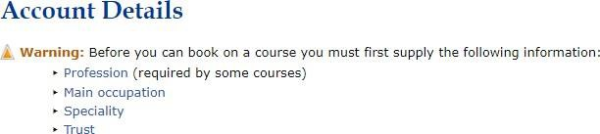
- You can use the Course List or Course Calendar to browse courses in Maxcourse
- To view the Future Leaders courses, change the subject filter to ‘Future Leaders Programme’, you may also need to change the period filter.
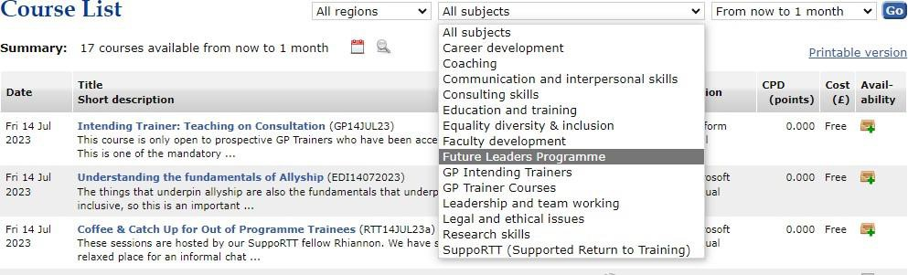

Information about Future Leaders courses is also available on our website: Future Leaders Courses

FLP Bimonthly Meetings
These meetings aim to promote networking with colleagues, encourage collaborative working, contain educational content relevant to leadership and encourage group cohesion amongst fellows of the Future Leaders Programme.
Meetings are held every other month with the dates for the year agreed at the beginning of each cohort. Meetings should be in person and rotate around the three main localities (South, West and East Yorkshire).
Meetings are a great opportunity to meet other Fellows, discuss your experiences, and support one another. Components of the meeting which fellows may contribute to include:
- Area of experience
- My journey
- My project
External speakers may also be invited to offer specific expertise on relevant leadership topics.

FLP Annual Conference
The Annual Future Leaders’ Conference takes place in Spring each year. In 2021 and 2022 the conference was held as a virtual event and as an in-person event in subsequent years. The entire conference is organised and delivered by Future Leaders Fellows, chaired by the Fellows to the FLP. The budget for the conference is provided by NHSE but is managed by fellows.
Expressions of interest to join the conference committee are sought in August each year. The theme of the conference is determined by fellows, typically based upon topical leadership issues. The conference also provides opportunity to present work on quality improvement and leadership related topics for healthcare professionals across the region.
- FLP Annual Conference is usually held towards the end of each financial year, specific timing decided by the conference committee.
- Target audience: Current, past, and potential leadership Fellows, supervisors, NHSE executives, potential bidders etc, healthcare professionals at all levels with an interest in leadership
- Previous conferences attendances between 170 (in-person) and 275 (virtual) places
All fellows are expected to submit a poster on some aspect of leadership to the conference whilst in post. This provides an excellent opportunity to get a poster publication on your CV.

Supervision
Fellows are encouraged to reach out to their Educational Supervisor before commencing in post to arrange a pre-meet; this can be helpful in forming connections and establishing expectations.
Within the first few weeks you should organise a project-specific induction. Fellows and supervisors should meet to establish:
- the remit and purpose of the project,
- consider what the measures of success will be
- how the fellow’s week may be spent
This induction should also be used to discuss the fellow’s personal development needs and to identify strategies to achieve these. You should also reflect on your learning needs relating to EDI in leadership – some prompt questions are provided within the personal development plan (PDP) to help facilitate this.
Ensure you have regular supervision meetings: fellows who meet regularly with their supervisors have recorded better satisfaction and productivity during the year. Learning outcomes should be reviewed periodically during and at the end of the fellowship year. Ensure that supervision focuses not only on the project, but also on the personal development.
You may also wish to seek out other mentors or sources of supervision. It is important for project momentum to meet with other leads within the host organisation (directors, chief executive) at an early stage. Your supervisor should be able to help facilitate this, along with other senior executive introductions.

Reflection
There are many ways of recording your activities over the course of your fellowship year. It is a good idea to get into a routine of regularly reflecting on learning events as they take place. The following are suggestions which previous fellows have found helpful; you may try several methods before finding one which fits you.
- Record progress through an adapted version of the PDP, keeping notes on 1:2:1 conversations with supervisors and mentors and documenting steps taken to achieve objectives (see example below).
May 6, 2022 | Example: Wellbeing / Work objectives | Example: Agreed to book in annual leave through to September to maintain wellbeing. We reviewed work objectives set and progress towards these.
Click or tap to enter a date.

- Keeping a weekly or monthly log or review may be helpful in terms of tracking your progress. These can be linked to the main objectives which you are prioritising at any given point. One method that some fellows have used is a ‘Friday Reflection’ which helps you to identify the small victories each week and prepares you for starting the following week off on the right foot. Another method is to record your progress in a more visual timeline of your learning journey:

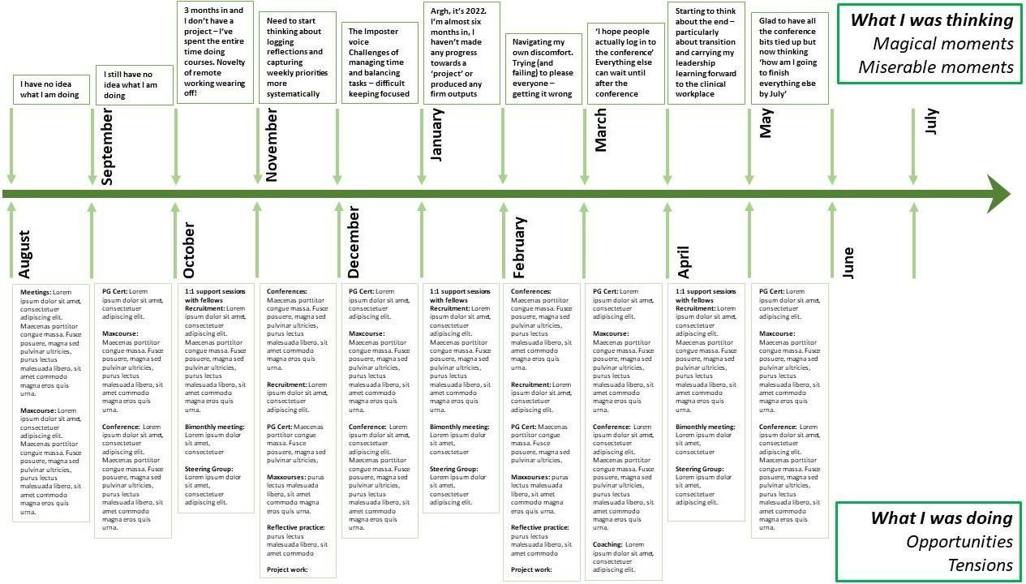
- You may also wish to keep notes on your progress on a regular (e.g., monthly) basis using the following prompt questions:
  - What have you delivered?
  - How did you do that?
  - What has gone well?
  - What did you find most challenging and why?
  - What learning will you take from this into future objectives or projects?
  - Do you have any development needs?

Reflective Writing
As you embark on your PG Certificates or equivalent academic learning on leadership you will be asked to reflect on the activities that you have been undertaking which are shaping our leadership (be that courses, meetings, or podcasts). Here are two simple guides to getting started with reflective writing:
Reflective Writing - YouTube
Introduction - Reflective Practice Toolkit - LibGuides at University of Cambridge Subject Libraries
Another part of reflective practice is to engage in critical thinking. You may find the following resources a useful starting point in developing your own critical thinking:
Samantha Agoos: 5 tips to improve your critical thinking
3 Simple Habits to Improve Your Critical Thinking (hbr.org)

Coaching
Fellows are encouraged to engage with the programme offered by NHSE. This is open to all fellows, regardless of professional background.
Coaching is time for you to think. Your coach won’t judge you or give you advice. This means it is ok to talk about anything that you feel gets in the way of you doing your best at work. You can really think things through in a way that is different to talking things over with a friend, partner, TPD or Educational Supervisor - all people who tend to have another agenda for you. Your coach will support you, and challenge you if necessary, to help you reach a conclusion that is helpful and meaningful to you. Coaching is a normal professional activity in other high responsibility jobs.
You can have up to six sessions of free coaching with a coach. It is up to you when you start coaching, individuals will derive benefit from coaching at differing times during their FLP year.
Please see the Coaching section of the website (under Learner Support)

360 Feedback
There is funding available for all fellows to complete a 360º feedback process using the NHS Healthcare Leadership Model 360° Feedback Tool. This is an online tool, which gathers information from raters via an anonymized online form, and then comprises a 2-hour facilitated feedback session. A 360º appraisal can be undertaken at any point of the Fellows choosing during the year, but it is probably most useful if undertaken in the latter half of their year. This leaves time to identify development areas and an action plan to address these, leaving enough time to work on any development points.
Further information can be found under Information for Fellows.

Fellows’ Networks
There are some trusts that offer a local Fellows’ network, which you may wish to consider in your trust. Here are some examples below.
At Leeds Teaching Hospitals NHS Trust, Mr Patrick Coughlin, Consultant Vascular Surgeon and Director of Medical Education at LTHT oversees and supports the ‘corporate-funded’ leadership posts. As a group of CLFs from different professional backgrounds, they work together as a group at LTHT, whilst each has their own project area of work. Together they are given leadership opportunities and responsibilities at Trust level too.
Examples of the opportunities for the fellows include:
- Meeting each Executive Director and senior leader; this includes Chief Executive Officer, Chief Nurse, Chief Medical Officer, HR Director, Chair of the Trust, Director of Risk, and Chief Operating Officer. These meetings often offer an opportunity to discuss the leaders’ journey and how they have developed their leadership skills, alongside increasing an understanding and awareness of their role within the wider operation of the trust.
- Shadowing Executive Directors and senior leaders on executive ward rounds and virtual or face to face meetings, including participating in the “Walk in my Shoes” programme, tactical and command meetings, medical directorate meeting, workforce planning, finance, quality, and risk meetings.
- Supporting the Trainee Doctors’ Body, by running the trainee doctors’ awards and tackling trainee doctors’ morale. Working alongside the Chief registrar to host the Junior doctors' awards and be involved with the shortlisting of the nominations.
- Involvement in quality improvement (QI) projects, and being involved in QI collaboratives within the trust, this includes opportunities to lead on improvement
- projects and interventions, and see how small-scale changes can be spread across a large organisation, alongside working with patient quality partners
- Developing the leadership programme for the future, shaping and
- developing future innovative posts, being involved in recruitment and interviewing.

Equality, Diversity, and Inclusion (EDI)
The Future Leaders Programme (FLP) is committed to promoting equity, diversity and inclusion and fostering a culture where everyone feels a sense of belonging and can be their authentic self. We recognise that healthcare professionals from protected characteristic groups continue to experience discrimination, exclusion and systemic barriers, and that people's experiences are shaped by multiple, intersecting aspects of their identity.
The FLP supports NHS England's commitment to becoming an anti-racist organisation and advancing equality, diversity and inclusion through initiatives such as the Distributed Leadership for Inclusion Framework, while recognising that equity extends beyond race to encompass all protected characteristics and intersecting identities.
The programme aims to develop compassionate leaders who value and champion equity, diversity and inclusion in healthcare. A diverse workforce and inclusive culture, where everyone's contributions are respected, contribute to improved staff experience, stronger organisational performance and better outcomes for patients.
Our commitment to EDI is reflected throughout the programme. This includes:
- embedding EDI principles within the recruitment process and programme design,
- providing reasonable adjustments and accessibility support where required,
- encouraging fellows to reflect on their own leadership, biases and inclusive practice through their Personal Development Plan (PDP),
- creating opportunities for open discussion, learning and reflection on inclusion throughout the fellowship,
- expecting all fellows, supervisors and faculty to uphold the standards of respectful, inclusive behaviour set out in the programme values,
- recognising that achieving equity is an ongoing process, and continuing to review and improve the programme in response to feedback
If you experience or witness behaviour that does not reflect the programme's commitment to equity, diversity and inclusion, we encourage you to speak up as early as possible. You can discuss your concerns with your Educational Supervisor, the FLP Support Team or your employing organisation, who will support you and work with you to address any issues raised.
Through your PDP, you will be encouraged to reflect on your own inclusion journey, identify areas for growth, and consider how you can contribute to creating more equitable and inclusive workplaces. We hope the FLP will equip you with the confidence, knowledge and skills to lead inclusively and champion equity throughout your career.

Support for Fellows
The transition from a clinical environment to a leadership role, where you are expected to undertake a much more self-directed workload, can be challenging. Exploring leadership topics can also be uncomfortable, particularly those which explore polarisation and opposing opinions. You should seek support from your educational supervisor if you are having difficulties adjusting to the new ways of working.

Remote Working
For some people, remote working can lead to feelings of loneliness or social isolation. Consider scheduling regular opportunities to connect with colleagues. Ideas from previous cohorts include:
- Virtual catch-ups with other fellows
- In-person: coordinating office-based days, meeting up with other fellows informally
- Other activities: book clubs and parkrun groups
We recognise that supporting health and wellbeing is vital to productivity and learning. The following tips may assist you with looking after your physical and mental wellbeing at home (from NHSE guidance):
- Take a break: Ensure you have regular breaks and get some fresh air whilst working from home
- Exercise: Build physical activity into your daily routine, either by using equipment or other options (cleaning your home, dancing to music, going up and down stairs, online exercise workouts, taking a lunchtime walk)
- Connect: Keep in touch digitally with people who you care about. Make plans to video chat
- Rest: Ensure you get enough rest, sleep, and eat well. Take care of your nutrition and hydration. Try to eat health, well balanced meals and drink enough water throughout your working day
- Minimise: Look after your mental wellbeing and if needed minimise your exposure to the news and have breaks from social media. Do something you enjoy which has a positive impact on your wellbeing.

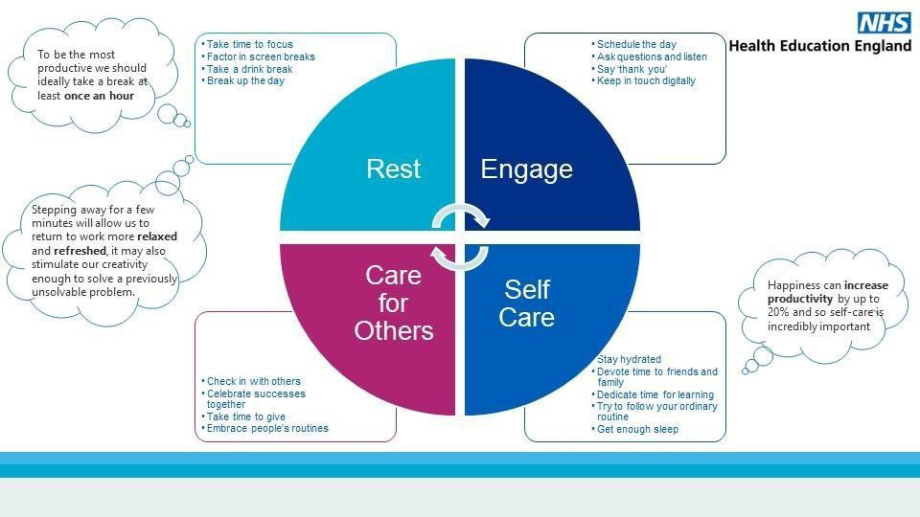

Support for fellows with disabilities, neurodivergence, or long-term health conditions and accessing additional support
Fellows requiring additional support should .approach their Educational Supervisor. Guidance is also available on the Yorkshire & Humber website: Training with a Disability or Long-term Condition | Health Education Yorkshire and Humber and Neurodiversity Support | Health Education Yorkshire and Humber.
Where concerns relate to employment matters, or where support from Occupational Health or Human Resources is required, this should be accessed via the lead employer.
Counselling is accessible on a confidential, self-referral basis from NHSE. Counselling and psychological support | Health Education Yorkshire and Humber (yorksandhumberdeanery.nhs.uk)

Administration

Terms of Employment
Through an agreement between NHSE, you may be paid by a different organisation to the one you are working in. For medical and dental trainees this is typically Hull University Hospitals Trust. For public health trainees this will be Leeds Teaching Hospitals.
For other pharmacy professionals it will be their substantive employer.
Whoever pays you is your employer, and you are bound by their terms and conditions.
You are not expected to work clinically during the fellowship. In exceptional circumstances you may be asked to redeploy (such as COVID-related pressures in previous years but not standard winter pressures). It is not permissible for the fellow to undertake any other form of employment during normal hours of work. Undertaking additional/alternative employment during normal work hours of a fellowship is fraudulent behaviour and fellows doing so may be subject to disciplinary procedures by their employer, NHSE and their professional regulator. This includes fellowships that are part-funded by the fellow’s substantive post or organisation.
If you are asked to work clinically, please contact the Future Leaders Team who will support you with negotiating additional clinical commitments with your FLP responsibilities.

Study Leave & Expenses
Fellows are responsible for identifying their learning needs and appropriate development opportunities in discussion with their Educational Supervisor. Fellows are provided with a study budget of £3700 which includes the cost of the PG Cert/equivalent academic qualification and other professional development opportunities over the 12-month period.
All study budget requests, outside of contact sessions for PG Certificate/Academic qualification and FLP run courses, need to be completed on the study budget form. Requests for time only should be agreed with your Educational Supervisor and do not require a study budget form.
When approving study leave the general principles in the NHS England (NHSE) Study Leave guidance should be followed. This includes that approver(s) must assess the educational benefit and value for money of the course. This requires consideration of the relative cost in comparison to other activities and the perceived benefit to the future NHS. The approver(s) must be assured that regional or more cost-effective alternatives have been explored.
Before requesting study budget funding, discuss the activity with your Educational Supervisor to secure their agreement for the educational appropriateness for the activity and agreement that you can be released for the duration of the course/conference.
Once you have secured Educational Supervisor support, please complete and submit the Study Budget Form to the FLP admin team who will forward it to the Associate Dean for consideration. If approved, the admin team will send you formal confirmation and reimbursement instructions.
Please send requests at least 4 weeks in advance, otherwise we may be unable to process requests at short notice. Please complete all fields to avoid delay. Your request will be considered taking the following factors into account:
- Please bear in mind that most fellows choose online learning or occasional single-day face-to-face events. Residential courses and overnight accommodation are not usually supported through the FLP budget. Any claims for overnight accommodation or travel outside the Yorkshire and Humber region require prior approval from Susy Stirling and the FLP Team.
- Any costs associated with your project, including travel, should be funded by your School (where funded 100% by NHSE) or your employer (in cases of 50/50 funded posts).
- Requests exceeding the overall study budget will not be considered, if you choose a PGCert or equivalent exceeding the allocated budget you will be required to self-fund the remaining cost
Expenses related to your fellowship (including travel to FLP meetings and other fellowship activities) can be claimed through your employer. For information about how to set up your account, contact your employing trust (see key contacts).
Training activities completed during the FLP year which are related to your specialty will be at the discretion of your FLP supervisor. You should also seek agreement from your parent school, TPD or substantive team. This will not be covered by the FLP study budget.

Less Than Full Time (LTFT) Working
The Future Leaders Programme is keen that working Less Than Full Time (LTFT) should not be a barrier to anyone wishing to undertake a Fellowship. When considering LTFT working, it is important to note that:
- The Fellowship year is a full and challenging year, with many additional opportunities, plus the commitment to undertake a PG Cert. It is worth discussing your work pattern and commitments with your supervisor before taking up the post.
- Funding is time-limited to one year so Fellows working LTFT should complete their Fellowship alongside their full-time peers. Funding does not carry-over to enable an extension. The Educational Supervisor must be supportive of the Fellow undertaking their project on a part-time basis and it must be recognised that CPD will form 50% of their time at work.
- The individual study leave allocation of £3,700 should be accessed only during the Fellowship and cannot be utilised once the Fellowship has ended. A Fellow working LTFT may be granted an extension to their PGCert, but this agreement would be between the fellow and course provider, and is outside the scope of the FLP.

Sickness and Extensions
Extensions are no longer available. Should extenuating circumstances result in a prolonged absence causing a significant delay in your learning and development due to circumstances outside your control please contact the Deputy Postgraduate Dean via the FLP Team to discuss your situation. Any episodes of sickness should be managed in accordance with your host organisation’s sickness policy.

Parental Leave
The Future Leaders Programme is intended to improve the leadership skills of professionals with as wide a range of backgrounds as possible. Becoming a parent is not therefore a barrier to undertaking a Fellowship. Please refer to our parental leave guidance for the options available.

Research Approval for your Leadership Project

Do I need research approval for my project?
During your FLP year you will carry out a quality improvement or service evaluation project. These projects should NOT be ones that are classed as research, or which require NHS Research Ethics approval. This is because the research approval process takes several months to obtain, and you are unlikely to be able to complete a research project within the remaining time available. During the bid process, bidders are asked to confirm that proposed projects do not require NHS research ethics approval to be eligible for the programme.
You can check and see if your project is classed as research using this ‘Decision Tool’ from the HRA http://www.hra-decisiontools.org.uk/research/
This tool also has a useful table with explanations about the difference between research and service evaluation.

Can I publish my project?
If you intend to publish your work in a traditional academic journal then it is important to identify a journal that can publish this, e.g. one that publishes service evaluation work with a new methodology. A good example is BMJ Quality and Safety.
If you wanted to publish work that was specific to a specialty (e.g. Psychiatry, Paediatrics or Public Health) it is worth contacting the journal to see if they would publish these sorts of initiatives under the service evaluation umbrella.

What if my project changes and it is now classed as research?
Things can change throughout a fellowship, and your project may evolve into something that is research. In this situation, you need to have a discussion as soon as possible with your supervisor about whether the project is suitable for completion within the FLP year. Your supervisor is responsible for ensuring that you have access to the necessary support, whether academic or service evaluation.

Indemnity
In terms of indemnification of work undertaken by Future Leaders, cover is provided under the NHS Resolution scheme for Fellows undertaking service evaluations. This would normally be through the Fellow’s employer. Where however the project primarily benefits NHSE rather than the employing NHS trust, it has been agreed that NHSE indemnifies the employer, and that NHSE will take the lead in the unlikely event of any litigation arising from the Future Leader’s work.
However, where the project primarily benefits NHSE rather than the employing NHS Trust, it has been agreed that NHSE indemnifies the employer. Therefore, NHSE will take the lead in the unlikely event of any litigation arising from the Fellow’s work.
Doctors and dentists in training should contact their medical indemnity provider to advise them of their change in role, you should also consider whether you wish to undertake locum work within a trust as this may alter the premium paid.

NHSE Organisational Structure

NHSE Offices
Postgraduate Medical and Dental Education (PGMDE) occupies three offices in Hull, Leeds, and Rotherham. Currently NHSE staff are working hybrid and you should discuss the expectations of home or office working with your Educational Supervisor. All fellows who are undertaking a School based post (100% FLP funded) have the option to work out of any of the three offices listed. All offices operate hot-desking system meaning staff must book a desk for any days they plan to work from the office and bring their equipment (dual monitors and laptop charges are available at every desk).
As fellows won’t be provided with an NHSE e-mail address this year you will need to ask your ES or an NHSE colleague to make a desk booking on your behalf. For the Leeds ad Rotherham office a visitor pass will need to be arranged by the person(s) responsible for you during your office working days. You may of course wish to work from a flexible location, including your home, and we would encourage you to discuss this with your ES.
Be mindful that working from home for long stretches can be isolating and plan around this. You may want to meet up with other fellows working in your locality, or who are working on similar project themes. Fellows bi-monthly meetings as well as other sessions such as journal club or book clubs are a really good way of ensuring that you stay connected with colleagues and to the programme.
Hull: Willerby Hill
Health House, Grange Park Lane, Willerby, Hull, HU10 6DT Reception: 01482 421180
Leeds: Wellington Place
7 Wellington Place, Whitehall Road, Leeds, LS1 4AP
Rotherham: Riverside House
Floors 1 & 4, Rotherham Borough Council, Main Street, Rotherham, S60 1QY

NHS.net Account
Due to the ongoing organisational restructure, NHSE will not be able to adopt your existing NHS.net e-mail address however your employer will. Your nhs.net account will give you access to Office 365 online apps necessary for your role. Your ES will be able to provide you with SharePoint access using your pre-existing NHS email account although this may need to be renewed as necessary by them.
Fellows will need to use their personal laptop / device, unless they have contacted the FLP admin team and separate arrangements have been agreed.

NHSE Branding
NHSE has branding guidance and templates available via NHS England templates and logos.
These can be used for letterheads, PowerPoints, posters etc. Support with branding and publicity documents may also be available at Meet the Team | Content & Publishing.
Please speak to your ES if you would like access to the content on either of the intranet webpages.
NHSE Yorkshire & Humber Postgraduate School structure
Postgraduate Dean
Jon Cooper

Deputy Deans

Willy Pillay

Umakanth Kempanna

Jon Hossain

Fiona Bishop

Caroline Mills

Key Contacts & Web Links
Name | Role | Email
NHSE
Fiona Bishop | Deputy Postgraduate Dean | fiona.bishop7@nhs.net
Kelly Rothery | PA to Fiona Bishop | kelly.rothery@nhs.net
Susy Stirling | Associate Dean | susy.stirling1@nhs.net
Katie Cobb | Business Manager | katie.cobb2@nhs.net
Kate Howard  Kezia Kuek | Fellows to the FLP (2025-2026) | kate.howard9@nhs.net  kezia.kuek@nhs.net
Penelope Sellers  Lewis Roberts | Fellows to the FLP (2026-2027) | penelope.sellers@nhs.net  lewis.roberts5@nhs.net
NHSE Learner Support and Faculty Development Team
Chloe Anderson  Jenny Owen | Programme Support Coordinator  Programme Support Administrator | england.futureleaders.yh@nhs.net
Hull Hospital Admin Support/Expenses
Charlotte Precious | Medical Education  Manager | charlotte.precious@nhs.net
Dawn Askwith | Hull Payroll Officer | dawn.askwith@nhs.net  Tel: 01482 624184
Joey Robson | Hull HR Officer and Team Leader, Medical Staffing | joseph.robson@nhs.net  Tel: 01482 674067
Andrew Baker | Deals with Hull expenses approval via sel expenses | andrew.baker13@nhs.net
Catherine Denton | Hull Payroll Officer – In charge of creating NHS ESR accounts for remote payslips | hyp-tr.systemadmin.esr@nhs.net  catherine.denton1@nhs.net  Tel: 03033306607 and choose option 4
You can find information regarding the Future Leaders Programme via:
http://www.yorksandhumberdeanery.nhs.uk/future_leaders_programme/
You can book onto courses via Maxcourse: https://www.maxcourse.co.uk/yhlsfd/

FLP Steering Group
The Future Leaders Programme (FLP) Steering Group provides strategic oversight and governance for the programme, ensuring it continues to deliver a high-quality experience for fellows and meets the needs of the wider NHS. The Steering Group meets quarterly to oversee the smooth running of the programme, review programme documentation and policies, monitor quality and governance, oversee recruitment and bid selection, and guide the ongoing development and continuous improvement of the programme.
The Steering Group also provides a forum for reviewing feedback from fellows and other stakeholders, considering any concerns raised about the programme, and identifying opportunities to improve the fellowship experience. Where appropriate, the group will oversee actions to address concerns and ensure these are managed in line with relevant policies and governance processes.
The Steering Group consists of:
- Dr Fiona Bishop – Deputy Postgraduate Dean
- Dr Susy Stirling – Associate Dean
- Chloe Anderson – Programme Support Coordinator
- Jenny Owen – Programme Support Administrator
- Current Fellows to the FLP

Resources

Organisations & Events

NHS Leadership Academy
The NHS Leadership Academy aims to help everyone in the NHS discover their full leadership potential and achieve the highest standards in health and care. All their leadership programmes, lifelong learning and talent scheme are designed to deliver the NHS People Plan and our People Promise. Host leadership development programmes, bitesize learning (through their learning hub), coaching, organisational tools and regular events.
Leadership Academy – Better Leaders, Better Care, Brighter Future

Faculty of Medical Leadership & Management (FMLM)
The Faculty of Medical Leadership and Management was established by all the UK medical royal colleges and endorsed by the Academy of Medical Royal Colleges in 2011, in recognition of the importance of effective medical and dental leadership and the impact this has on patient care. The aim was to create a body promoting the recruitment and development of doctors and dentists wishing to be actively involved in healthcare leadership, with FMLM becoming the professional home for medical leadership within the UK. The strategy of FMLM has therefore built on this fundamental aim.
Regular events and conference (Autumn); Education and CPD | Faculty of Medical Leadership and Management (fmlm.ac.uk)

King’s Fund
The King’s Fund is an independent charitable organisation working to improve health and care in England. Our vision is that the best possible health and care is available to all
We were founded in 1897 by the Prince of Wales, later King Edward VII, to raise money for London’s voluntary hospitals. The work of the Fund has evolved over time in response to the changing needs of the population, but our mission – to improve health and care for all – has endured. They are not aligned with any political, professional or any other interests.
Regular events and conference (Autumn); Events | The King's Fund (kingsfund.org.uk)

Medical Education Leaders UK
Medical Education Leaders UK was originally founded in 1969 to further the interests of what were then called District Clinical Tutors nationally and to help and support them in their work. Our membership has grown since then to encompass the variety of leading educators involved at the local level in the management and delivery of postgraduate medical education across the UK. Through our courses, workshops and conferences, we provide opportunities for our members and others to improve their skills and knowledge in the field of PGME. Alternating ‘Winter Meeting’ and ‘DEMEC: Developing Excellence in Medical Education Conference’
Events; Medical Education Leaders UK

Healthcare Leadership Academy
The Healthcare Leadership Academy formed in response to demand from young clinicians and medical students to learn about leadership. The HLA houses an exciting faculty from across the health sector and beyond. our shared aim is to inspire and nurture the next generation of healthcare leaders. Too often in healthcare, leadership is confused with management. Through a combination of mentoring, Socratic discussion, and philosophical exploration, the HLA aims to inspire our scholars to change the world of healthcare, one small step at a time. At a time when the world seems an ever more worrying place, it is important that the next generation of healthcare professionals truly understand how to motivate the people they work with in order to best look after the populations they serve.
Courses; HLA Programme (medics.academy)
Events and Essay prize; Home | Healthcare Leadership Academy

Podcasts (External & Alumni)
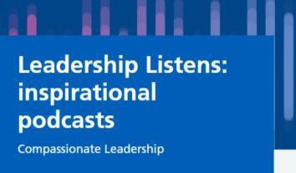
NHS Leadership Academy: Leadership Listens
Leadership Academy

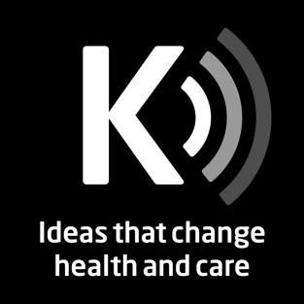
King’s Fund
The King's Fund podcast | The King's Fund (kingsfund.org.uk)


TED Talks
TED Talks Daily | TED Talks | Programs & Initiatives | About | TED
Also;
WorkLife with Adam Grant; WorkLife with Adam Grant: A TED original podcast | Podcasts | TED
How To Be A Better Human; How To Be A Better Human | Podcasts| TED


You are not a frog
Podcasts - You are not a frog

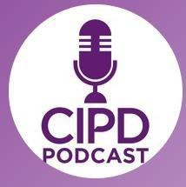
CIPD – Chartered Institute for Personal Development
Podcasts | CIPD


Harvard Business Review – HBR IdeaCast
Podcasts (hbr.org)
Also:
Women at Work; Women at Work (hbr.org)
Race at Work; Race at Work (hbr.org)


High Performance Podcast
Podcast — High Performance Podcast (thehighperformancepodcast.com)


This Working Life
Episodes - This Working Life - ABC Radio National


Squiggly Careers
Podcasts Archive | Amazing If

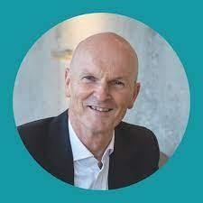
Compassionate Leadership Podcast – Chris Whitehead
The Compassionate Leadership Interview | Podcast | Sheffield (compassionate-leadership.co.uk)


How To Fail: Elizabeth Day
Podcast — Elizabeth Day

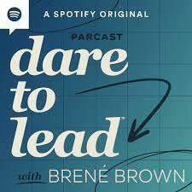
Dare to Lead – Brene Brown
Podcast Episodes Archive - Brené Brown (brenebrown.com)
Also
Unlocking Us


Defining Your Success - Waqas Din https://open.spotify.com/show/7oNoNTXtQR6pwbVbAXo7AU?si=50 808838ed084fba
Fellow to the FLP alumni and ENT registrar


Fairhealth Health Inequalities Podcast – Harvir Braich FLP alumni and GP Registrar
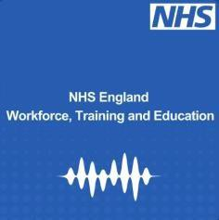
Supported Return to Training Yorkshire and Humber International Medical Graduate Podcast Series- Raykal Sim. https://open.spotify.com/episode/5ZB88fc9X1tKftnYLhRytb?si=5- 2Lm0cHQoeIKqchtg4UcQ
FLP alumni and IMG GP Registrar


Hidden Healthcare Leaders Podcast Series by Alexander Booth
Hidden Healthcare Leaders Podcast • A podcast on Spotify for Podcasters FLP Alumni and physiotherapist

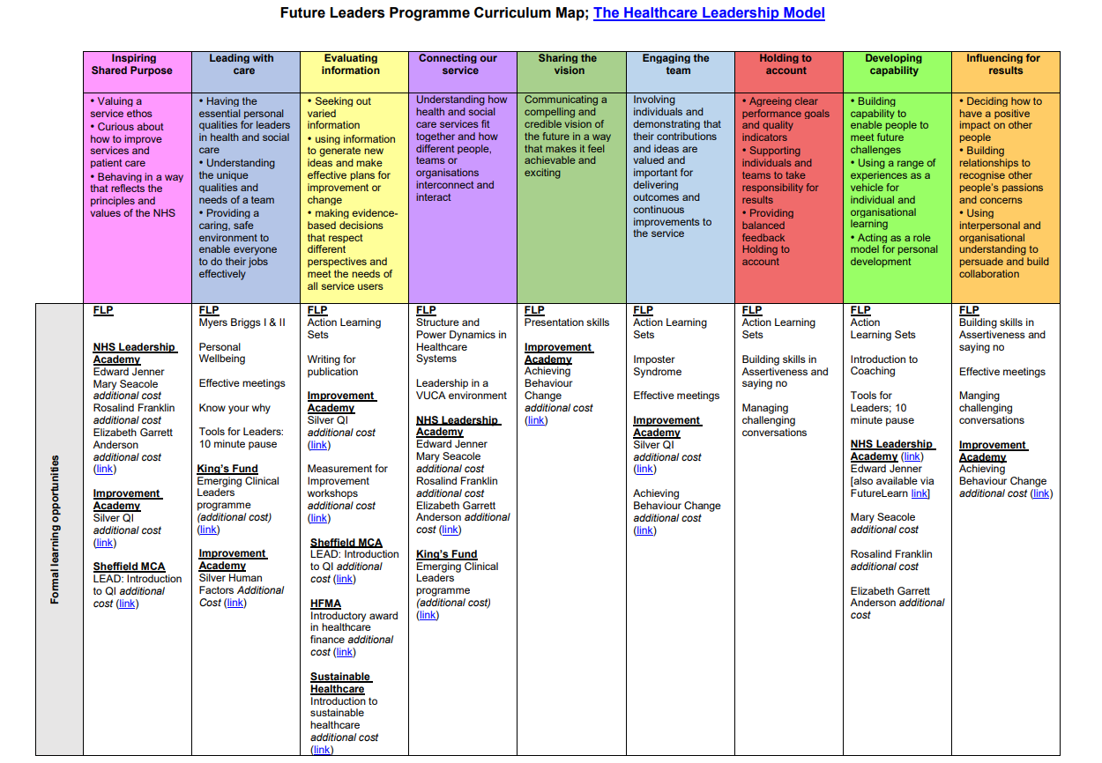
Appendix 1: FLP Curriculum Map
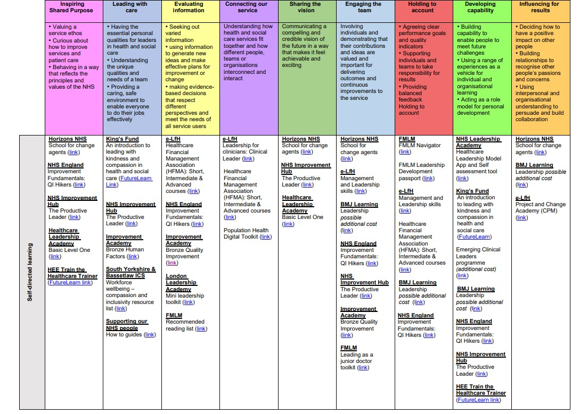
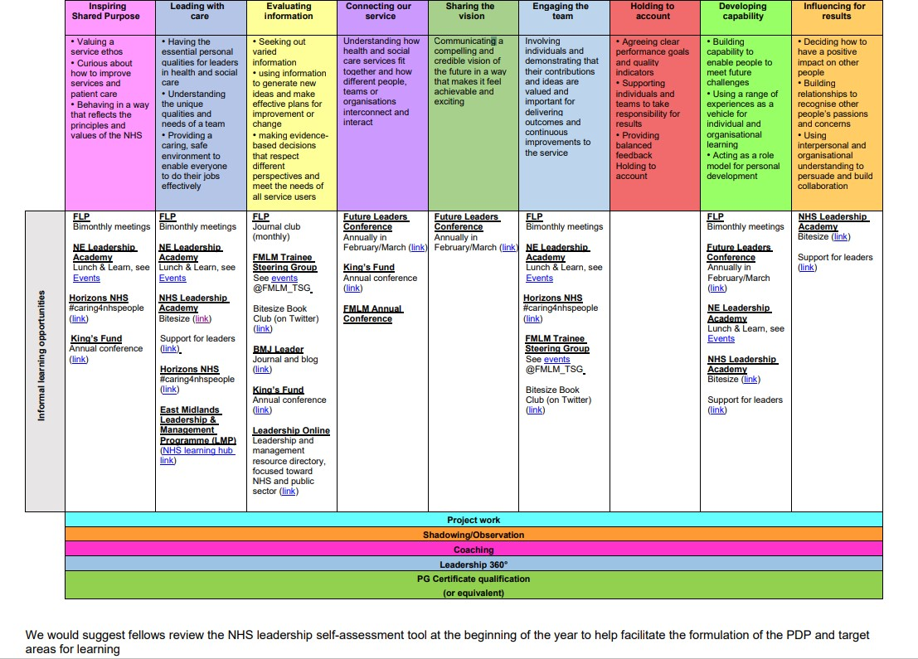

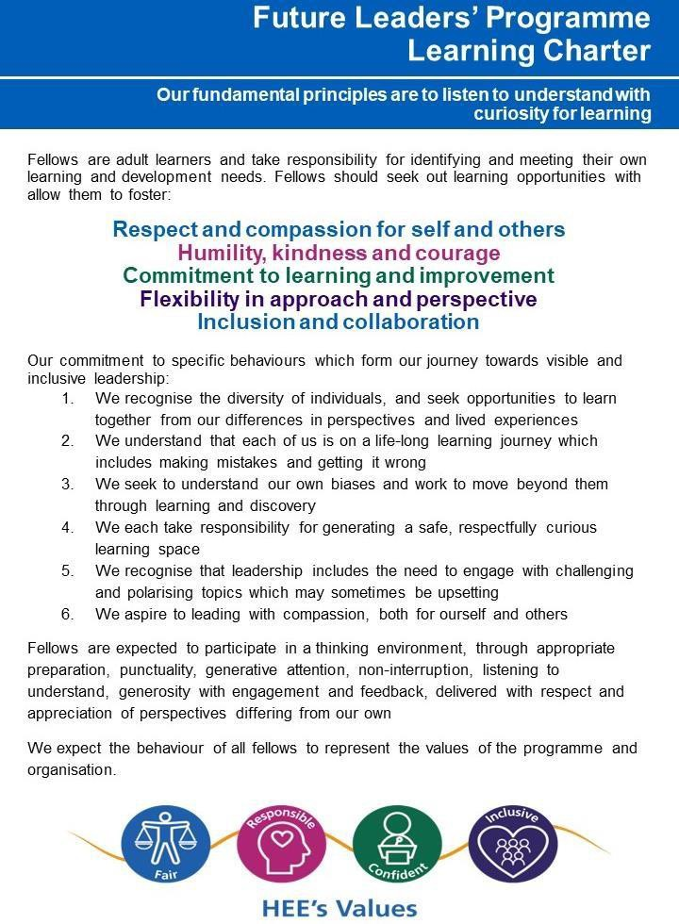
Appendix 2: FLP Learning Charter

Appendix 3. EDI Summary for Fellows

