Guidelines on Temporary Registration with the GDC (V1.4)

**Overview:**

The GDC is the regulatory body which regulates dentists in the UK. To practice in the UK, one requires registration with the GDC. There are two types of registration:

1. Full registration which you can gain on graduating from a UK dental school, or in most cases a European dental school, or by passing the Overseas Registration Examination. More guidelines can be found on the [GDC website](https://www.gdc-uk.org/registration/join-the-register/how-to-join-the-register), including some alternative paths to full registration.
2. Temporary registration which is given by the GDC for a limited period of time, typically to work in secondary and tertiary care NHS hospitals. Please note, [temporary registration](https://www.gdc-uk.org/registration/join-the-register/temporary-registration) does not lead to full GDC registration and can only be given for a maximum of 5 years.

**Dental Core Training and Temporary Registration:**

Getting a DCT post which is “suitable for temporary registration’’ makes you eligible for temporary registration with the GDC. It is important to note that not all DCT posts allow people to work on temporary registration, hence it is important to only choose those posts in the preference list on Oriel which are suitable for temporary registration. DCTNRO publishes an Excel sheet every year on the posts across the UK along with which posts are eligible for temporary registration. A copy of the Excel sheet can be downloaded from the following link:

[Dental Core Training (DCT) | Dental Hub (hee.nhs.uk)](https://dental.hee.nhs.uk/dental-trainee-recruitment/dental-core-training-dct/dental-core-training-recruitment/dental-core-training-overview)

If a DCT post remains vacant after National Recruitment, it is sometimes recruited to locally. When that happens, the post will typically still be eligible for temporary registration, and the guidance in this document remains valid. However, in those cases, the employing Trust handles any visa requirements in place of NHS England’s national team. Locally recruited posts are advertised on local Trusts' websites and on websites like [www.jobs.nhs.uk](http://www.jobs.nhs.uk) or [www.trac.jobs](http://www.trac.jobs).

**Getting A DCT Post:**

Dental Core Training is a program which allows dental graduates who have worked clinically as a dentist for at least 1 year after graduation to work in dental specialties and OMFS. DCT recruitment has two components, a situational judgement test (SJT) and an Interview. More information on acquiring a DCT post can be found on the DCTNRO Website below:

[Dental Core Training (DCT) | Dental Hub (hee.nhs.uk)](https://dental.hee.nhs.uk/dental-trainee-recruitment/dental-core-training-dct/dental-core-training-recruitment/dental-core-training-overview)

**Steps involved for applying for GDC registration:**

After you have successfully managed to secure a DCT post suitable for temporary registration, it is important to start your registration process with the GDC as soon as you receive your offer on Oriel as it can take some time. The following steps should be followed to apply for temporary registration:

1. Using the following website, fill the route to registration questionnaire [Route to Registration (egdc-uk.org)](https://www.egdc-uk.org/Application/RouteToRegistration)
2. The answers to the questionnaire will look like this for someone who is applying for temporary registration. Click on the “Temporary Registration Application” at the end of the questionnaire and fill in your personal details.

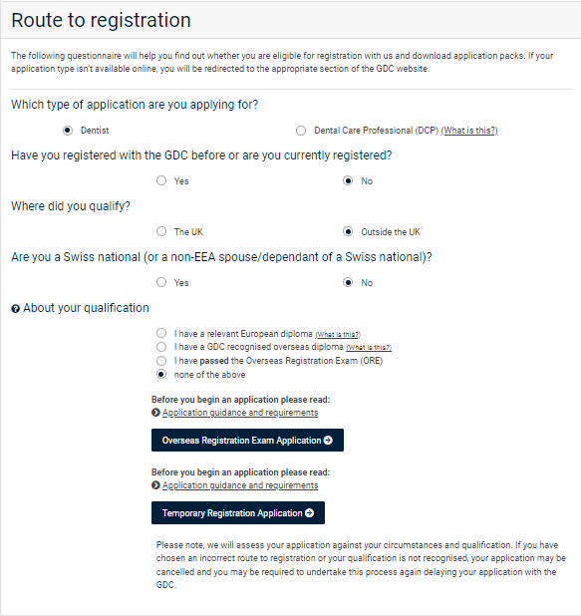

1. After filling the personal details, a form will be generated in the PDF format. This is the Temporary Registration Form which is unique to you and will have your name. This form cannot be used by another individual.
2. The PDF form needs to be emailed to the relevant HR department or Lead Employer Trust, which will have been in touch with you to discuss your contract and to carry out relevant employment checks. Section 2 of the form needs to be filled out by the relevant HR officer. **It is important to let HR know that they will need to print out Section 2 of the form, hand fill it and hand sign it (also known as wet signature), and send it by post back to you i.e sending the signed hard copy back to your address or any address in the UK if you have family/friends and it is difficult for HR to send it internationally. They should also scan it and send an electronic copy as well for record purposes.**
3. A screenshot of a computer

   Description automatically generatedSection 3 of the form needs to be emailed to your relevant supervising consultant or Training Program Director. To find out the email address of the relevant consultant, please check on the Excel sheet provided by DCTNRO. Scroll towards the right of the excel sheet to find the relevant details under the heading “Contact Email Address”. This will either be the relevant consultant, or someone who can put you in touch with them. **Again, it is important to mention that the form needs to be printed, hand filled and hand signed by your supervising consultant (also known as wet signature) and then posted back to your address or any address in the UK if you have family/friends and it is difficult for the department to send it internationally. They should also scan it and send an electronic copy as well for record purposes.**

Consultants’ email addresses

1. Please request the HR officer dealing with your case to get in touch with the Deanery’s office to send you a “letter from the Deanery” which is an appointment letter that is generated from the Dental Dean’s office, confirming that you have been appointed to the relevant DCT post. That letter can be sent directly to the GDC on their email address and can also be emailed to you. Please print a copy of the letter and attach it to your application.
2. Section 4 (Character Reference) and Section 6 (Clinical Reference) of the form can be filled by the relevant authorities in the country you are practicing in currently. If you are not actively practicing, then the Dean of the dental university you graduated from can fill and sign the form on your behalf. Please read instructions provided at the end of the temporary registration form for further detail.
3. It is important to note that you need to have taken the IELTS examination and to have at least a 6.5 band in Reading, Writing, Listening and Speaking and a 7.0 band overall. Alternate paths of proving English language skills can be found here [gdc-guidance-on-english-language-controls.pdf (gdc-uk.org)](https://www.gdc-uk.org/docs/default-source/english-language-controls/gdc-guidance-on-english-language-controls.pdf?sfvrsn=88adf167_2)
4. A degree certificate and a passport copy along with proof of identity needs to be attached to the form, details of which are provided at the end of the temporary registration form.
5. After all the relevant documents are attached to the form, this application bundle needs to be [sent to the GDC by post](https://www.egdc-uk.org/Help/ContactUsPublic) for example Royal Mail, DHL, Fedex etc.

**Visa Requirements:**

If you are not a UK citizen and require visa sponsorship for a DCT post in England, then NHS England Overseas Sponsorship team will get in touch with you to issue you a “Certificate of Sponsorship” (also known as CoS). Their email address is [england.sponsorship@nhs.net](mailto:england.sponsorship@nhs.net). If your DCT post is located in another part of the UK, then there will be separate arrangements regarding visa sponsorship for you to follow.

A CoS is needed to apply for a Health and Care Visa. NHS England will require you to create an online account on the website mentioned in their email where you will be required to fill your personal information and additional details needed for them to generate a CoS. Please follow the instructions provided in the email that you will receive from the team. Those instructions are also given below:

[Overseas applicants | Medical Hub (hee.nhs.uk)](https://medical.hee.nhs.uk/medical-training-recruitment/medical-specialty-training/overseas-applicants/overseas-sponsorship-guidance/certificate-of-sponsorship-cos)

It is recommended to start as soon as you receive your email from the team to avoid any delays in getting the CoS issued. After your CoS has been issued, you can apply online for a Health and Care Visa as per the link below:

[Health and Care Worker visa: Overview - GOV.UK (www.gov.uk)](https://www.gov.uk/health-care-worker-visa)

**Practical Tips:**

1. Remain vigilant and keep a lookout for any emails that you receive. It is important to apply for your temporary registration, certificate of sponsorship and your health and care visa as soon as possible as during the months of April-September, the GDC is very busy with processing registration applications and NHS England has a huge workload of processing all the applications for new doctors/dentists starting in August and September.
2. After your visa has been processed, start looking for accommodation. Hospital accommodation is a great option and can be requested in the relevant hospital where you will be working. It is best to ask the HR officer whom you are in contact with to give you details of the hospital accommodation team so you can apply for the accommodation in due time.
3. If unable to acquire hospital accommodation, websites like [www.rightmove.com](http://www.rightmove.com) or [www.zoopla.com](http://www.zoopla.com) can be used to search for accommodation. If you are not applying for hospital accommodation, then you will most likely require a guarantor who is someone who will sign on your behalf during your tenancy agreement to pay for any rent which you have failed to pay. Most accommodations will require you to produce a guarantor, who can be anyone from your friends or family.
4. Keep in touch with your Educational Supervisor and try to visit the department for shadowing before your official start date.
5. Creating a UK bank account when you have landed in the UK is important for the HR to credit your salary into. A letter from HR stating your annual salary, working arrangements, work location, and confirmation of your employment should be requested. This letter can then be shown to relevant bank staff which will help expedite the process of opening a UK bank account.

**Acknowledgements**

This advice was first prepared by Zaid Bin Sohail, DCT2 and temporary registrant, in July 2024. It was reviewed by Paul Blaylock, Associate Dean for DCT, and colleagues in NHSE England Workforce, Training & Education North East.