**The Harrogate and District NHS Foundation Trust SAS Project Leadership Programme**

At Harrogate and District NHS Foundation Trust we have been running an exceptionally successful Project Leadership Programme for our SAS Doctors. Nine doctors signed up to the programme and together they are leading on 8 separate projects. The projects are ones that they have identified as being important to improving quality in the areas in which they work.

The projects have included:

Lean Project Emergency Department Stock

Developing a QI Culture in Emergency Department

Ripon Minor Injuries Unit Training and Governance

OMG Cards in the Emergency Department and Resuscitation Trollies

Operating Department Practitioner Lead Nerve Blocks for Cataract Surgery

23 Hour Day Surgery

Naso-gastric Tube Insertion in Neonatology

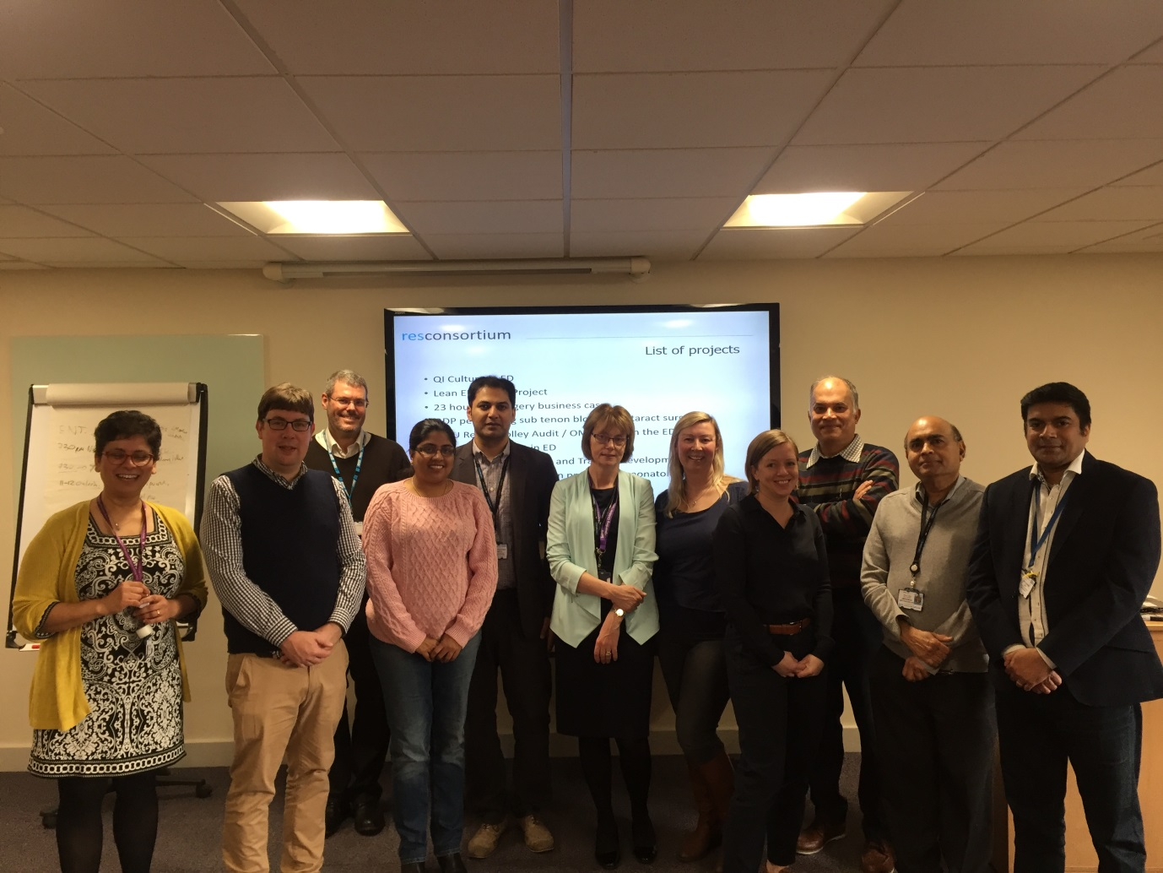

However, this scheme has been about much more than just delivering projects, it has been about raising the profile of SAS Doctors within our Trust. The SAS Doctors have shown themselves to be confident, capable, professional doctors who are able to bring about change.

What are the ingredients that have made this Project Leadership Programme so successful?

1. The course was offered to all the SAS Doctors. However applicants had to commit that they would attend all 3 of the whole day workshops and would work independently between the workshops on their projects before their place was confirmed. This high level of commitment by the SAS doctors was key to the success of the programme.
2. From the outset the SAS tutor ensured that the Executive Team, including our Chief Executive knew about the SAS Project Leadership Programme and they were in support of it. This support and interest from the Executive Team was key to success.
3. It was the Doctors themselves who identified the projects they wanted to work on and that were of particular relevance to them.
4. Each SAS Doctor was asked to identify a Project Buddy. The Project Buddies needed to be people who had an in depth knowledge of the workings of Harrogate and District NHS Foundation Trust. Their role was to help the SAS doctor think through any difficulties and advise the Doctor on how to draw on the resource. Sometimes these resources were practical things other times it was knowing who to approach to facilitate solutions. The Project Buddies were either a General Manager or a Consultant colleague.
5. We had a very enthusiastic trainer Graham Knight from Res Consortium who led the workshops and also offered one to one telephone support and encouragement to the Doctors between the workshops. Graham had access to all the resources of Res Consortium and therefore could draw on different areas of expertise for different projects.
6. The SAS Tutor received regular updates on all the projects and was able to identify potential hurdles and advise on how these could be overcome. When necessary she made contact with Clinical Leads and General Managers to discuss solutions to any particularly tricky challenges.

The final day when the Doctors presented their projects was amazing. The Doctors were so enthusiastic about not only their projects but also about the skills that they had learnt along the way and the fact that they could see how much they could contribute to improving the services in which they work. For our Doctors in the Emergency Department who were undertaking CESR one of the requirements is for them to lead on a Quality Improvement Project so these projects will provide the evidence they need for that. The Executive Team listened with genuine interest about each project and has committed to integrating these projects into the Annual Directorate Business Plans.

A fantastic “Well Done” to the SAS doctors at HDFT.

For more information contact myself, Dr Natalie Lyth, at Natalie.Lyth@hdft.nhs.uk or Graham Knight on gknight@resconsortium.com.