# How to access Neurodiversity eLearning for Educators and Trainers on Blackboard

If you already have a Blackboard Account, skip to Enrolling onto a course.

If you have already enrolled onto a course and want to access it directly from Blackboard, skip to [Accessing a Course in Blackboard](bookmark://_Accessing_the_course).

### Creating a Blackboard Account

1. To access the sign-up page, you will need to use the following link to launch [Blackboard's self-service portal](https://hee.blackboard.com/webapps/consulting-central/app/launch/TDMv2) (TDM v2). Once the page has loaded, click Sign Up.

1. This will open a sign-up page. You will need to complete the fields marked with a red asterisk (*)

**Please note** that when you are creating a password, it needs to be at least 12 characters long, be alphanumeric with at least one capital, and contain a special character. For example, ‘Welcome2025!’ would work.

1. Once you have completed the form, click save in the bottom right corner of your screen. You will then be sent an automated email containing a unique code to validate your email address and complete the set-up of your account.

## Enrolling onto a course

1. To enrol onto a course, visit [Blackboard's self-service portal](https://hee.blackboard.com/webapps/consulting-central/app/launch/TDMv2) (TDM v2)
2. You will automatically be taken to the Course Catalogue. In the search bar, enter ‘Neurodiversity’. The available courses should automatically show on the page:

1. Click on the image of the course you wish to enrol onto

1. Click Enrol Now:

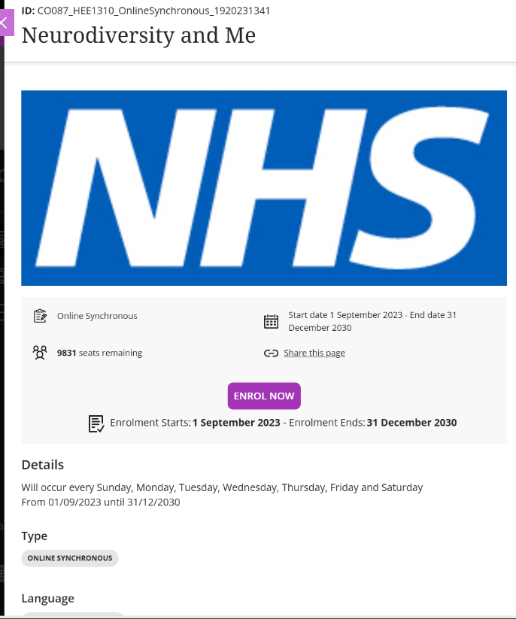

1. A pop-up box will appear asking you to confirm your enrolment.

Once you have clicked on Enrol, a green banner will appear across the top of your screen confirming your enrolment, and you will receive a confirmation email.

1. Once enrolled, to open the course in Blackboard, click go to your dashboard. Once in your dashboard, click on the course to open it and then click on Continue Course:

1. You can now access the course content in Blackboard:

## Accessing the course in Blackboard

1. After enrolment, to access the course, [log into Blackboard](https://hee.blackboard.com/).
2. Click on Courses:

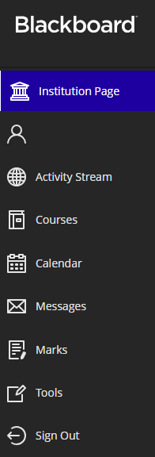

1. Click on Open beneath the course name:

1. You can now access the course content:

## Downloading your Certificate of Completion: Neurodiversity in the Workplace

A certificate of completion is provided at the end of the course and can be downloaded by selecting ‘Download your Certificate’ on the penultimate page of the ‘Summary’ section:

## Downloading your Certificate of Completion: Neurodiversity for Line Managers

A certificate of completion is provided in each individual section of the Neurodiversity for Line Managers eLearning course, rather than a singular certificate provided at the end.

To download your certificate(s), select the ‘Download your Certificate’ option when you conclude each section:

