Job description for the Trainee Executive Forum,

Wellbeing and Support Lead

Mission statement

Yorkshire & the Humber Trainee Forum: “The influential voice for trainees”. Ensuring postgraduate doctors and dentists in training in the Yorkshire and Humber region are fairly, equitably and transparently represented. We aim to drive improvements in quality of education and training, well-being, and support.

Purpose of the Trainee Forum

The purpose of the Trainee Forum is to improve engagement of postgraduate doctors and dentists in training with the work of Health Education England Yorkshire and the Humber (HEE YH). It will facilitate an increasing contribution of postgraduate doctors and dentists in training towards day to day work, innovative projects and working groups. This in turn will help deliver our objectives of delivering excellent training, enhancing recruitment and retention and improving the postgraduate doctor and dentist in training experience. Ultimately this will benefit our region by leading to the provision of the highest quality patient care.

Specifically, the trainee forum will:
- Increase postgraduate doctor and dentist in training engagement with HEE YH to enhance the quality of postgraduate medical and dental training and education.
- Represent postgraduate doctor and dentist in training views from all medical and dental specialties in all localities in the YH region.
- Provide a mechanism for bidirectional communication and information dissemination between HEE YH and postgraduate doctors and dentists in training.
- Provide direct contact for postgraduate doctors and dentists in training with senior HEE YH faculty and management allowing postgraduate doctors and dentists in training to contribute to the development of relevant strategies and processes.
- Provide a representative to attend HEE YH management meetings to deliver a postgraduate doctor and dentist in training voice and opinion on policymaking.

Structure of the Trainee Forum

Accountable to: The Postgraduate Dean HEE YH
Responsible to: The Chair of the Trainee Forum

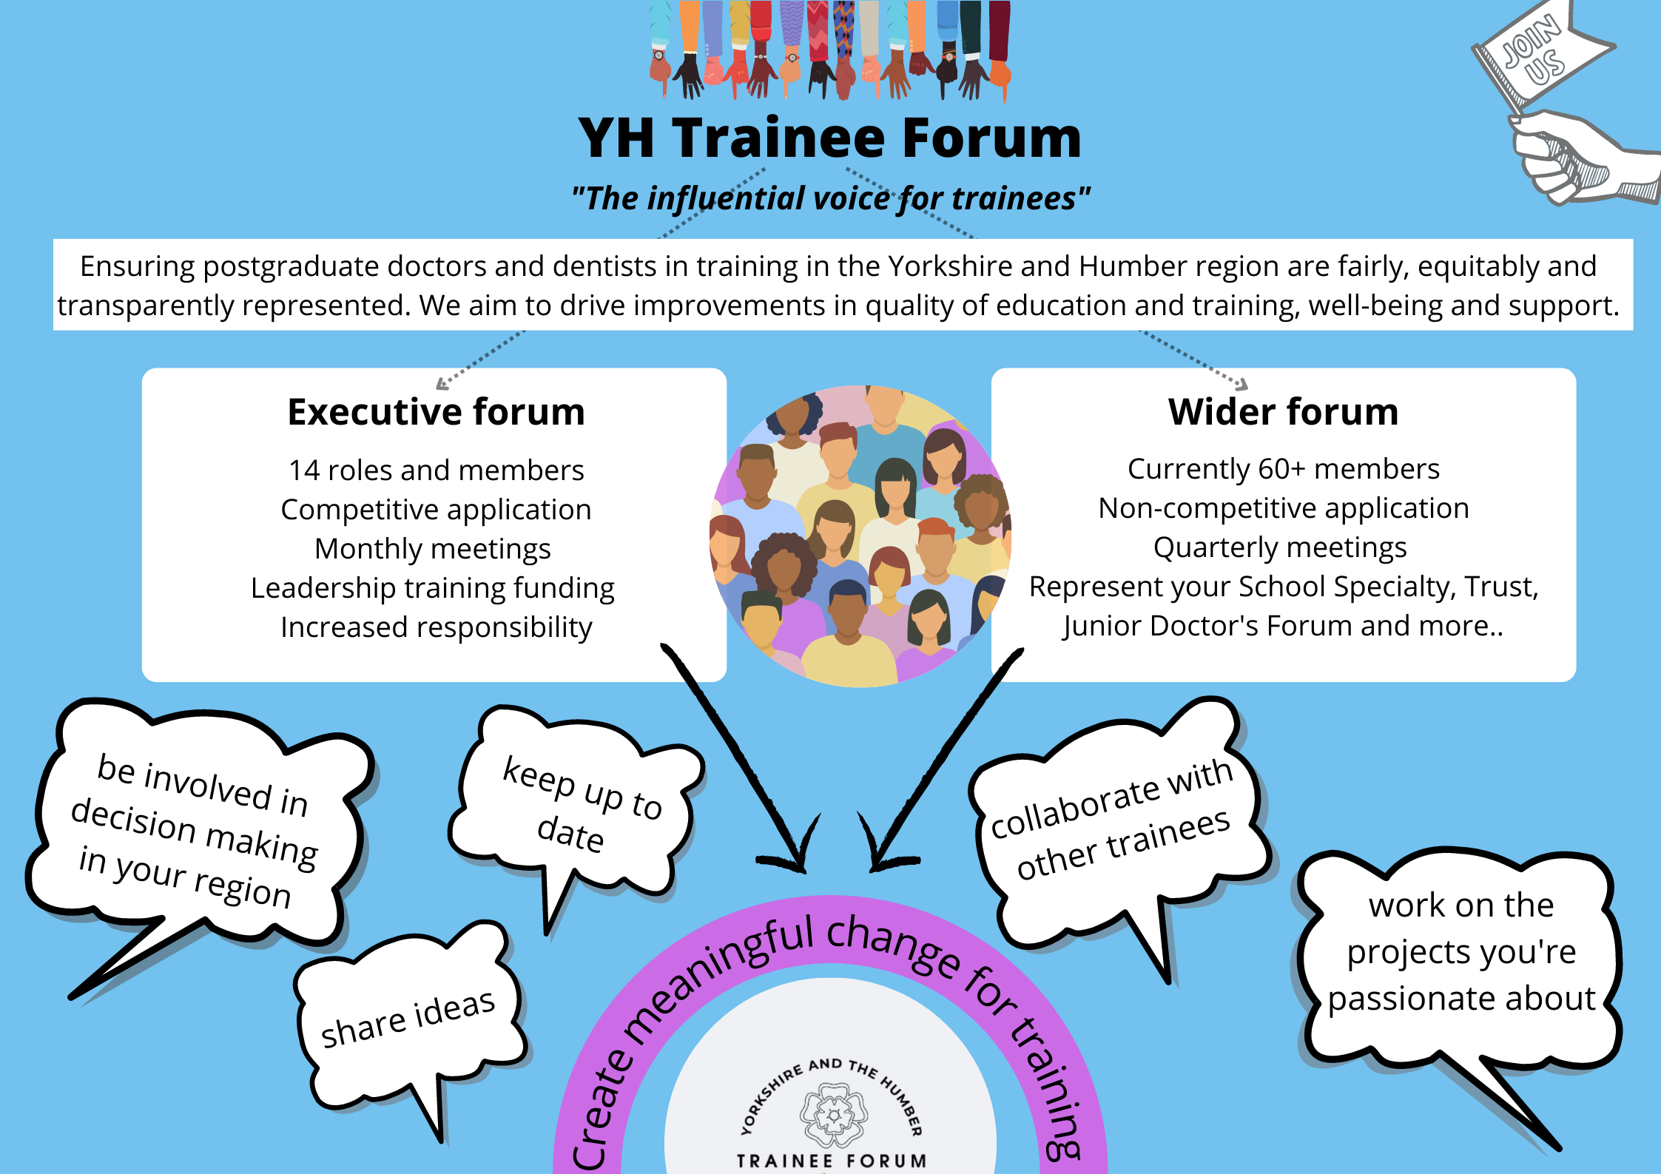

The Trainee Executive Forum is comprised of 14 executive committee members, who have been appointed via a competitive application process:
- 1 Chairperson (held by a Future Leader Fellow)
- 1 Vice Chairperson
- 1 Secretary
- 1 Wider Forum Lead
- 1 Quality lead
- 1 Employers lead
- 3 Locality leads (East, South, West)
- 2 Equality, Diversity and Inclusion leads
- 1 Less than full time Lead
- 1 Wellbeing and Support Lead
- 1 Communication and Engagement Lead

The Trainee Wider Forum is open to anyone with a passion to improve training in Yorkshire and the Humber. This includes trainees at all levels of training from all specialities and schools across medicine and dentistry. We hope this will lead to a diverse and inclusive forum, so we can fully understand issues for all trainees.

Expectations of the role

Job description
This is a voluntary role to represent postgraduate doctors and dentists in training across Yorkshire and the Humber.

The aim of the Trainee forum is to improve postgraduate doctor and dentist in training engagement with the work of HEE YH to improve the quality of training and education in the region. As the Wellbeing and support Lead, you will be expected to bring wellbeing and support to the meeting agendas on a regular basis and have an awareness of the requirements, demands and available services in the region. You will also be expected to promote wellbeing and support to postgraduate doctors and dentist in training both directly and by working on the development of new and existing projects.

In an Executive Forum role, you will have the dual role of representing your School and Specialty as well as the executive role.

Key role-specific responsibilities include:
- To work collaboratively with the Trainee Forum and HEE YH in promoting the awareness and uptake of wellbeing and support resources available for the YH region.
- Collaborate with the HEE Programme Support team in their development of resources and/or resource advertisement.
- Take a proactive approach to wellbeing and support, by considering it during formal decision-making processes about training and education in the YH region.
- Seek and represent the thoughts/ideas/concerns of postgraduate doctors and dentists in training with shared unique challenges; such as with integration, return to training or complex requirements

Duration:
Maximum term 2 years (no minimum term, but we expect that you will have a minimum of 6 months left of your current training programme at the time of application). A minimum of 1 year commitment to the Executive Forum roles is highly encouraged.

Forum members will be eligible to serve a second term (a further 2 years) if they wish to do so and have demonstrated commitment to the role. A re-election process with support from the majority of the acting Executive Forum is required.

What to expect as a Trainee Executive Forum member
The Trainee Executive Forum will meet monthly, and all meetings are currently expected to be virtual although a hybrid model may become available; they will be held in working hours and last approximately 3 hours. Members will work together, forming working groups, on projects

that promote development and improvements in quality of education and training, wellbeing, and support.

Executive Forum members are entitled to two sessions (equivalent to 1 day) of professional leave per month to complete Trainee Forum work and attend Executive Forum meetings. (This is the same entitlement for both full time and less than full time postgraduate doctors and dentists in training, i.e. it is not calculated pro-rata). This professional leave will be available as long as requested with at least 6 weeks notice. Please note, professional leave is different from “study leave” so study leave allowance will not be affected.

Membership of the Trainee Forum is a significant leadership and management opportunity. An annual certificate and/or letter of contribution/confirmation of attendance will be issued acknowledging meeting attendance and thanking members for their engagement, work and support.

General responsibilities and expectations
The most important expectation for members of the Trainee Forum is that you are enthusiastic about representing your fellow postgraduate doctors and dentists in training and improving quality of training and education, wellbeing and support across Yorkshire and the Humber. You should also recognise and celebrate the beautiful differences that we all possess and be open, respectful and inquisitive about opposing viewpoints and different experiences.

There is further expectation that you will:
- Attend meetings whenever possible (at least 50% of meetings) and offer apologies if you are unable to do so.
- Action tasks assigned to you within the time set during meetings and disseminate this to the relevant parties.
- Actively engage as part of a working group on local or regional improvement projects and action any tasks assigned to you.
- Seek opinions and present the views of all postgraduate doctors and dentists in training in the Yorkshire and the Humber region, both to the Trainee Forum and to HEE YH.
- Ensure the work of the Trainee forum is disseminated appropriately.
- Liaise with postgraduate doctors and dentists in training in your School, Speciality and/or area as appropriate.
- Raise awareness of the Trainee Forum within Yorkshire and the Humber.
- Work towards continuous improvement including reaching out to find good practice and share this.
- Support recruitment to the Trainee Forum and executive roles as required to ensure all positions are filled.

- To provide input, along with the rest of the Trainee Executive Forum, to an annual report summarising the Trainee Forums developments, achievements and ambitions for the following year.
- Comply with the governance structure of HEE YH.
- Hand over comprehensively to your successor.

Opportunities
Being a member of the trainee forum will give you a number of opportunities:
- Leadership and management skills for personal and professional development (including to meet required training competencies).
- Opportunity to represent, meet with and work alongside your fellow postgraduate doctors and dentists in training, colleagues and seniors within HEE and Yorkshire and the Humber.
- Develop a greater understanding of the functions and roles within HEE YH and the management of education and training across the region.
- Completion of two leadership courses funded by HEE YH:
  - Effective meetings
  - NHS Structure and Power Dynamics
- Completion of the healthcare leadership 360 appraisal and receive bespoke feedback on this (2 hour 1:1 session).

Term of Reference

Please see the Trainee Forum Terms of Reference for further details on membership, representation, tenure, meetings, communications and responsibilities.

Trainee Executive Forum Person Specification

 | Essential | Desirable
Eligibility | Postgraduate doctor or dentist in training in HEE YH of any grade or specialty.
Skills, abilities, and knowledge | Understanding of the function of HEE and its responsibilities in relation to training.  Enthusiastic self-starter with awareness of own limitations; seeks help appropriately.  Excellent interpersonal skills and ability to work in partnership with others.  Excellent organisational skills.  Proven ability of working in a multidisciplinary team environment and delivering team objectives.  IT skills including use of Word, Excel and PowerPoint and virtual communication tools/ apps.  Awareness of current initiatives and priorities within the NHS – locally and nationally. | Website writing skills.  Experience in production of webinars, podcasts etc
Experience | Evidence of participation in audit, evaluation, QIP or research projects. | Evidence of previous leadership role.  Evidence of previous effective trainee representation (in a formal role or otherwise)
Teaching | Evidence of contributing to teaching & learning of others | Enthusiastic and experienced in teaching in workplace or training environment.
Fitness to practice | Is up to date and fit to practice safely.

