Job description for the Trainee Wider Forum,

Wider Forum member

Mission statement

Yorkshire & the Humber Trainee Forum: “The influential voice for trainees”. Ensuring postgraduate doctors and dentists in training in the Yorkshire and Humber region are fairly, equitably and transparently represented. We aim to drive improvements in quality of education and training, well-being, and support.

Purpose of the Trainee Forum

The purpose of the Trainee Forum is to improve engagement of postgraduate doctors and dentists in training with the work of Health Education England Yorkshire and the Humber (HEE YH). It will facilitate an increasing contribution of postgraduate doctors and dentists in training towards day to day work, innovative projects and working groups. This in turn will help deliver our objectives of delivering excellent training, enhancing recruitment and retention and improving the postgraduate doctor and dentist in training experience. Ultimately this will benefit our region by leading to the provision of the highest quality patient care.

Specifically, the trainee forum will:
- Increase postgraduate doctor and dentist in training engagement with HEE YH to enhance the quality of postgraduate medical and dental training and education.
- Represent postgraduate doctor and dentist in training views from all medical and dental specialties in all localities in the YH region.
- Provide a mechanism for bidirectional communication and information dissemination between HEE YH and postgraduate doctors and dentists in training.
- Provide direct contact for postgraduate doctors and dentists in training with senior HEE YH faculty and management allowing postgraduate doctors and dentists in training to contribute to the development of relevant strategies and processes.
- Provide a representative to attend HEE YH management meetings to deliver a postgraduate doctor and dentist in training voice and opinion on policy-making.

Structure of the Trainee Forum

Accountable to: The Postgraduate Dean HEE YH
Responsible to: The Chair of the Trainee Forum

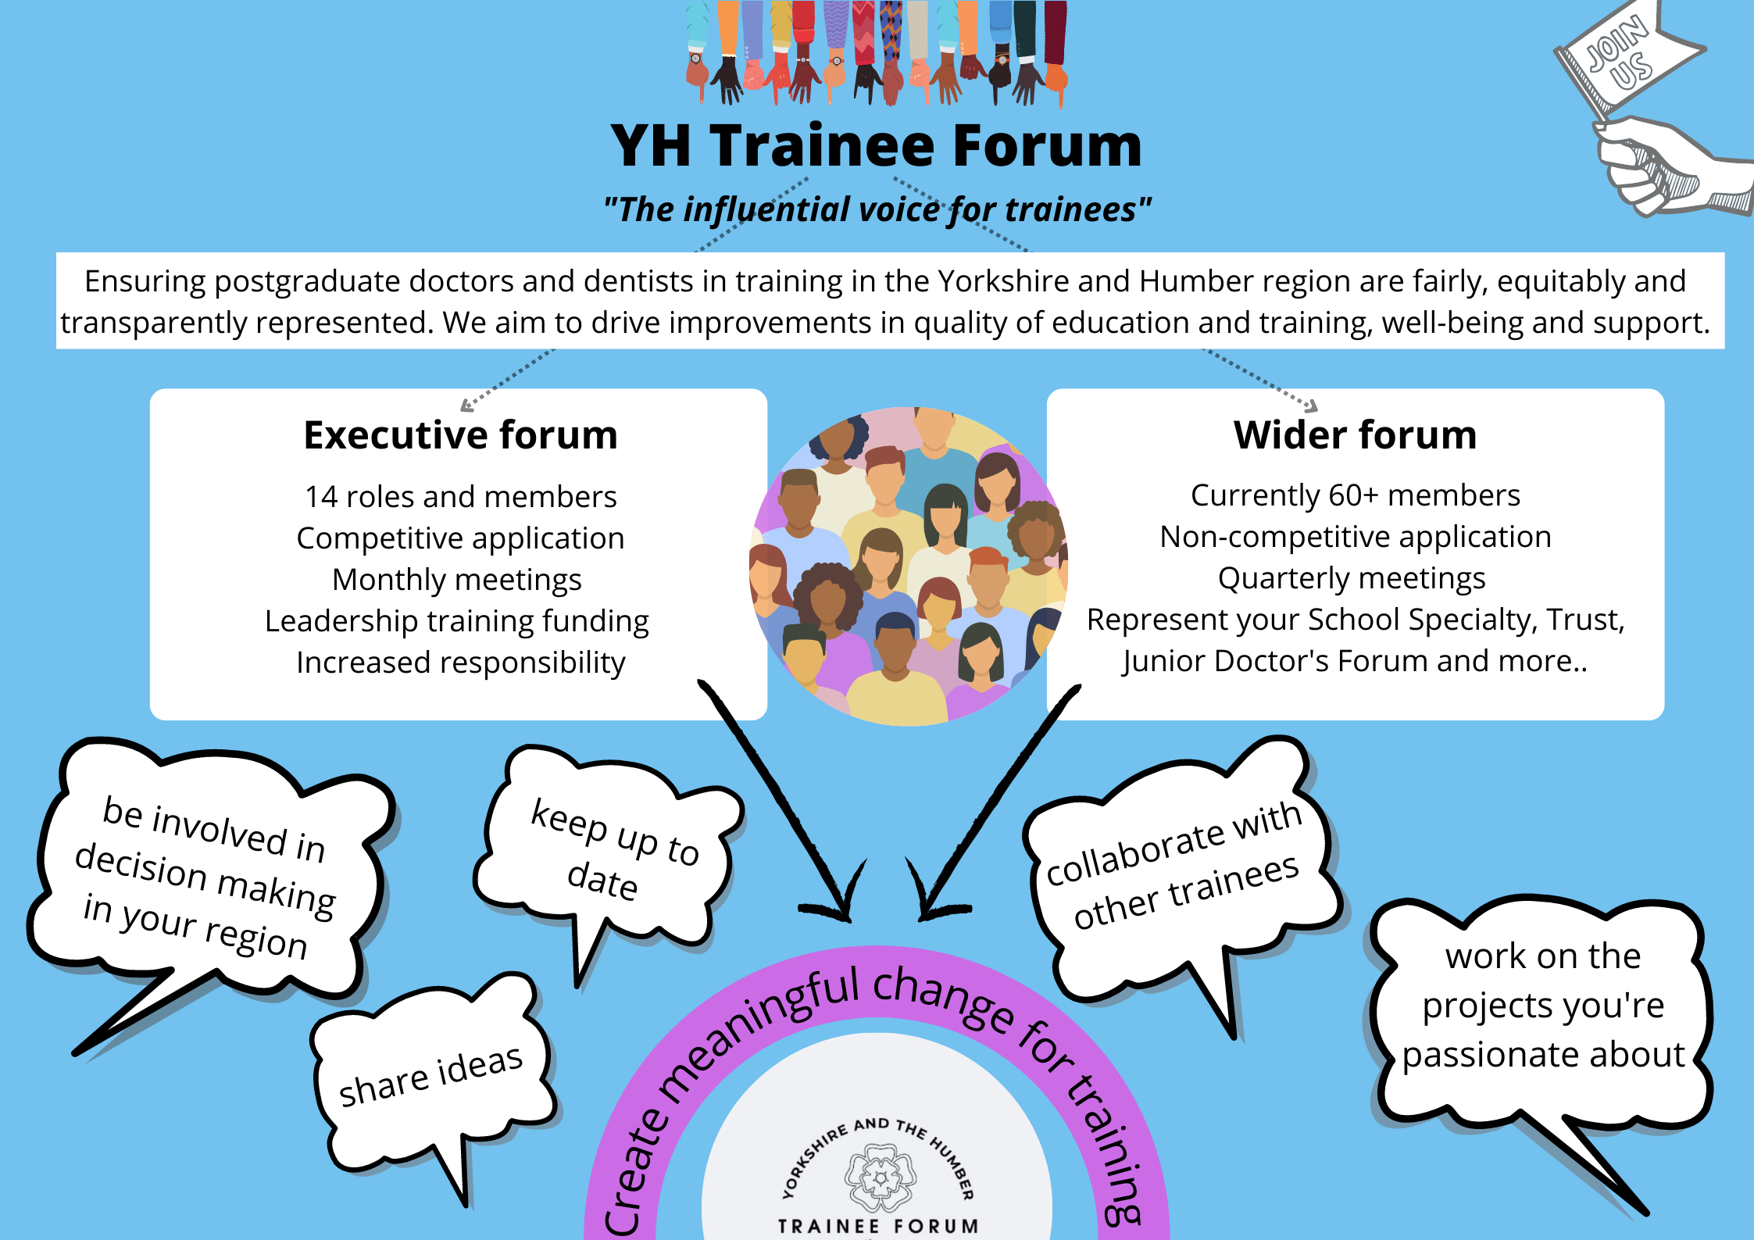

The Trainee Executive Forum is comprised of 14 executive committee members, who have been appointed via a competitive application process:
- 1 Chairperson (held by a Future Leader Fellow)
- 1 Vice Chairperson
- 1 Secretary
- 1 Wider Forum Lead
- 1 Quality lead
- 1 Employers lead
- 3 Locality leads (East, South, West)
- 2 Equality, Diversity and Inclusion leads
- 1 Less than full time Lead
- 1 Wellbeing and Support Lead
- 1 Communication and Engagement

The Trainee Wider Forum is open to anyone with a passion to improve training in Yorkshire and the Humber. This includes trainees at all levels of training from all specialities and schools across medicine and dentistry. We hope this will lead to a diverse and inclusive forum, so we can fully understand issues for all trainees.

Expectations of the role

Job description
This is a voluntary role to represent postgraduate doctors and dentists in training across Yorkshire and the Humber.

The aim of the Trainee forum is to improve postgraduate doctor and dentist in training engagement with the work of HEE YH to improve the quality of training and education in the region. As a Wider Forum member, you’ll be expected to seek and represent the views, ideas and concerns of postgraduate doctors and/or dentists in training in your School, Specialty or Trust. This may include utilising specialist knowledge, such as from the local Trust’s Junior Doctors Forum, School/Specialty trainee reps, BMA reps, Chief Registrars and Future Leader Fellows. You will be supported to work collaboratively with others on improvement projects which you are interested in.

Duration:
No minimum or maximum term.

What to expect as a Trainee Wider Forum member
The Trainee Wider Forum will meet quarterly, and all meetings are currently expected to be virtual although a hybrid model may become available; they will be held in working hours and last approximately 3 hours. Members will have the opportunity to work together, forming working groups, on projects that promote development and improvements in quality of education and training, wellbeing, and support.

Wider Forum members are entitled to one session (equivalent to 1/2 day) of professional leave per month to complete Trainee Forum work and attend Wider Forum meetings. (This is the same entitlement for both full time and less than full time postgraduate doctors and dentists, i.e. it is not calculated pro-rata). This professional leave will be available as long as requested with at least 6 weeks notice. Please note, professional leave is different from “study leave” so study leave allowance will not be affected.

Membership of the Trainee Forum is a significant leadership and management opportunity. An annual certificate and/or letter of contribution/confirmation of attendance will be issued acknowledging meeting attendance and thanking members for their engagement, work and support.

General responsibilities and expectations
The most important expectation for members of the Trainee Forum is that you are enthusiastic about representing your fellow postgraduate doctors and dentists in training and improving quality of training and education, wellbeing and support across Yorkshire and the Humber.

You should also recognise and celebrate the beautiful differences that we all possess and be open, respectful and inquisitive about opposing viewpoints and different experiences.

There is a further expectation that you will:
- Utilise professional leave to attend meetings whenever possible and offer apologies if you are unable to do so.
- Aspire to actively engage as part of a working group on local or regional improvement projects and action any tasks assigned to you.
- Seek opinions and present the views of all postgraduate doctors and dentists in training in the Yorkshire and the Humber region, both to the Trainee Forum and to HEE YH.
- Ensure the work of the Trainee forum is disseminated appropriately.
- Liaise with postgraduate doctors and dentists in training in your School, Speciality and/or area as appropriate.
- Raise awareness of the Trainee Forum within Yorkshire and the Humber.
- Work towards continuous improvement including reaching out to find good practice and share this.

Opportunities
Being a member of the trainee forum will give you a number of opportunities:
- Leadership and management skills for personal and professional development (including to meet required training competencies).
- Opportunity to represent, meet with and work alongside your fellow postgraduate doctors and dentists in training, colleagues and seniors within HEE and Yorkshire and the Humber.
- Develop a greater understanding of the functions and roles within HEE YH and the management of education and training across the region.
- Signposting to the ‘Leadership for Clinicians Early in their Careers’ course, for postgraduate doctors and dentists in training up to ST4 level. (ST5+ level have access to a three-day ‘Leadership and Management’ course as part of their generic skills offer on Maxcourse).
- Opportunity to apply for a role in the executive forum when executive committee members vacancies arise. The executive committee application is a competitive process which will include recognition for previous work as a member of the wider trainee forum.

Term of Reference

Please see the Trainee Forum Terms of Reference for further details on membership, representation, tenure, meetings, communications and responsibilities.

How to apply to the Trainee Wider Forum

Please send a Mini CV (limited to 1 side of A4) to the following email address: traineeforum.yh@hee.nhs.uk

Please include the following:
- Name, email address, phone number, postal address, GMC/GDC number, speciality, grade and hospital/base, as well as previous jobs/positions held.

- A section entitled “What people appreciate about me” – please provide 3 points you’d like us to know about you and brief explanation (can be in work environment, or personal life)

All applications are on a non-competitive basis: everyone is welcome! Should there be multiple applicants from the same hospital/specialty and rota, there may have to be a selective application process via reviewing CV’s.

