LinkedIn; Feel The Fear & Do It Anyway! 0.5 day
LinkedIn is the premier business to business social media platform. It is the number one place to position your authority and expertise in your field. For clinicians it is vital to learn how to use it effectively to ensure risks are managed as a professional.
In this workshop you will explore how to create a LinkedIn profile that brings your personal career story to life, whether you are managing your career or promoting the specialism you work within.
Workshop Objectives:
At the end of the workshop, delegates will understand not only what LinkedIn is but how to use it and gain opportunities from this powerful platform.
At the end of the half day workshop, delegates will have the necessary knowledge to:
- Set up their own LinkedIn profile
- Promote a confident and credible presence via posts
Workshop Outline:
This course is fast paced and designed to be interactive (you can use your phone and/or laptop) and will cover these main topics:
- What is LinkedIn?
- The benefits of LinkedIn for clinicians
- Setting up an account
- Understanding the importance of a great profile
  - Profile phone best practice
  - Creating a custom headline
  - Introducing yourself in the summary section
  - Showing your CV/expertise on line
- Writing posts
  - Scheduling tools
  - Using groups
  - Encouraging engagement including generating graphics in Canva
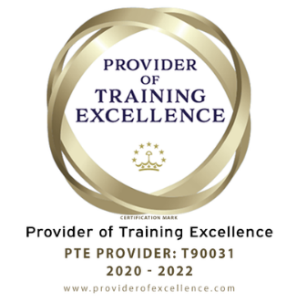
3 guided learning hours
3 CPD Points

