Looked After Children Dental Pathway Toolkit

This toolkit provides information about setting up a pathway to support dental assessment and dental care for looked after children (LAC). The pathway facilitates access to care and information sharing between organisations which can help to improve the oral health of a vulnerable group who are known to face inequalities.¹

Evidence surrounding dental health of LAC is scarce and data collected as part of the pathway could help inform future care planning for this group.

Stakeholders have been involved throughout the development of this simple framework including Paediatric Dentistry Managed Clinical Networks, Local Dental Committees, the Local Dental Networks, LAC health teams and Local Authorities.

This pathway aims for timely consistent high-quality assessment of a child’s oral health with findings incorporated into overarching health reports.

Contents

- Pathway
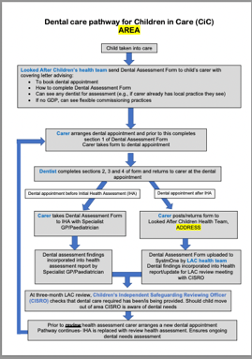

This document provides an overview of how the pathway works. Local authorities and LAC health teams are structured differently in different areas. The pathway here states that information should be sent to foster carers by LAC health teams, but it may be appropriate for this to be shared by local authority teams.

- Dental Assessment Form
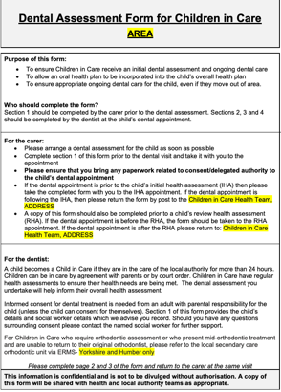

The dental assessment form is taken to the dentist and completed by the dentist when a child has a check-up. The form records the dental findings and treatment plan, and these are then shared with local authority and LAC health teams who can support the child to receive the ongoing care they need.

- Sample Carer letter

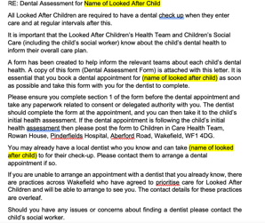 Whe
A letter is sent to foster carers with a copy of the dental assessment form when the child enters care. In this example the area of dental practices commissioned to provide care for groups including LAC and contact details are provided. The letter could be amended to suit different area needs

- Training video for General Dental Practitioners

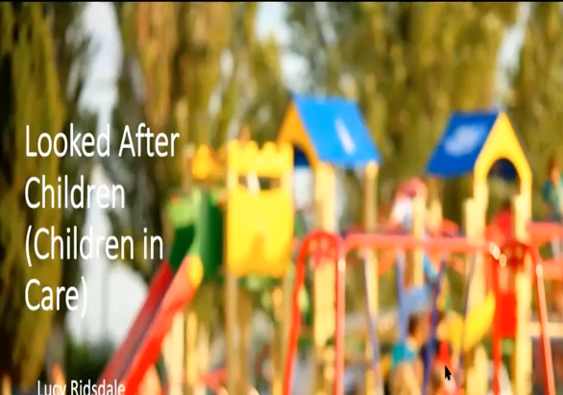
This video provides information about who looked after children are, who can give consent and parental responsibility

Pathway developed by Lucy Ridsdale, Laura Johnston and Simon Hearnshaw.

References

- Public Health England. Inequalities in oral health. 2021. Available from https://www.gov.uk/government/publications/inequalities-in-oral-health-in-england/inequalities-in-oral-health-in-england-summary [accessed 4 August 2022]

