Executive trainee meeting: 30/11/2021

Apologies: Sanah, Sidra, Lucy
Present: Ope, Pete, Alex, Rammina, Sana, Hussain, Annabelle, Sara, Maria, Lauren,

- Introductions made & Wellbeing check in.
- New forum members welcomed to their first meeting:
- Sana Fatima: lead for wellbeing and SUPPORT introductions to team.
- Hussain Sarward: new joint vice chair introduced. Medical trainee.

Update from previous meeting actions:
- Wider Forum date 8th Feb Am. Jon Cooper confirmed to be present at the meeting.
- Team to think about anyone who may be able to contribute as External speaker for learning burst.
- Thoughts on agenda for Feb wider trainee meeting to be discussed at the Jan executive trainee meeting.
- Jon Cooper has agreed to create small mini 5minute recordings on aspects of his job and introductions on his HEE role but unclear on frequency of this. Helen Bellis assisting with this. He wants to contribute column/area on the forum newsletter.
- Communication transparency who’s who of deanery: Jon Cooper agreed for wider team to create mini recordings for website to introduce themselves as deputy deans/ heads of schools etc.
- Jon Coooper focusing on IMG training and equality in the new year.
- Section to be created for each project of forum for the website/newsletter to explain what the team are doing/projects.

National wellbeing development project:
Wellbeing update for fellow doing national project as HEEI development project. Would like forum to review local initiatives that have worked for wellbeing support to feedback to national project development. Thoughts so far from team:
- York has free parking still for doctors and if no space at hospital can park at local multistorey and leave for free after 1800.
- Teaching for foundation trainees with lunch and support session
- Brave space for people to drop in and talk about their experiences.

Action point: Over next 2 weeks team to review if there are any local trust initiatives for preventing racism and inequality. Any local good practice.

Forum newsletter:
Sent out this week. Some of the forum had not received this therefore need to feedback issues with all staff receiving this via email. Those received it had no concerns regarding feedback.
- Need to upload to website to allow access to links.
- If trainee forum committee could contact Annabelle if they are happy to have email contact on website/newsletter for trainees to contact to raise concerns.
- Agreed for newsletter quarterly.
- Trainee forum committee to volunteer aspects of themes to contribute to newsletter: Sana volunteered to do professional support. Rammina agreed to do a leadership charter update.
- Lauren and Sara to work on section for LTFT.
- Ope and Sidra to start creating IMG update in depth for the newsletter in 3months time.

New generalist school:
Helen Cattermole: head of generalist school which is a new role. Associate dean for GP school. Orthopaedic consultant surgeon in Hull and head of education.
Creation of generalist school focusing on integrating social and health care in line with ICS. Place based programme focusing on professional development working within systems rather than clinical training. Multiprotection training from the beginning. Focusing on improving care for debriefed groups of the population and creating equal opportunities and access to services to all. Improving awareness of staff on the services and interaction of these to improve care for those in most deprived areas or experiencing inequality in care.
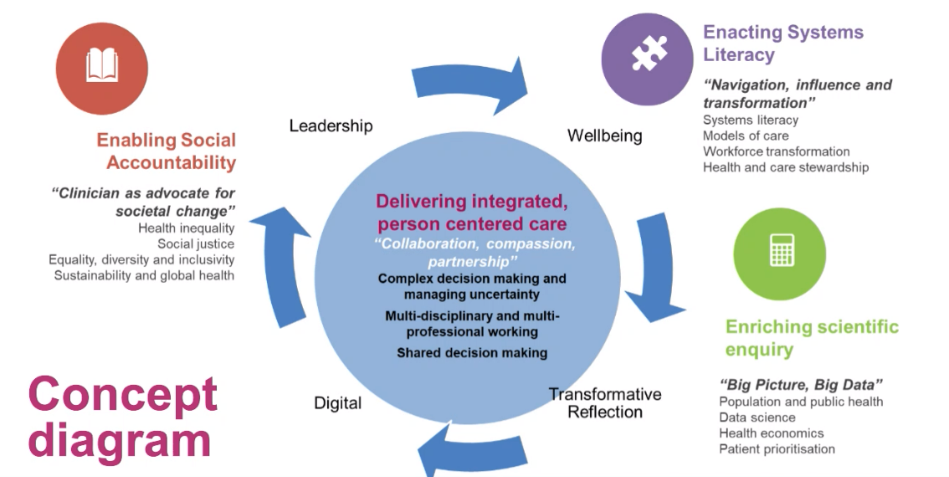

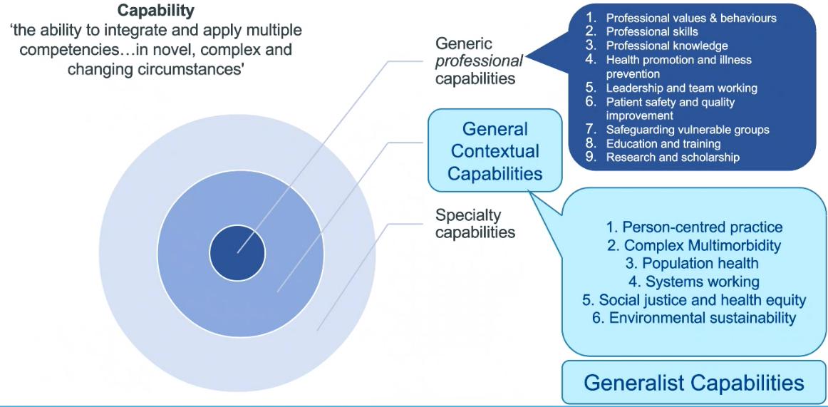

- Piloting stage at the moment.
- Awaiting finalisation of handbook outlining the generalist school.
- Learning hub with podcasts, papers, elearning being created to collate learning resources into one place.
- Website available with basic information but will have more development in future.
- Framework to create guidance on areas to focus on development
- For medical trainees provides resources and themes to focus curriculum outcomes alongside their training profile to assist in development and evidence links.
- Examples of other pilot projects: In east England deanery the foundation doctors are doing this alongside their other training. One day out in rota is having a day to focus on development in this curriculum as a LIFT programme.
- North east and Yorkshire are piloting multiprofessional from start of project. Cultural integration a focus and food poverty.
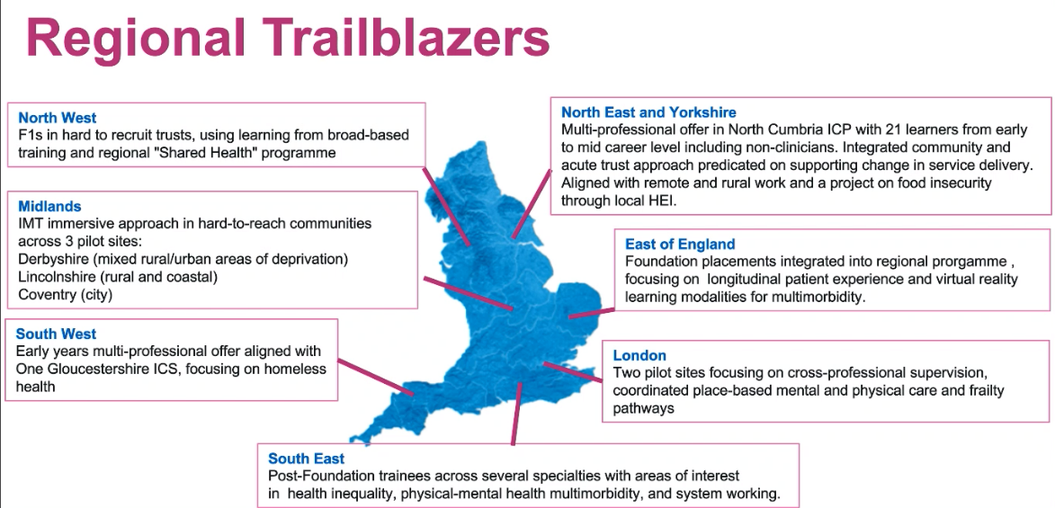
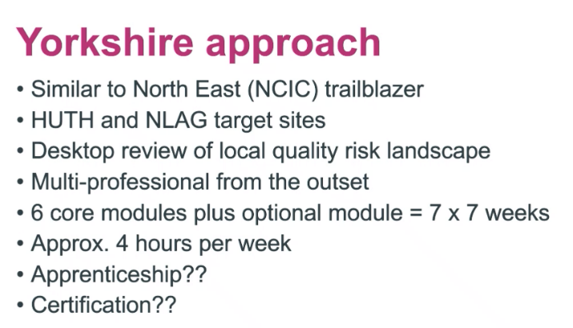

- Helen Cattermole requesting support and input from trainees to assist with development of this curriculum.
- Issues discussed:
- Concerns regarding use of reflection practice in legal cases.
- How can we attract those staff who are less aware or interested into this area as those are often the people to focus on however this is likely to attract people who are already interested in this area.
- Those wanting to get involved in developing this project further to contact Helen Cattermole directly.

Update by Jon Cooper:
- Newsletter being created for TPD/head of schools to summarise the COVID funding plan initiatives. Asked if we could have a copy which could be summarised in newsletter for trainees to be aware of actions occurring.
- Asked regarding HEE and NHS England merge: Deanery function not currently being altered and structure existed prior to HEE. Deanery structure and education will maintain at the moment as priority with no expected change at present.
- Q&A podcast for deanery management time suggested as area for development.

Emma Diggle update on COVID recovery bids:
- Innovative projects and ideas received and agreed funding.
- Some funding left over for further innovation for COVID recovery
- Encouraging trainees to get in touch with head of school and supervisors to discuss ideas.
- 10th December deadline however likely to be extended to give more time for bids.
- Pete expressed concern regarding some schools more presented then others.
- Emma advised to contact if any ideas for improvement: trainingrecoveryyh@hee.nhs.uk
- Dr Cooper expressed financial challenges due to government financial restrictions if over £10,000 requires governmental approval.
- Dr Cooper encouraging trainees to submit ideas.
- Annabelle queried if it is worth having a focus group of trainees to voice any ideas and widen awareness.
Emma Diggle going to create formal email update for trainees on current ideas of bids and update for further bid ideas to be submitted.
Rammina felt that there is a lack of active interaction with trainees to encourage ideas regarding COVID Bids. Forum suggested a drop in session for trainees via teams to met with Emma and trainee rep to put ideas forward and find out more about the COVID bids. To be done the next few weeks before Christmas.
Action plan: Annabelle to try organise a drop in session with Emma (and other forum members if free) to invite trainees to access to discuss covid recovery ideas).
Advised examples from the successful Bids as ideas and concepts that can be used with Bids.
- GP school: cameras for filming sessions for assessment and training.
- Simulation facilitates and increased sessions.
- Microscope for training by ophthalmology.
- National idea summary https://learninghub.nhs.uk/catalogue/supportingtrainingrecovery
Trainee forum advised that will try contact trainees within specialty to encourage COVID bids.

Any other action:
- Doddle poll for the next TEF meeting in Jan https://doodle.com/poll/7ip676edibf64itb?utm_source=poll&utm_medium=link
- Can people please let Annabelle Know if they are happy to have their email addresses shared on the TEF website?
- New chair Emma is starting in Feb and having induction with Annabelle over next few months.

