Covid Photo Diaries
GP Registrar Conference July 30th, 2020

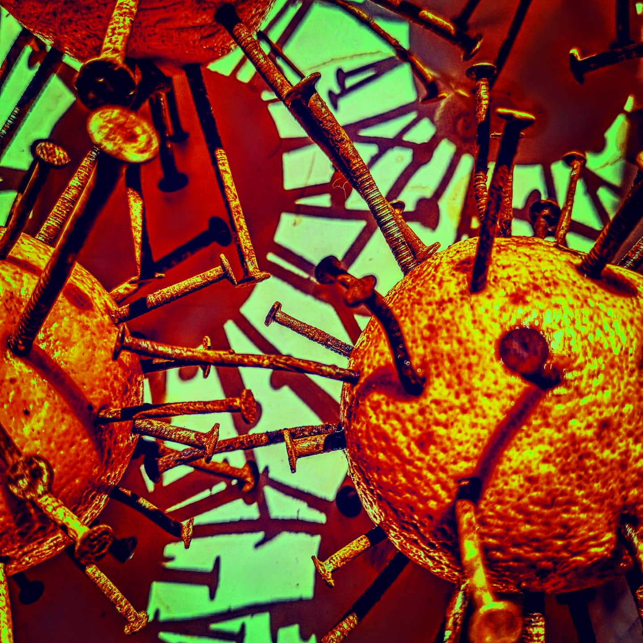
Photo by Jo Carina

Please send me a photograph of your experiences through the recent COVID pandemic- pictures of you working in PPE, wearing masks, empty streets, your garden, your favourite recipe, an instrument or piece of music you have played, zooming with family -or anything else that sums up what you’ve been through.
These photos will be used and shared as background to our on-line conference as a photo montage.

Please send your photo to lucy.clark9@nhs.net – closing date; July 20th 2020

