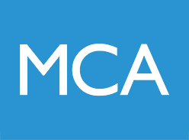
QUALITY IMPROVEMENT OPPURTUNITIES FOR JUNIOR DOCTORS!

I am one of the new quality improvement fellows, also a junior doctor. We are trying to improve(!) junior doctors’ involvement in the STH QI programmes.

We have reserved spaces on the 2 day QI course for junior doctors; it is free, and excellent!!

Following this I’ll be offering project support sessions to enable you to achieve your QI goals!

- The dates are:
      - 13 & 14 September
      - 18 & 19 October
      - 15 & 16 November
      - 13 & 14 December

The website is: http://www.sheffieldmca.org.uk/the-two-day-course
My email address is: claire.cruikshanks@sth.nhs.uk

Please get in touch about this or any other QI needs

