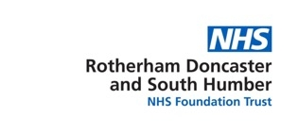SAS Doctors Teaching day
11th September2019
Dining Room, St Catherine’s House
Doncaster, DN4 8QN

PROGRAMME
09:00 Registration
09:30 Management of patients with comorbid illicit substance misuse.
Dr Navjot Ahluwalia, Executive Medical Director, & Consultant Psychiatrist in Substance Misuse, RDaSH

11:00 Tea/Coffee

11.15 Management of patients with comorbid illicit substance misuse (Continued from previous session)
12:30 Lunch

13:30 Prescribing decisions ·
Dr John Bottomley, Associate Medical Director, Doncaster & Consultant Psychiatrist in Older People’s Mental Health services, RDaSH
14:45 Tea/Coffee

15:00 Application of the Mental Capacity Act 2005
Dr John Bottomley, Associate Medical Director, Doncaster & Consultant Psychiatrist in Older People’s Mental Health Services, RDaSH.
16:30 Close
To book on this programme please contact Ms Nicola Bird, Medical Workforce & Education Administrator by e mail only. E mail: rdash.medicalpersonnel@nhs.net
For any other query, please e mail SAS Tutor Dr T. Sinha on e mail: tanuja.sinha@nhs.net
Certificate of attendance would be provided following attendance and receipt of feedback.

