Yorkshire and the Humber Deanery
Safeguarding Children Course (2010)
PRE-COURSE READING
N.B. This course, and associated reading, is derived from the work by Ruth Bastable (Cambridge) & Andrew Mowat (Lincolnshire). This was specifically demonstrated in ‘A Safety Check’: an RCGP child protection course run at Nottingham City Hospital in March 2006.

1. CHILD ABUSE (direct)

Summary Comment
- Child abuse is an important public health problem, which has significant morbidity and mortality
- Child abuse is preventable
- GPs have an important part to play at all stages of the child protection process (primary prevention, early intervention, diagnosis, referral, assessment, continuing management and secondary prevention)

Definition of child abuse
- Child abuse is not a diagnosis like diabetes; it is a social construct
- What is and is not thought to be ‘abusive’ is defined by society, and changes with time
- What was acceptable and widespread practice (e.g. beating children with belts and sticks, a common practice 100 years ago) is not acceptable now

Recognition of child abuse
- 'The first step in recognizing abuse is acknowledging that it exists'.
- Recognition of child abuse depends not just on recognizing signs and symptoms, but on the process which all of us as individuals and within cultures and societies must go through in their approach to child abuse.

Numbers (see chart below)
- There are 11 million children in England
- Vulnerable children: About 1/3rd (4 million), mostly through poverty
- Children in need: 300,000 – 400,000 (36 per 1000 < 18)
- Children in need of child protection: 27,000 on child protection register (2.4 per 1000 < 18)
- Looked after children (LAC): 53,000 (about 5 per 1000 < 18)
- N.B. The number of children on the child protection register represents the number we know about; it is not the same as the number of children suffering abuse.

Incidence
- Severe abuse (per year): 3 per 1000 children < 18 (widely acknowledged to be an underestimate).

Prevalence
Not really known, but an NSPCC study of 2689 young people between 18 and 24 yrs found:
- 7% had suffered serious physical abuse
- 6% had suffered serious physical neglect
- 6% had suffered serious emotional or psychological maltreatment
- 4% had suffered serious sexual abuse within the family (1%parent, 3% another relative, most often brother or step brother)
- 11% had suffered sexual abuse by another non-related but known person. In this group, perpetrators almost all male, and 75% of victims female.

Morbidity
- The effects of abuse may be transient, situational, permanent or intermittent
- There are victims and survivors; this depends on context, severity and persistence of abuse, and features of the child itself
- There is no 1 – 1 relationship between abuse and outcome; cruel treatment can produce an aggressive child or a timid & crushed one
- If attachment in infancy and childhood is disordered, effects can persist throughout life (e.g. high incidence of history of child abuse and neglect in young adult offenders, runaways and homeless)
- Abuse survivors and victims are very frequent consulters in general practice.

Mortality
- Child death is the most severe form of child abuse
- Child abuse is responsible for 1 – 2 deaths per week in England, but ‘likely to be significantly higher'
- Somewhere between 50 and 200 child deaths occur each year in England because of child abuse and neglect
- This puts child abuse as a relatively common cause of child deaths (i.e. comparable with deaths on the road as pedestrians or cyclists: about 180 a year)
- Most child homicide is as a result of parental or step-parental activity; murder by a stranger is rare.

Essential Jargon:

CHILD IN NEED (Section 17 of the Children Act 1989): A child in need is one whose vulnerability is such that they are unlikely to reach or maintain a satisfactory level of health and development, or that health and development will be significantly impaired, without the provision of services

CHILD IN NEED OF CHILD PROTECTION (Section 47 of the Children Act, 1989): A child in need of child protection is one suffering from or likely to suffer from significant harm.

SIGNIFICANT HARM: 'This has a particular meaning and establishes a threshold for concern. Significant in the context means noteworthy, which may be through presenting seriousness or presenting implication.’ (Polnay 2001)

LOOKED AFTER CHILD (LAC): This refers to one who is accommodated by the local authority, whether or not a care order has been made. Children in public care may be fostered, in a children's home or otherwise accommodated by the local authority.

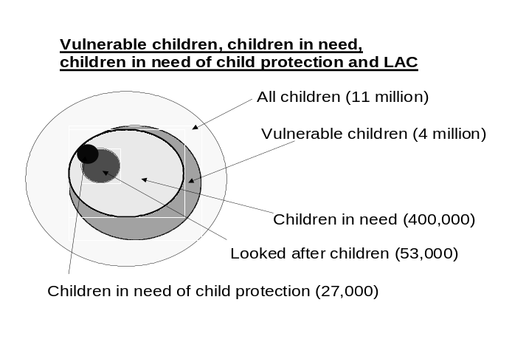

MANAGING POTENTIAL CASES OF CHILD ABUSE
(In the primary care setting)
1. Before or during the consultation
- Look carefully at the child’s notes: go back to the birth, not just the last few entries. Is there a pattern to concerns expressed or injuries/‘accidents’ recorded?
- Check for concerns in the notes of any other children (e.g. unexplained injuries, failure to thrive or past history suggestive of abuse) and both parent(s) (e.g. drug or alcohol misuse, previous social services involvement)
- Make an assessment of the child’s health, well-being and development, as well as specific issues
- Ask about the presenting problem, past medical history and social history. Pay particular attention to the child's wider social functioning
- Unless doing so would place the child at risk, seek an explanation from the child's parent(s) and the child as well, if this is appropriate
- If you suspect the parent presenting the child is the perpetrator, you will need to be circumspect in your questioning. There is a risk of the child being 'coached' in her story
- Examine the child, as appropriate. Do relevant areas seem normal? (You can only learn what is normal by looking or checking)
- If you see signs that make you suspect sexual abuse (e.g. bleeding or bruising in relevant places), get help. Ensure the immediate safety of the child, but no more
- Unless doing so would place the child at risk, explain your concern to the child's parent(s)
2. During or after the consultation (as appropriate)
- STOP: Ask yourself, 'Is this child safe?' If you think not, then refer urgently (usually to social services, but when necessary to other doctors/hospital)
- ACT: If you are concerned, seek advice and/or make a referral (Refer to the Flow Chart).

3. After the consultation
- Advice may come from social services, the designated or named doctor or nurse, a senior hospital paediatrician or, in some areas, the NSPCC
- Where hospital admission is needed, make doctor-to-doctor contact with a senior pediatrician
- Inform the rest of the general practice team, as appropriate, of your concerns. Also seek information from them as appropriate, and inform them of any referrals
- Where relevant, contact social services and agree with them how to proceed. Ideally, you should have parental consent to do this, but you can proceed without such consent if seeking it would jeopardize the safety of the child, or if consent is withheld and you believe the child to be suffering from (or at risk of suffering from) 'significant harm'
- Make a clear entry in the child's notes (the history, observations, findings, concerns) and refer to this entry in the notes of other household members. The next concern to arise may be about another child or another member of the household
- Good safety-netting is essential. Follow up your actions: treat child protection concerns as you would any case of a Serious illness.

[N.B. This should be re-read in conjunction with ‘Child Protection: Good Practice Guideline’ & ‘Flow Chart: Referral’ (see ‘Post-Course Reading’, handed out at the end of the forthcoming session).]

Some of the barriers to recognising and responding to child abuse:
The problem is hidden
Parents will present their child with something other than abuse, such as an ‘accident’.
Parents may be frightened or feel ashamed. They may want help, but be unwilling to accept responsibility for their actions. Rarely, they may actually induce illness (Fabricated Induced Illness, previously referred to as Munchausen’s Syndrome by Proxy).
Underestimating the problem
Failing to appreciate the danger to a child where there is domestic violence.
Failing to appreciate the significance of unexplained injury in a pre-mobile child.
Normalising the problem
For example, where there is material deprivation. Neglect is more common where there is deprivation, but deprivation does not cause neglect.
Not seeing the child
The child’s needs can easily be overshadowed by those of the parents.
We must put the needs of the child above all others (The Children Act ‘Paramountcy Principle’) and see the child, not just the parents.
Not looking
There is no doubt that child abuse is upsetting. It is easier to ignore the problem or seek other, more comfortable explanations for our observations.
Doing nothing
Acknowledging that there is a problem can cause a lot of work and strife. It is less trouble, at least in the short term, to do nothing
Relationships
We are often concerned for our relationship with the family; they will be angry and upset and we may fear for our safety if we raise the issue of child abuse. The family may feel betrayed by us if we express our concerns. Relationships may be fragile anyway or we may feel that the family is doing their best under very difficult circumstances
Trust
Our relationship with our patients is founded on trust and mutual respect. Where there are suspicions of child abuse, we have to adopt a much more inquisitorial and forensic approach that cuts across this relationship of trust.
Inter-professional relationships
Working effectively in child protection demands an inter-professional approach involving at least health, education, social services and the police. This creates problems: confidentiality and information sharing, the different languages, cultures and expectations of the different agencies, and the practical difficulties of finding the right professional at the right time and being able to talk to them.
Lack of confidence in the system
Sometimes we feel that the cost of engaging the child and family in the child protection system outweighs the benefits. It can feel easier to ‘go it alone’.

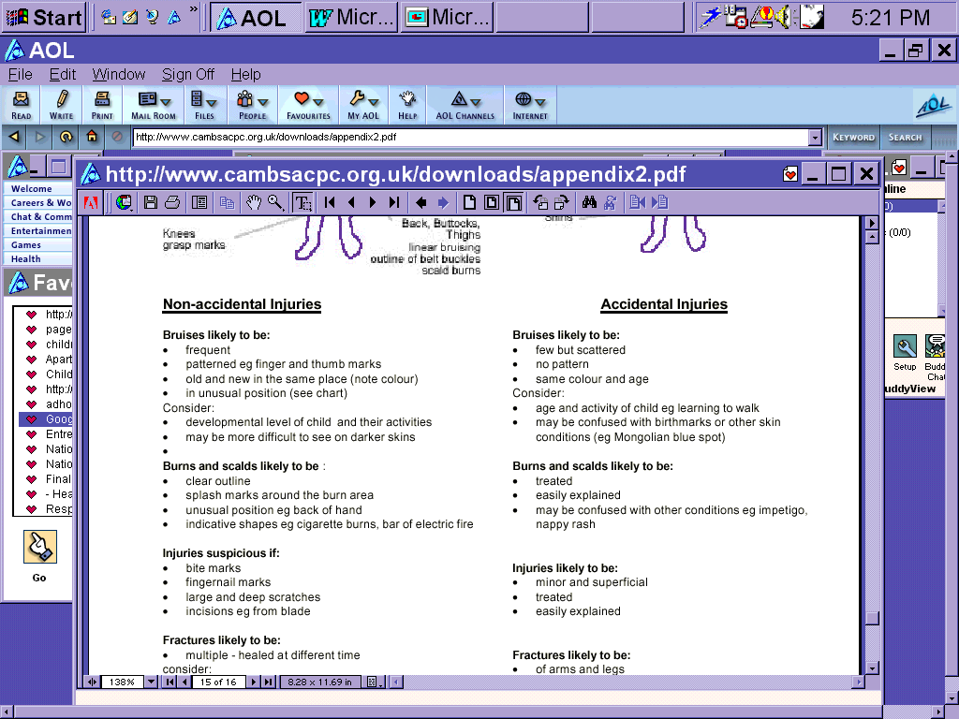

2. CHILD ABUSE (within domestic violence)
[N.B. Because the majority of domestic abuse is committed by men on women, the following refers to women as the presumed victims. It is important to remember that this is not always the case.]
Summary Comment
- Everyone working with women and children should be alert to the frequent interrelationship between domestic violence and the abuse and neglect of children (DfES, 2006)
- The trauma and long-term effects suffered by children living in a violent household is incalculable
- Witnessing violence against another constitutes ‘harm’ (Children Act, 1989).

Definition (Domestic Abuse)
- Any incident of threatening behaviour, violence or abuse between people who are or have been intimate partners or family members, regardless of age, gender or sexuality. The abuse can be psychological, physical, sexual, financial, verbal or emotional [see box below for examples]
- Domestic violence is abuse involving physical aggression

Incidence (Domestic Abuse)
- It is committed mainly but not exclusively by men on women; can also occur in same-sex partnerships
- Only c. 30% of abused women ever tell their GP – but 80% have never been asked. If asked, they are twice as likely to disclose (good consultation skills facilitating disclosure)
- On average, a woman will be assaulted by her partner/ex-partner 35 times before reporting it to police
- It occurs irrespective of social class, racial, ethnic, cultural, religious or sexual relationships or identity
- It is more likely to cause significant harm to children where the abuse is chronic and serious
- A woman is at most risk of serious injury at or around the time she leaves the relationship

Numbers (Domestic Abuse)
- One in 4 women in the UK experiences domestic abuse in their lifetime
- 6-10% women experience domestic abuse per year
- Where a male perpetrates domestic violence, 45 – 70% of children will also suffer physical abuse
- 130 women per year are killed by a male partner/ex-partner in England & Wales (c. 40% of female homicides)
- Thus for Doncaster (c. 150,000 adult females) these figures would equate to:
- c. 15,000 women living with domestic abuse
- 2 – 4 children in a class of 30 living with domestic abuse
EXAMPLES OF DOMESTIC ABUSE
Physical
Shaking, smacking, punching, kicking, presence of finger or bite marks, starving, tying up, stabbing, suffocation, throwing things, using objects as weapons, female genital mutilation, ‘honour violence’. Physical effects are often in areas of the body that are covered and hidden (i.e. breasts and abdomen)
Sexual
Forced sex, forced prostitution, ignoring religious prohibitions about sex, refusal to practise safe sex, sexual insults, sexually transmitted diseases, preventing breast-feeding
Psychological
Intimidation, insulting, isolating the victim from friends and family, criticising, denying the abuse, treating the victim as an inferior, threatening to harm children or take them away, forced marriage
Financial
Not letting the victim work, undermining efforts to find work or study, refusing to give money, asking for an explanation of how every penny is spent, making the victim beg for money, gambling, not paying bills
Emotional
Swearing, undermining confidence, making racist remarks, eroding independence.

Children’s experience of domestic abuse
The majority of children living in a home where there is domestic abuse know their mother is being abused, although mothers often believe they do not. In 90% of incidents, children are in the same room or the next room. Children can be:
- physically harmed: either because they are accidentally caught up in violence (or try to separate the parents or protect a parent) or because the violence turns on the children
- psychologically & emotionally harmed: by witnessing or overhearing the abuse of others, being encouraged to take part, being threatened to remain silent, or seeing the ill-treatment of pets or damage to home and toys
Almost 75% of children who are the subject of a child-protection plan live in households where domestic violence occurs. In Doncaster, Domestic Abuse is a feature in 66% of cases subject to a child protection plan.

Effects on children and young people
The effects on a child or young person living with domestic abuse can be one or a combination of physical, sexual and psychological. They vary according to the age of the child, the duration and the severity of abuse and whether the child is directly abused him/herself [see box below for examples].
The impact on the child can be modified by protective or mediating factors:
Protective factors (e.g.)
- the child’s personal resources
- the ending of the abuse and the safety of the mother
- protective and supportive networks outside the immediate family
- a good relationship with the non-protective parent
- opportunities to re-build family relationships
- counselling/group work with other children who understand their experiences
Mediating factors (e.g.)
- the child: age, gender, developmental stage or special needs irrespective of the abuse
- family/family members: economic and social disadvantage or stability; mother’s mental health
- the abuse: extent & frequency, or repeated house moves and separations resulting from it.
After moving to a safe place, a child can still be at risk during contact visits with the abusing parent. Sometimes children develop difficult behaviours (related to the domestic abuse) only after they leave the threatening situation and are living in a safe place.
EXAMPLES OF THE EFFECT ON CHILDREN

PHYSICAL EFFECTS PYCHOLOGICAL/BEHAVIOURAL EFFECTS
Bruising Fear, panic, guilt, anxiety
Broken bones Depression/poor mental health
Burns or stab wounds Introversion or withdrawal
Death Eating disorders
Neurological complications Post-traumatic stress disorder
Tiredness and sleep disturbance Anger, aggressive behaviour and delinquency
General poor health Substance misuse
Stress related illness (e.g. asthma, skin conditions) Loss of self confidence
Enuresis or encopresis Assumes a parental role
Eating difficulties Hyperactivity/tension
Damage following self-harm Sexual problems or sexual precocity
Teenage pregnancy Suicide or thoughts of suicide
Gynaecological problems Difficulty in making and sustaining friendships
Damage to unborn child in pregnancy Truancy or other difficulties at school

Understanding abused women
The main barrier to women disclosing that they have been abused is a common belief that the problem is their own (i.e. an internal barrier). Sometimes women will make decisions about domestic abuse that appear hard to understand. They always want the abuse to end but not always the relationship. The issues for women are many but include a fear that she may not be safe after the couple separate, she may be afraid of the abuser but also afraid to live and cope practically and financially on her own or she may have post-traumatic stress syndrome and be unable to make decisions. She may think the abuser will change, and want her children to grow up with a father around – or want to prevent upheaval for herself and her children. Remember that for a woman, a change to a safer lifestyle is a process, not a single event, and will probably take some time.
When the woman alone is involved, health professionals may continue to give support but have to leave the woman to make her own decisions. However, if there are concerns about the safety of children, then child protection procedures should be instigated.

MANAGING POTENTIAL CASES OF CHILD ABUSE WITHIN DOMESTIC ABUSE
Any health professional having contact with children and families should be aware of domestic abuse and it’s impact on women and children, and of the appropriate response once it has been recognised. The health professional’s role is to:
- focus on the woman’s safety and that of her children
- give information and refer to relevant agencies
- make it easy for the woman to talk about her experiences
- be non-judgmental
- be able to do a simple assessment of risk to woman and child
- refer to social services if you consider the children to be at risk
If you think a woman is being abused, always think of the implications for her children – including the possibility that the children may also be suffering abuse. Similarly, if you suspect a child is being abused, be alert to possible domestic abuse within the family. Always be guided by the need to keep the woman and her children safe.
In the consultation
Asking about domestic violence is difficult. Asking women more general questions about possible fear of their partner, or his controlling behaviour, may be a useful way of identifying those who have experienced domestic violence and lead to further questions.
Below are some possible ways of leading into the subject:
- “Sometimes in relationships things get out of hand…”
- “I notice you have what appear to be bruises/cuts/burns on your arm…”
- “I don’t know if you’re aware…” [DOH suggestion, to introduce appropriate statistics]
- “How are things with your partner at the moment?”
More generally:
- Let the woman know you believe her and that she is not alone
- Attend to her health needs and ask her what she wants to do
- Support her in any decisions she makes, and let her do things for herself
- Emphasise that you can keep the conversation confidential and only share it with the woman’s consent,
unless you suspect there are children at risk – when you must share information with other agencies
such as social services.
- If the risk is high, and the woman discloses and wishes to take action, follow protocol [Ref 11, p72-74]
- Following referral, social services will decide whether to activate child protection procedures, child in need procedures or take no further action. You should be notified by them of their intended course of action.

References & Further reading
Child abuse
- Framework for the Assessment of Children in Need and their Families. DH, Stationary Office, London 2000. http://www.doh.gov.uk/scg/cin.htm
- Working together to safeguard children. Department of health, Home office, department for education and employment. The Stationery office. 1999, London http://www.doh.gov.uk/quality5.htm
- Child Maltreatment in the United Kingdom, NSPCC 2000 http://www.nspcc.org.uk/html/home/informationresources/research.htm
- Out of sight. NSPCC report on child deaths from abuse. 2nd Ed. NSPCC January 2001
- Safeguarding and promoting the welfare of children in need in Cambridgeshire. Cambridgeshire ACPC.2000 http://www.cambsacpc.org.uk/index.htm
- Polnay J. Child protection in Primary Care. Ed Janet Polnay. Radcliffe Medical. Oxford 2001
- Hobbs C, Hanks H, Wynne J. Child Abuse and Neglect: A Clinician's Handbook 2nd ed. Churchill Livingstone, 1999
- Bannon MJ, Carter YH (Ed) Protecting Children from Abuse and Neglect in Primary Care. Oxford University Press. Oxford 2003
- RCGP. The Role of Primary Care in the Protection of Children from Abuse and Neglect. Position Paper for the Royal College of General Practitioners. October 2002. www.rcgp.org.
Domestic abuse (& children)
- Responding to domestic abuse: a handbook for health professionals. Department of Health, 2005.
http://www.dh.gov.uk/en/Publicationsandstatistics/Publications/PublicationsPolicyAndGuidance/DH_4126161 [N.B. ‘... DH_4126161’ at the end.]
- Safeguarding Children and Young People affected by Domestic Abuse, Sheffield Inter-agency Protocol and Practice Guidance, June 2006
- Domestic violence and child abuse, Research and Practice Briefings: Children and Families, Every Child Matters, Change for Children. (DfES, 2006)

