

Rheumatology StR Rotation
S. Yorkshire
Induction Information
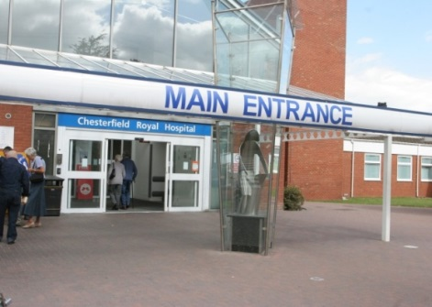
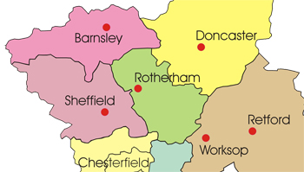


Overview
Welcome to the South Yorkshire Rheumatology registrar training programme. As you know, the 5 year programme combines Rheumatology training with GIM, and rotates through Sheffield Teaching Hospitals, Rotherham Foundation Trust and Doncaster Royal Infirmary/ Bassetlaw. In addition, we have a professorial unit in Barnsley that doesn’t currently have registrars.
Typically trainees undertake “high intensity” GIM training alongside Rheumatology in years 1 or 2. In years 3 & 4 you will train exclusively or mostly in Rheumatology alone, then in your final year train in both specialties (“low intensity” GIM) to fulfil the CCT requirements for dual accreditation. Rheumatology is a multisystem specialty, and this experience in GIM is invaluable for managing your patients in the future. Overall a minimum of 2.5 years GIM is required. You should expect to spend time in each of our training centres.
Currently the StR posts are distributed as follows:
Doncaster (+/- low/ high intensity GIM as required) 1
Rotherham (+/- low/ high intensity GIM as required) 1
Sheffield (pure Rheumatology) 3
The Rheumatology curriculum is delivered through your day-to-day clinical experience in each centre, and supplemented with dedicated StR Training Days [run jointly with the East Midlands Deanery, covering the curriculum over a rolling 3 year programme], and our own regional Postgraduate Rheumatology Meeting [see later sections]. As registrars you are expected to help organise the content & delivery of these meetings, in conjunction with a named supervising Consultant. This provides a valuable learning experience as you go through your training & gives you senior feedback on your performance.
We hope that you enjoy your training here in South Yorkshire. We think it is a lovely part of the world to live in, and we continually strive to provide the highest quality training. There is a strong tradition of support for education in the region, and our commitment to you is taken seriously. Please come and talk to me, or your clinical or educational supervisors if you have any queries or concerns.
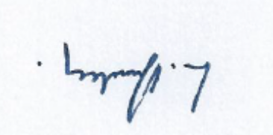
Lisa Dunkley (TPD South Yorkshire)
Lisa.dunkley@sth.nhs.uk
0114 271 1936

Clinical & Educational Supervisors
Educational Supervisor
For the duration of your training, you will be allocated an Educational Supervisor. This will be one of the consultants in the region. You should meet with your Educational Supervisor at the beginning, middle and end of every year (as a minimum). As well as making sure that the “nitty gritty” of the Rheumatology Curriculum is being covered, that you are confident in your clinical work, and that you are making educational progress – your ES will work with you to ensure that throughout your training you keep an “eye on the future.” You should build your experience with your future career aspirations in mind. This might mean identifying a clinical special interest that you would like to organise additional training in. It might mean undertaking a research project with a view to formal time out of programme to pursue this (OOPR=out of programme experience for research). It might mean taking a leadership role on one of the BSR trainees’ committees. Whatever you choose to do to develop your professional role, you should make the most of these training years, as what you do now definitely shapes your career for the future.
Clinical Supervisor
Every year you will be allocated a new clinical supervisor (in addition to your ES), who will be one of the consultants at the hospital where you are working. Their role is to supervise your day-to-day training, and together you need to be happy that you are meeting the targets for training set out in the curriculum, in the gold guide, and on your ePortfolio. When you work in the same hospital as your ES, your ES might be your clinical supervisor for the year. As with your ES, you should meet with your CS at the beginning, middle and end of the year. It is your responsibility to set up these meetings with your ES & CS. We won’t chase you!

ARCPs – Annual Review of Competence Progression
We hold our Rheumatology ARCPs in June every year [hold the date for Thu 7 June 2018]. Your GIM ARCP may be combined with your Rheum ARCP or held separately, usually also in May or June, and you should speak to your GIM TPD Dr Mohsen El Kossi about the details of your GIM training Mohsen.ElKossi@dbh.nhs.uk.
‎We invite all our registrars to attend in person. As we are a relatively small specialty, we feel it is important that you get an opportunity to formally share your training experiences over the year with a panel of senior colleagues. It is your opportunity to share all the hard work you have put in, but also to tell us where improvements to training may be made. You are asked to give a 5 minute powerpoint presentation to include your weekly timetable, courses attended, details from your patient log eg how many patients seen in clinic, number of joint injections of different types performed, audit projects, teaching commitments, presentations given etc etc. A lot of this information will also be available on your ePortfolio but this gives the panel a helpful overview, and also allows you to “sell yourself”.
The annual minimum requirements for ARCP progression are available on your Rheumatology Curriculum ARCP decision aid http://www.jrcptb.org.uk/trainingandcert/ST3-SpR/Documents/2010%20Rheumatology%20ARCP%20Decision%20Aid.pdf .
The 2010 Rheumatology Curriculum (decision aid 2014 version) is your curriculum http://www.jrcptb.org.uk/trainingandcert/ST3-SpR/Pages/Rheumatology.aspx . It doesn’t take that long to read, and is a document that you will need to be very familiar with over the 5 years! Please also read the accompanying JRCPTB Rheumatology pages.
The overall guide to StR training is the “gold guide” http://specialtytraining.hee.nhs.uk/files/2013/10/Gold-Guide-6th-Edition-February-2016.pdf. This contains useful information on what you can expect from us, and is also a useful first point of reference for any queries that may arise during your training. Another very useful source of information is the Yorkshire Deanery website (or Health Education Yorkshire & Humber as we are now correctly called). If you have any queries during your training, from courses available through to advice on time out of programme, acting up as a consultant, less than full-time training etc – you will find useful contacts, FAQs and policy documents here http://www.yorksandhumberdeanery.nhs.uk/.

E Portfolio
You will already be familiar with the ePortfolio from your CMT training. Make sure that you sit down with your ES at the beginning of your training, review your portfolio with them & make sure you understand your way round the various pages. In particular, make sure you sign a “Personal Development Plan” right at the outset. Throughout your training you should be undertaking and uploading work-place based assessments [WPBAs]/ supervised learning events [SLEs] at regular intervals during the course of the year. For each of these, you need to “link” the experience to the relevant sections in the 2010 Rheumatology Curriculum. At your PYA [Penultimate Year Assessment], the external college rep has a long list of procedures and clinical headings taken directly from the curriculum. They have to sign you off as competent under each heading – and use the curriculum links section of your ePortfolio to do this. If you have failed to make links over the 5 years you will have a big task ahead of your PYA, or a long list of mandatory targets to complete in your final year!
Completing WPBAs/ SLEs is your responsibility. You must approach your supervising consultants in ordinary clinics and ward rounds and ask them on the day to complete the relevant section on your ePortfolio. Failure to complete the required number / breadth of assessments will lead to failure to progress at ARCP. All ePortfolio entries must be finalised & submitted for panel review 6 weeks ahead of your ARCP (deadline 01 May 2018). This must include your Educational Supervisor’s report, & they can only write this if you have already met your ARCP targets. Don’t leave it all until the last minute.
One helpful tip is to organise your “personal library” section systematically. For example, set up folders for Audit/ Research/ Teaching/ Patient Log etc separately & upload all relevant material into individual folders OR set up a folder for each year of your training, and subfolders under “audit” etc. The more organised your ePortfolio is, the easier it is to demonstrate competency to the panel. Come and ask me if you are struggling with this.
Patient Log
All trainees are expected to keep a patient log. This should be an anonymised database of patients seen in clinic, on-call, ward reviews, in-patients or ad-hoc extra patients. Upload it to your ePortfolio making sure no patient identifiers are present. Keeping a log is time consuming. To make the task manageable, keep a detailed record of diagnoses of all patients seen for perhaps one out of every 3 or 4 months. For the rest of the time, simply tot up raw numbers of patients eg in February I saw 32 follow-up patients, 15 new patients in clinic, 6 ward reviews and we had 2 inpatients. Keep a record of all joint injections that you do – this could simply be a tally of numbers. We expect you to present all this data at your ARCP. It supplements evidence from your WPBAs.
Study Leave
Study Leave is awarded according to standard Deanery and Gold Guide regulations. There are generic and Rheumatology specific courses that you are expected to attend. There are also GIM courses/ training days that will be covered by your GIM TPD. Your ALS certificate must be valid at all times.
Funding is only awarded for mandatory courses. Generic courses are provided by the Deanery free of charge but you have to apply early via the relevant Deanery webpage http://www.yorksandhumberdeanery.nhs.uk/generic_skills/ . Other courses may well be approved for “leave only” if they are of suitable educational value – you will either have to fund these personally, apply to the Rheumatology Special Fund [formal letter written to Dr Mohammed Akil who manages this fund citing reasons for wanting to attend course] or seek sponsorship.
Generic Deanery Run Courses: Mandatory
Research Methodology/ Research Skills/ Core Module | At least one of these in ST3 or ST4
Teaching and presentation skills | ST4 onwards
Legal & Ethical Issues/ Medical Ethics & Law | One of these during training
Train the Trainers | ST5 onwards
Leadership & Management | Final Year
Good Clinical Practice (for clinical research) | ST3 (contact Sarah Moll, research co-ordinator for enrolment Sarah.Moll@sth.nhs.uk )
There are many other deanery courses available that you may choose to go on if you wish
Rheumatology Specific Courses: Mandatory
BSR Core Course | ST3/4
Yorkshire Deanery Injection Course | ST3
Yorkshire Deanery Rheumatology Emergency Simulation Course | ST4/5
BSR Foot & Ankle Course | ST4/5 (book early as this is often oversubscribed)
BSR Autumn Conference | Once in your 5 years (any year)
BSR Basic USS Course | ST4/5
“Ten Topics” in Rheumatology | ST3/4 (St Thomas’ London, Lupus Unit. SpRs attend for nominal fee if apply early)
BSR Annual Conference (usually April/ May) | Funding available for 2 visits in 5 years
Again there are many other good courses available including the EULAR on-line courses, but these will not be funded from the Deanery. Do make use of the Rheumatology Special Fund (for training) where you can.

Study Leave forms
See: http://www.yorksandhumberdeanery.nhs.uk/pgmde/policies/curriculum_delivery/study_leavecurriculum_delivery/Forms need to be completed for all the above. They should be signed off by your rota co-ordinator & clinical supervisor to ensure your daytime duties are adequately covered. They should then be forwarded to me for signature as TPD (referred to in the form as SSLA Specialty Study Leave Advisor)/ forwarded to “Study Leave Support”, Medical Education Centre, NGH who will in turn forward your forms on to me for approval. Please do not give me GIM forms – these need to go to Dr El Kossi.

Registrar Training Days
SpR Training Days are run together with the E Midlands Deanery. The programme for the next 2 years is given below. The programme covers the Rheumatology Curriculum over a 2 year period, so that there are at least 2 opportunities to attend teaching on any given subject during your 5 year training.
Attendance is mandatory for all S Yorks SpRs, except the registrar doing high intensity general medicine [if they are on-call for GIM]. All other SpRs should be released from clinical duties. If there are any difficulties with this – direct your queries to me. In Sheffield, it has been agreed that the on-call will be covered by the Consultant but it is your responsibility to flag this up to the relevant consultant at least 8 weeks in advance, and also to notify switchboard and the wider Rheumatology clinical MDT/ admin & secretarial staff. An attendance register is taken on the day and submitted to all the relevant TPDs.
In every centre, it is also your responsibility to cancel clinics as far in advance as possible (ie now!) and let your consultant and nursing colleagues know that you will not be available that day. You still need to complete a local Study Leave form.
The programme is co-ordinated by two senior trainees. Based in South Yorkshire is Dr Sameena Khalid (sameenakhalid@nhs.net) and for E Midlands is Dr Lit Hiang Lee. The E Midlands TPD, Dr James Francis (james.francis@uhl-tr.nhs.uk), also keeps an overview.
Exact dates will be confirmed asap:

Rheumatology SPR Training Days
Date | Region | 2015/2017
August 2015
September 2015 | Nottingham | Cancelled – rearranged March 2016
23 October 2015 | Northampton | SLE  Wrist/hand
9 October 2015 | MRS
25 November 2015 | Uveitis Study Day, Sheffield
26 November 2015 | Sheffield | Systemic Sclerosis  Pregnancy & Rheumatic disease
December 2015
28 January 2016 | Doncaster | Behcets  Shoulder/Elbow
No SPR training day in February
10 March 2016 | Sheffield | RARE day
18 March 2016 | MRS
23 March 2016 | Nottingham | ANCA vasculitis  What to expect as a consultant
April 2016
May 2016 | Cancelled | Leicestor - rescheduled
3 June 2016 | Leicester | Takayasu’s Arteritis, Kawasaki’s, PAN  Dermatology
15 July 2016 | Kettering | Crystal arthritis  Osteoarthritis
August 2016
8 September 2016 | Sheffield | Sports and Exercise Medicine Day
21 October 2016 | Northampton  MRS | Adult onset stills disease / Sarcoidosis  Radiology
24 November 2016 | Sheffield | Management / Becoming a consultant  Neurology
December 2016
January 2017 | Nottingham | Polymyositis/ Dermatomyositis  Immunology (incl auto inflammatory syndromes)
February 2017 | Derby | Rheumatoid arthritis  Renal
March 2017 | Lincoln | Seronegative inflammatory arthritis  Haematology
April 2017
May 2017 | Leicester | Metabolic Bone disease & osteoporosis  Hip/Knee
June 2017 | Mansfield | Adult onset stills disease / Sarcoidosis  Radiology
July 2017 | Kettering | Relapsing Polychondritis  Radiology

South Yorkshire Regional Rheumatology Postgraduate meeting [PGM]
This runs on a Thursday afternoon from 2-5pm on the 2nd and 4th weeks of the month. The host site rotates between hospitals in the region and venue is variable. An up-to-date timetable can be obtained from Tania.Damms@sth.nhs.uk.
The 2018 timetable is below. Please note that changes are commonly made, so do check with Tania for the latest version. Also ask Tania to add your email address to the PGM distribution list.

Date  (Thurs 2018) | Cons/ SpR Leads | Curriculum Topic
11 Jan | Dunkley/ Croot/ Jade/ | RA incl. JAK inhibitors & surgical approaches
25 Jan | Doncaster NTRM
8 Feb | Kuet/ Smith | Respiratory presentations of rheumatic disease
22 Feb  (Half term Sheffield) | Fawthrop/ Smith | Crystal arthropathy and OA
8 Mar | Coote/ Jade | PMR/ GCA
22 Mar | Rotherham NTRM & SpR Training Day  Trainer’s meeting (lunchtime 1pm-2.15pm) | Seronegative SpA  Elbow/ shoulder incl. physio  Afternoon = NTRM (case-based)
12 Apr | Easter holidays Sheffield  No meeting here
26 Apr | Tattersall/ SpR team | SpR presentation afternoon/ Regional audit/ Research, QIMP &audit afternoon for all
[BSR Liverpool 1-3 May]
10 May | MA/ RFK/ Haque/. SHO team  Remote ARCP reviews – involves LAD/ RK/ WG only + academic rep | Renal disease & pregnancy in rheumatic disease
24 May  (not half term) | Barnsley NTRM
[7 June | ARCP Face to Face reviews – this is only of interest to SpRs and those on ARCP panel ie LAD/ WG/ RK +/- academic rep
14 June  [EULAR Amsterdam 13-16 June] | Paediatric/ transition team  SCH/ RHH  AMM/ DH/ LAD/ RST | Adolescent and transitional Rheum
28 June | Hughes/ Jade | Scleroderma/ other CTD
12 July | Grant/ Haque | GI disease related to Rheumatology  +/- utility of USS in Rheum/ real-life data from an USS clinic?
26 July | Kumari/ Haque | SLE
13 Sep | Chesterfield NTRM  With Trainer’s meeting prior (commencing at 1pm)
27 Sep | Carter/ Haque | Auto-inflammatory diseases & emerging treatments
11 Oct | Combined Dermatology Meeting
[ACR Chicago 19-24 Oct]
25 Oct  (not half term) | Kazmi/ Jade | Upper limb presentations/ treatment
8 Nov | Mathew/ Smith | Neurological presentation of Rheumatic disease
22 Nov | Sheffield SpR Training Day/ Sheffield NTRM  Dunkley am  Sheff Team pm (JRM) | PM/DM  Ophthalmology  PM = Sheffield NTRM
13 Dec | Dr Amos | Xmas Meeting

Much like the SpR training days, the Rheumatology Curriculum is covered on a rolling 2-3 year programme, running January to January. Dr Dunkley co-ordinates the programme. Attendance is expected at a minimum of 70% sessions, and a register is kept. Annual attendance certificates are issued.
The format for the programme is that a named SpR and Consultant are responsible for putting on the programme each time. The onus is on the SpR to contact the supervising consultant about 6 months in advance to begin putting the programme together. The focus is on clinical cases, presenting patients in person if relevant/ appropriate, and a topic update based on the latest peer-reviewed evidence. You do not have to do all the presenting! In fact, it is much better if you invite additional speakers, maybe from within your own hospital, or even better, external speakers. The earlier you start to plan this, the greater the likelihood that you will secure good speakers in advance [& that makes life much easier for you].
The standard of presentations and information presented is expected to be high. Include your patient’s imaging and clinical photographs. Use video. Take time to produce slides of high quality. Do a proper literature review and present a brief summary of the “headlines” from this. Make sure you run through your presentation(s) with the supervising consultant ahead of the day.
Periodically (usually once a year) you will be given some formal written feedback on your performance on the day by one of the regional consultants. This is designed to be a formative educational process so that you can improve your presentation skills as time goes by. It can be uploaded to your ePortfolio as a “teaching assessment”.

Academic Work, Audit, Research
Throughout your training we expect & encourage you to actively pursue academic interests over and above your clinical work. For some of you, this might lead to time out-of-programme [OOPR] working on a specific project for a year, or maybe leading to a higher degree [PhD]. For others, this will be work undertaken alongside clinical work.
Discuss this with your Educational Supervisor at an early stage. What do you want to do? Time passes very quickly, and it is easy to fall into the trap of approaching consultant interviews and wishing you had more “stuff” to put on your application form. Like it or not, extra-curricular work often makes the difference between being successful in securing a consultant post of your choice, or not. Moreover, academic work will make you a better clinician – the ability to question an area of clinical practise, then set up an audit/ service evaluation/ undertake research to answer your question – is the basis of successful lifelong learning. We all need to question and evaluate what we do.
You are all given a half day per week on your timetable for research. You need to take this time. You are not expected to cover clinical duties during this time except in exceptional circumstances. Utilise this time right from Day 1. If you don’t protect the time, no-one else will protect it for you.
In central Sheffield, there should always be at least one other SpR to hold your bleep. You are not on-call on your research day. You can leave the building if another SpR is on duty (and this should be almost all the time).
In other centres, check the local arrangements with your clinical supervisor.
The quid pro quo is that we expect to see results! Once a year, we will ask you to present your audit/ service evaluation/ research data to the PGM.
What do we mean by “academic work”?
This could be de novo research. Regional interests include connective tissue disease, early arthritis, paediatric and adolescent medicine, sports medicine, qualitative research, educational research & service improvement. Ask your Educational Supervisor to point you in the right direction.
Get involved in NIHR portfolio clinical studies. All the local centres participate in portfolio studies. There is a Local Specialty Group [LSG] for Rheumatology Research chaired by James Maxwell James.Maxwell@sth.nhs.uk. You will need your GCP certificate to participate as sub-PI (sub Principal Investigator) on a study – but this is good experience.. In Sheffield, you have the opportunity to spend your research half day in the Clinical Research Facility (CRF) on O Floor, where you could undertake screening and assessment of patients participating in Rheumatology trials. Speak to your ES or Dr Akil as research lead if you are interested in this.
Get writing! If you’ve seen an interesting patient with an unusual condition/ complication or if a senior colleague offers you the opportunity to write up a series of patients they’ve had “on the back burner” – seize the opportunity. Published papers, letters to journals, posters/ oral presentations at conferences all count. Once you get started, it becomes easier and less daunting. Look at posters when you attend meetings/ conferences – they are truly not rocket science in the most part. Ask your consultants to show you examples of their previous posters/ publications.
Audit/ Service Evaluation – a good audit or service evaluation can be published/ presented. Take an idea to your local audit office, complete the approval form and get going. We have an established programme of Regional Audit to which all SpRs contribute.

British Society for Rheumatology [BSR]
If you have not already, now is probably a good time to consider joining the BSR. You will receive information about the BSR courses, reduced rates to attend the annual conference, but more importantly, this is our national professional body. They do an enormous amount of work to improve clinical care, provide CPD opportunities for us & engage with an ever-changing political landscape. Many of us continue to have active roles within the BSR, or have done so in the past.
It is possible to get involved as a trainee. Contact the‎, chair of BRITS [British Rheumatologists in Training], to be included on the email distribution list for Rheumatology Trainees. You will receive updates on training developments, courses, future jobs etc. BRITs meet every year at the BSR conference, so make the time to attend. There are trainee reps on most BSR committees - this is a useful insight into the workings of the BSR & national issues – if you are interested, put your name forward for one of these roles.
British Society for Rheumatology http://www.rheumatology.org.uk/

Dec 2017

The Sheffield Teaching Hospitals
NHS Foundation Trust

Rheumatology Department

INJECTIONS HANDBOOK

A Guide for SpRs and SHOs

June 2010

Indications
Joint Aspiration:
- Effusion (inflammatory / OA / crystals)
- Haemarthrosis
- Diagnostic:
  - Infection
  - Crystals
  - Cellularity

Joint Injection:
- Persistent synovitis / recurrent effusion
- Reduced range of movement
- Pain (osteoarthritis)
- Haemarthrosis (aspirate to dryness first)

Contraindications
- Joint infection: clinical suspicion or if aspirated fluid is very opaque or greenish – send fluid for culture and do not inject
- Prosthetic joint
- Local infection:
  - Skin infection at site of injection
  - Cellulitis or leg ulcers on same limb
  - Psoriasis or eczema at injection site (likely to be colonised with bugs)
- Severe systemic infection e.g. pneumonia, SBE
- Same joint previously injected within previous 3 months (although if severe persistent synovitis sometimes 2 injections within 3 months may be required)
- Frank blood aspirated: suggests trauma or bleeding diathesis, although steroid injection is often used in haemarthrosis associated with haemophilia (seek advice from senior)
- Raised INR due to Warfarin (>2.5) or bleeding diathesis
- Drug allergy
- End stage OA – unlikely to be helpful
- Within 2-3 months prior to joint replacement (depending on surgeon involved)

Warnings for Patient
- Pain during injection
- Joint infection
  - This is a rare but serious complication
  - Occurs in 1 in 78,000 injections (this is less than 1 infection per rheumatologist in their entire career)
- Flushing: 12%
- Transient increased pain and stiffness of the joint (flare): 15%
- Thinning of subcutaneous tissues around the injection site: very rare
- Depigmentation of the skin around the injection site: very rare
- Absorption of the steroid into the body may occur – this could cause generalised side effects from the steroid e.g. increased blood sugars, weight gain, thinning of bones – this would only be an issue if many joints are injected frequently
- Drug allergy
- Inefficacy
- Recurrence of symptoms
- Increased blood glucose in brittle diabetics
- Tendon rupture if intratendinous injection given

Drugs Used
Hydrocortisone:
- Short-acting
- Less likely to cause skin atrophy or depigmentation
- Less potent
- May be better for soft tissue or injections close to the skin

Depo-Medrone (Methylprednisolone)
- Long-acting
- More potent
- Also comes ready mixed with Lidocaine

Kenalog (Triamcinolone)
- Long-acting
- More potent

Lidocaine
- Can use 1 or 2% mixed with Depo-Medrone or Kenalog – gives faster pain relief, may reduce the incidence of flares and can aid diagnosis (differentiating if pain is coming from joint)

Marcaine (bupivacaine)
- Longer-acting local anaesthetic used for nerve blocks

Patient Positioning
This obviously varies for each type of injection, but it is very important that you and the patient are relaxed and comfortable in case the injection takes longer than planned. The patient should be able to relax the muscles at the site of injection (reduced pain and makes injection easier).

Aseptic Technique
- Wash hands thoroughly
- Palpate joint and decide where you are going to inject
- Mark the injection site with pen or indent with your fingernail
- A refrigerant spray can be used to numb the skin
- Clean area with alcohol wipe or cleaning solution e.g. 1% Chlorhexidine
- Do not open needle or syringe until immediate before use
- Do not touch area again before injecting
- Use a 21g (green needle) for all knees and shoulders if obese and if aspiration is required
- Cover with plaster (keep on 24°)

Needle Size

White (19g) | Aspirating thick fluid e.g. suspected sepsis or haemarthrosis in a large joint and no fluid obtained using green needle
Green (21g) | Aspiration of joints (except small hand/foot joints)  Injection of knees  Injection of shoulders  Trochanteric bursa (use extra-long needle if obese)
Blue (23g) | Soft tissue injections and nerve blocks  Injection of all joints except knee
Orange (23g) | Injection of small hand/feet joints

Needle Placement
Signs that you are in a joint:
- Decreased resistance to needle advancement
- Able to aspirate fluid
- Little resistance to injection of drug (do not inject against resistance as you may be in a tendon or ligament)

Signs that you are in a tendon/ligament (do not inject)
- Difficult to advance needle
- Resistance to injection

Macroscopic Appearance of Synovial Fluid
Normal / non-inflammatory SF:
- Pale yellow, appears clear
- Few cells & little debris
- Viscous (shake fluid to create bubbles – if the bubbles rise slowly the fluid is viscous and is unlikely to be inflammatory)
- Does not clot

Inflammatory Fluid:
- Decreased viscosity
- Increased turbidity (impossible to read print through it)
- Deepening colour (yellow/orange/green)
- Spontaneous clot formation
- Blood staining common (mainly due to trauma & therefore not uniformly mixed with fluid)
- Rice bodies can be seen in severe synovitis (RA)

Infected:
- Looks like pus: thick, can be yellow / green
- Do not inject steroid if possibility of infection
- Send fluid to lab in plain universal container – mark as urgent, ring lab and chase up result – septic joints require urgent treatment
- If infected joint is strongly suspected and fluid cannot be obtained, consider injecting the joint with saline and re-aspirating. Alternatively seek an ultrasound guided aspiration.

Uniformly blood-stained:
- Common causes:
  - Trauma
  - Severe inflammatory or destructive arthropathy:
- Pyrophosphate arthropathy
- RA
- Sepsis
      - Uncommon causes:
- Bleeding disorder (haemophilia, Warfarin)
- PVNS
- Abnormal blood vessels

Sending Fluid for Analysis
Suspected Sepsis:
If sepsis is considered, send fluid to lab in a plain universal container – mark as urgent, ring lab asking for urgent microscopy/culture and chase up result – septic joints require urgent treatment. Initial microscopy and gram stain can be negative even in the presence of sepsis. In most cases treat with antibiotics until culture result is known.

- If lots of fluid is obtained, additional fluid can be inoculated directly into blood culture bottles.
- If infected joint is strongly suspected and fluid cannot be obtained, consider injecting the joint with saline and re-aspirating. Alternatively seek an ultrasound guided aspiration.
- Specific examination and culture for TB is indicated in certain cases. Although false negatives can occur and synovial biopsy may be required if high index of suspicion.

Crystals:
- Fluid can be sent to microbiology for examination for crystals (plain universal container). However they are often missed. Therefore a negative result does not rule out crystal disease.

- Examination for crystals is on the SpR curriculum.
  - Urate: needle shaped, negatively birefringent
  - Calcium pyrophosphate: short and thick, negatively birefringent

Cellularity:
- Cellularity of synovial fluid can sometimes aid diagnosis (inflammatory vs degenerative) – send to microbiology for microscopy in a plain universal container. Alternatively a sample can be sent in an EDTA (FBC) container (ring lab first to check).
- In general in cell count and proportion of polymorphs increases with inflammation:
  - >90% polymorphs suggests acute crystal synovitis, acute sepsis or active RA
  - <50% polymorphs suggests OA or mechanical derangement
  - Marked monocytosis reflects viral infection (hep B, rubella) or serum sickness

Cytology:
- Rarely required – PVNS

Post Injection Advice
- The joint may be painful for up to 24 hours post injection
- It may take several days for benefit to occur
- The injected joint should be rested 24 hours: day off work, minimal walking, wear splint etc.
- If increased pain, swelling or pain beyond 48 hours – patient needs to contact GP or the department.

The following pages describe some of the most common injections in detail. For further examples look at the Leeds handbook on the deanery website http://www.yorksandhumberdeanery.nhs.uk/medicine/rheumatology/west_east/

Wrist: Radiocarpal Joint

Indication:
Persistent synovitis
Effusion (aspirate fluid before injection)
Reduced range of movement
Pain (osteoarthritis)
Diagnostic (aspiration)

Alternatives / Additional Therapies:
Increase DMARD
Increase analgesia
Physiotherapy & splints
USS-guided injection

Warnings for Patient:
Pain, joint infection, flushing, flare, skin atrophy, skin depigmentation, steroid absorption, allergy, inefficacy and recurrent of symptoms

Drugs:
Depo-Medrone 40mg or Kenalog 20mg
+/- 1ml 1-2% Lidocaine

Technique:
Place the patient’s hand on a pillow or rolled-up towel so that the wrist joint is slightly flexed (25°). Feel for the gap between the end of the radius and the lunate and scaphoid bones. Using a blue needle and septic technique introduce the needle into the joint perpendicular to the skin. Aspirate any fluid present and inject.

Post Injection Care
Rest for 24 hours
If increased pain, swelling or pain beyond 48 hours – patient needs to contact GP or department.

Elbow: Joint – Posterior Approach

Indication:
Persistent synovitis
Effusion (aspirate fluid before injection)
Reduced range of movement
Pain (osteoarthritis)
Diagnostic (aspiration)
Alternatives / Additional therapies:
Increase DMARD
Increase analgesia
Physiotherapy & splints
USS-guided injection
Warnings for Patient:
Pain, joint infection, flushing, flare, skin atrophy, skin depigmentation, steroid absorption, allergy and inefficacy
Drugs:
Depo-Medrone 40mg or Kenalog 20mg
+/- 1ml 1-2% Lidocaine

Technique:
Flex elbow to 90° and feel the depression in the midline at the back of the elbow, between the two halves of the triceps tendon. Use a blue needle and aseptic technique. Place the needle just above the olecranon process into the elbow joint at the olecranon fossa. Aspirate any fluid present and inject.

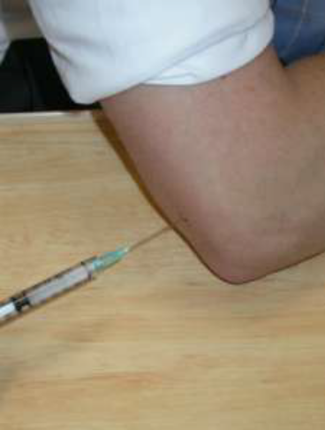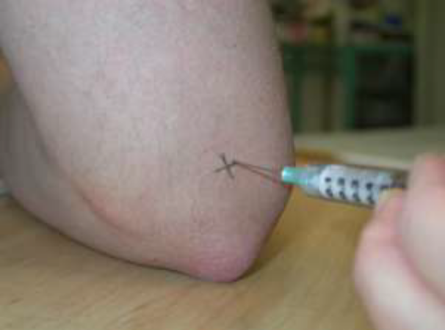

Post Injection Care
Rest for 24 hours
If increased pain, swelling or pain beyond 48 hours – patient needs to contact GP or department.
Shoulder: Subacromial Bursa

Indication:
Pain on abduction / painful arc
Impingement
Calcific tendonitis
Synovitis (RA)
Effusion (aspirate fluid before injection)
Diagnostic (aspiration)
Alternatives / Additional therapies:
Increase analgesia
Physiotherapy
USS-guided injection
Warnings for Patient:
Pain, joint infection, flushing, flare, skin atrophy, skin depigmentation, steroid absorption, allergy and inefficacy
Drugs:
Depo-Medrone 40mg or Kenalog 20mg mixed with 1-2ml of 1-2% Lidocaine.
A large volume is required to ensure the bursa (which has a large potential space) is adequately filled.
Technique:
Ask the patient to sit with their elbow flexed and their hand in their lap so that the muscles of the shoulder are relaxed.
Palpate the coracoacromial arch and feel for the gap between the acromion and humeral head (posterolateral). Using a blue needle (or longer green needle in obese patients) and aseptic technique, aim the needle towards the centre of the head of the humerus (can be felt anteriorly). Very little resistance to injection should be felt.
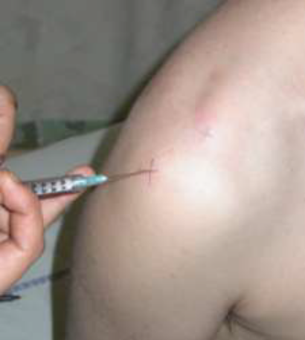

Post Injection Care
Rest for 24 hours
If increased pain, swelling or pain beyond 48 hours – patient needs to contact GP or department.
Shoulder: Glenohumeral Joint

Indication:
Adhesive capsulitis (often combined with a SAB injection)
Pain on internal / external rotation
Synovitis (RA)
Effusion (aspirate fluid before injection)
Diagnostic (aspiration)

Alternatives / Additional Therapies
Increase DMARD
Increase analgesia
Physiotherapy
USS-guided injection

Warnings for Patient:
Pain, joint infection, flushing, flare, skin atrophy, skin depigmentation, steroid absorption, allergy and inefficacy

Drugs:
Depo-Medrone 40mg or 20mg Kenalog
+/- 1-2ml 1-2% Lidocaine

Technique:
Posterior Approach:
Ask the patient to sit with their elbow flexed and their hand in their lap so that the muscles of the shoulder are relaxed.
Indentify the coracoid process in the front and the joint line at the back. The site of injection is 1.5cm inferior and medially to the acromion. Use a blue needle (or longer green needle in obese patients) and aseptic technique.

Post Injection Care
Rest for 24 hours
If increased pain, swelling or pain beyond 48 hours – patient needs to contact GP or department.

Knee

Indication:
Persistent synovitis
Effusion (aspirate fluid before injection)
Reduced range of movement
Pain (osteoarthritis)
Diagnostic (aspiration)
Neuropathic pain
Baker’s cyst (intact or ruptured)

Alternatives / Additional therapies:
Increase DMARD
Increase analgesia
Physiotherapy (if decreased range of movement or OA, quadriceps wasting)
Local infiltration of painful areas around the knee e.g. collateral ligament insertion in an unstable knee.

Warnings for Patient:
Pain, joint infection, flushing, flare, skin atrophy, skin depigmentation, steroid absorption, allergy and inefficacy

Drugs:
Depo-Medrone 80mg or Kenalog 40mg
+/- 1-2 ml 1-2% Lidocaine

Technique:
Can be injected from lateral or medial side of patella
The site of injection is ⅓ down from top of patella
A gap between the patella and the femur should be felt at this site
If the needle is in the joint, you should be able to aspirate fluid
Use a green needle and aseptic technique

Post Injection Care
Rest for 24 hours
If increased pain, swelling or pain beyond 48 hours – patient needs to contact GP or department.

Ankle: Tibiotalar joint

Indication:
Persistent synovitis
Effusion (aspirate fluid before injection)
Reduced range of movement (foot dorsi/plantar flexion)
Pain (osteoarthritis)
Diagnostic (aspiration)

Alternatives / Additional Therapies:
Increase DMARD
Increase analgesia
Physiotherapy / orthotics

Warnings for Patient
Pain, joint infection, flushing, flare, skin atrophy, skin depigmentation, steroid absorption, allergy and inefficacy

Drugs:
Depo-Medrone 40mg or Kenalog 20mg
+/- 1ml 1-2% Lidocaine

Technique:
As the patient to dorsiflex the foot so as to put the tibialis anterior tendon on the stretch. Palpate just immediately laterally to it the space between the tibia and the talus. Avoid the anterior tibial artery. Use a blue needle and aseptic technique. Angle the needle slightly cranially.

Post Injection Care
Rest for 24 hours
If increased pain, swelling or pain beyond 48 hours – patient needs to contact GP or department.

Hand: Interphalangeal Joints

Indications:
Persistent synovitis
Effusion (aspirate fluid before injection)
Reduced range of movement
Pain (osteoarthritis)
Diagnostic (aspiration)
Alternatives / Additional Therapies:
Increase DMARD
Increase analgesia
Physiotherapy & splints
USS-guided injection
Warnings for Patient
Pain, joint infection, flushing, flare, skin atrophy, skin depigmentation, steroid absorption, allergy, recurrence of symptoms and inefficacy
Drugs:
Depo-Medrone 10mg or Kenalog 5mg
Technique:
Make sure patient is comfortable so can sit still for 5-10 minutes
Place hand on pillow
Gradual traction on end of finger, PIPJ flexed at 45°
Use 1ml syringe, an orange needle and aseptic technique
Aim the needle tangentially to the joint underneath the extensor expansion
Aspirate any fluid present
Inject gently and slowly (may need to inject v small amounts at a time e.g. 0.1ml with a short break between each push)
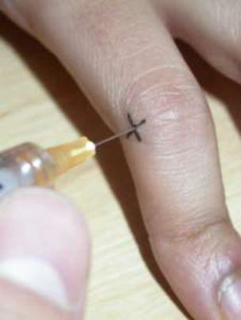

Post Injection Care
Rest for 24 hours
If increased pain, swelling or pain beyond 48 hours – patient needs to contact GP or department.

Hand: MCPs

Indications:
Persistent synovitis
Effusion (aspirate fluid before injection)
Reduced range of movement
Pain (osteoarthritis)
Diagnostic (aspiration)
Alternatives / Additional Therapies:
Increase DMARD
Increase analgesia
Physiotherapy & Splints
USS-guided injection
Warnings for Patient
Pain, joint infection, flushing, flare, skin atrophy, skin depigmentation, steroid absorption, allergy, recurrence of symptoms and inefficacy

Drugs:
Depo-Medrone 10mg or Kenalog 5mg
+/- 0.5ml 1-2% Lidocaine
Technique:
Make sure patient is comfortable so can sit still for 5-10 minutes
Place hand on pillow
Gradual traction on end of finger, MCPJ flexed at 45°
Note that the joint line is approximately 1cm beyond the crest of the knuckle
Use 1ml syringe, an orange needle and aseptic technique
Aim the needle tangentially to the joint underneath the extensor expansion
Aspirate any fluid present
Inject gently and slowly (may need to inject v small amounts at a time e.g. 0.1ml with a short break between each push)
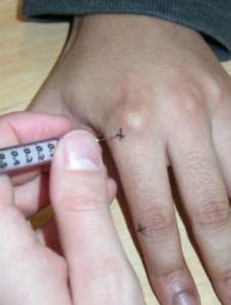

Post Injection Care
Rest for 24 hours
If increased pain, swelling or pain beyond 48 hours – patient needs to contact GP or department.
Hand: Flexor Tendon Nodules

Indication:
Palpable nodules causing trigger finger

Alternatives / Additional Therapies:
May settle spontaneously in some cases

Warnings for Patient
Pain, infection, flushing, flare, skin atrophy, skin depigmentation, steroid absorption, allergy, recurrence of symptoms and inefficacy

Drugs:
Hydrocortisone 12.5mg - 25mg
Depo-Medrone 10mg or Kenalog 5mg

Technique:
Make sure patient is comfortable so can sit still for 5-10 minutes
Place hand on pillow, palm side up
Use 1ml syringe, an orange needle and aseptic technique
Inject in the direction of the patient’s wrist
Advance the needle until finds a space where the injection proceeds without much resistance.
May be helpful to remove the syringe from the needle and advance it slowly until a point is reached when the needle tilts as the finger is flexed, the needle is withdrawn slightly and the injection made.
Do not inject against resistance as you may be injecting into the tendon itself.

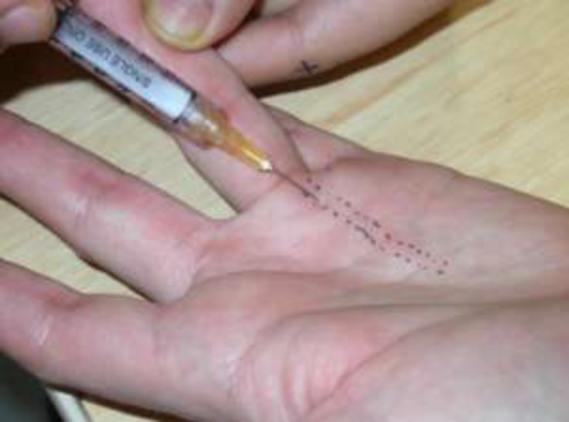

Post Injection Care
Rest for 24 hours
If increased pain, swelling or pain beyond 48 hours – patient needs to contact GP or department.
Hand: First CMC Joint

Indications:
Pain (osteoarthritis) – majority of cases
Persistent synovitis
Effusion (aspirate fluid before injection)
Reduced range of movement
Diagnostic (aspiration)

Alternatives / Additional Therapies:
Increase DMARD
Increase analgesia
Physiotherapy & Splints
USS-guided injection

Warnings for Patient
Pain, joint infection, flushing, flare, skin atrophy, skin depigmentation, steroid absorption, allergy, recurrence of symptoms and inefficacy

Drugs:
Depo-Medrone 40mg or Kenalog 20mg
+/- 1ml 1-2% Lidocaine
Technique:
Distract the thumb with your free hand. Feel for the joint line at the base of the thumb mark accordingly. Using an orange needle and 1ml syringe and introduce the needle perpendicular to the skin.
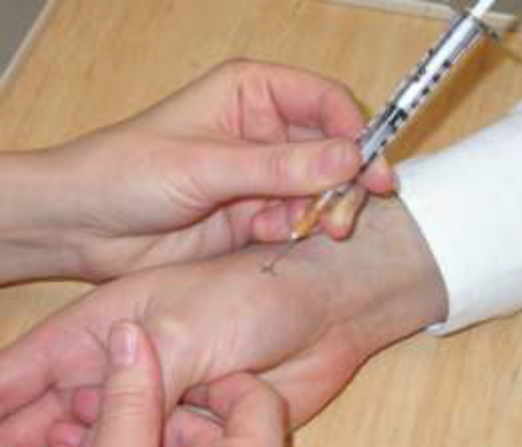

Post Injection Care
Rest for 24 hours
If increased pain, swelling or pain beyond 48 hours – patient needs to contact GP or department.

Wrist: Carpal Tunnel Injection

Indication:
Symptoms of median nerve compression

Alternatives / Additional Therapies:
Splints
Surgery

Warnings for Patient
Pain, infection, flushing, flare or CTS symptoms, skin atrophy, skin depigmentation, steroid absorption, allergy, inefficacy and recurrence of symptoms.

Drugs:
Depo-Medrone 20mg or Kenalog 10mg or Hydrocortisone 25mg
+/- Lidocaine

Technique:
The median nerve lies just underneath the tendon of the palmaris longus muscle. The injection site is just lateral to the tendon (or the midline if no tendon is present) at the level of the distal palmar crease. Use an orange needle and aseptic technique. Aim the needle down at 45° into the palm in the direction of the index finger. Insert the needle 1cm.

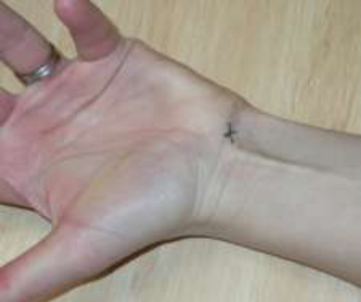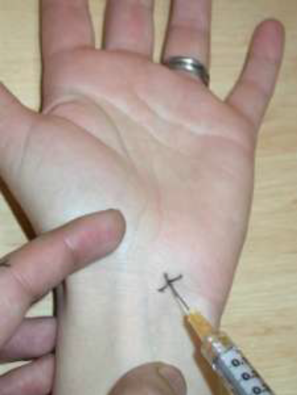

Post Injection Care
Rest for 24 hours
If increased pain, swelling or pain beyond 48 hours – patient needs to contact GP or department.

Elbow: Radio-Humeral Joint

Indications:
Persistent synovitis
Effusion (aspirate fluid before injection)
Reduced range of movement
Pain (osteoarthritis)
Diagnostic (aspiration)

Alternatives / Additional Therapies:
Increase DMARD
Increase analgesia
Physiotherapy & Splints
USS-guided injection

Warnings for Patient
Pain, joint infection, flushing, flare, skin atrophy, skin depigmentation, steroid absorption, allergy and inefficacy

Drugs:
Depo-Medrone 40mg or Kenalog 20mg
+/- 1ml 1-2% Lidocaine

Technique:
Flex elbow to 90°. Feel the head of the radius at the radiohumeral joint by pressing with your thumb and rotating the patient’s forearm with your other hand. Aspirate and inject tangentially into the joint.

Post Injection Care
Rest for 24 hours
If increased pain, swelling or pain beyond 48 hours – patient needs to contact GP or department.

