Training and Development Manager (TDM) v2 trainee information

Introduction
Training and Development Manager (TDM) v2 is the self-service portal, integrated into Blackboard, where trainees create their accounts, enrol onto courses, and access their certificates for completed courses.
This guide will take you through accessing TDM v2, creating your profile, accessing the catalogue and enrolling onto courses, accessing a course you enrolled onto, accessing your certificates, unenrolling from a course and joining a waiting list. We will also cover updating your profile as you will need to do this each time your training grade changes.
If you have any issues at any point, please contact the team for assistance at england.regionalteaching.yh@nhs.net

Part 1: Creating your profile
1.1 To access the sign-up page, you will need to use the following link to launch TDM v2: https://hee.blackboard.com/webapps/consulting-central/app/launch/TDMv2
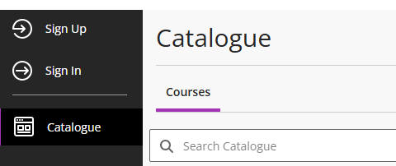
1.2 This will open a sign-up page. You will need to complete the fields marked with a red *
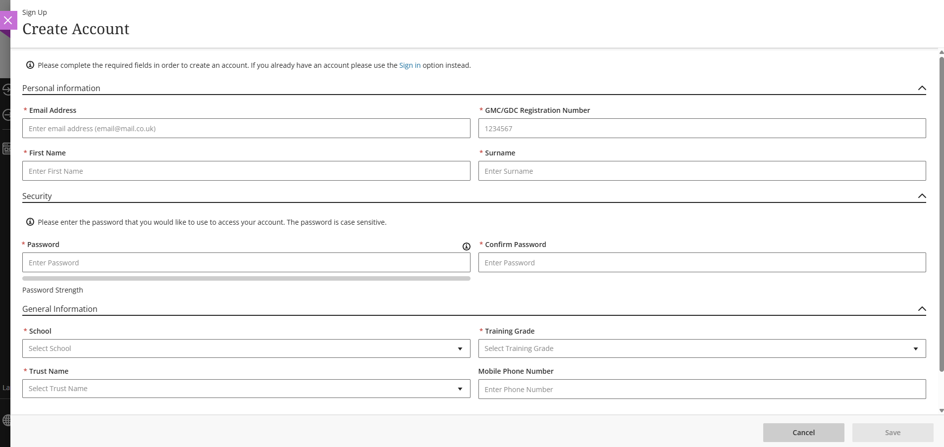
Please note that when you are creating a password, it needs to be at least 12 characters long, be alphanumeric with at least one capital, and contain a special character. For example, ‘Welcome2025!’ would work.

1.3 Once you have completed the form, click save in the bottom right corner of your screen. You will then be sent an automated email containing a unique code to validate your email address and complete the set-up of your account.

Part 2: Accessing TDM v2 once you have an account
2.1 There are two ways of accessing TDM v2 once your account has been created. It can be accessed directly using the following link: https://hee.blackboard.com/webapps/consulting-central/app/launch/TDMv2 or it can be launched through the main Blackboard Learn platform.
2.2 To access TDM v2 via Blackboard Learn, please access Blackboard using your school’s link from the table below.
Anaesthesia and ICM | heeyhanaesthetics.blackboard.com
Dental | heeyhdental.blackboard.com
Emergency Medicine | heeyhemergencymedicine.blackboard.com
Foundation | heeyhfoundation.blackboard.com
General Practice | heeyhgeneralpractice.blackboard.com
Histopathology | heeyhpathology.blackboard.com
Medicine | heeyhmedicine.blackboard.com
Obstetrics and Gynaecology | heeyhobsandgynae.blackboard.com
Ophthalmology | heeyhophthalmology.blackboard.com
Paediatrics | heeyhpaediatrics.blackboard.com
Psychiatry | heeyhpsychiatry.blackboard.com
Radiology | heeyhradiology.blackboard.com
Surgery | heeyhsurgery.blackboard.com

2.3 If accessing TDM v2 via blackboard, once you have opened the landing page, please navigate to ‘Catalogue’ on the left-hand side menu on the landing page (please note that each School’s landing page will look different, but the side menu will remain the same). This will launch a new window and open TDM v2 for you.
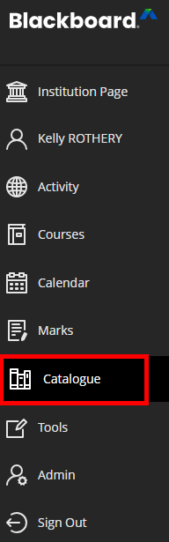

Part 3: Accessing the course catalogue and enrolling onto a course
3.1 To enrol onto a course, click on Catalogue on the left-hand menu. This will take you to the latest version of the course catalogue
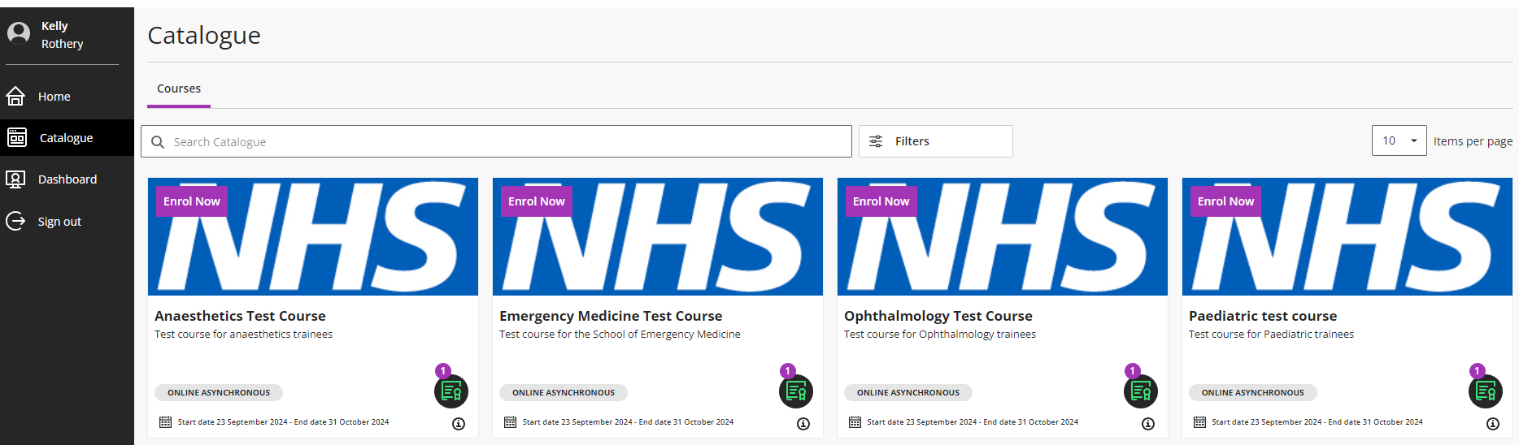
3.2 To find courses relevant to your training, click on ‘Filters,’ this will open a drop-down window in which you can search courses by school (categories), training grade (tags), type of course (modality), course dates, and availability.
The main ones you will need to use are categories and tags, as courses are visible only to users from the appropriate school and at the correct training grade.
3.3 Select your school (from the categories list) and training grade (from the tags list) to filter the catalogue and then click ‘Apply Filters’.
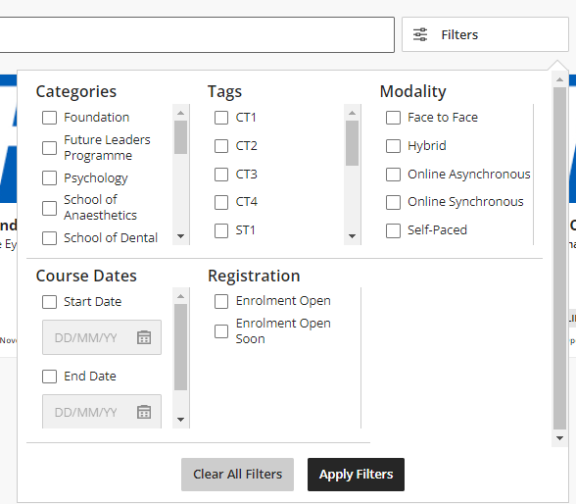
3.4 To enrol onto a course, click on the thumbnail of the course you want to enrol onto. This will open the course information page.
Click ‘Enrol Now’ to add yourself onto the course.
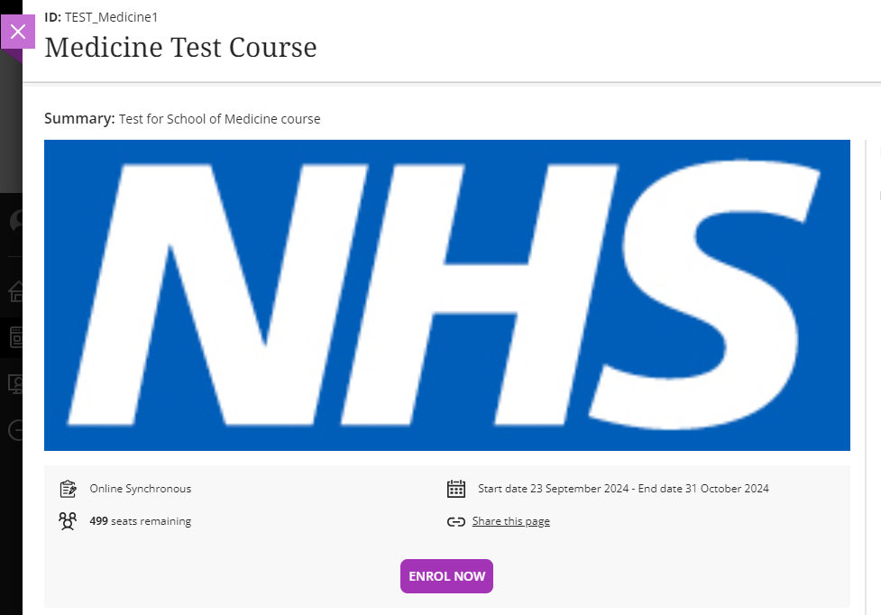
3.5 You will receive an email confirming that you have been enrolled onto the course.

Part 4: Accessing a course
4.1 Once you have enrolled onto courses, you can find these in your ‘Dashboard’ in the left-hand menu of TDM v2.
These are split into 3 categories:
- ‘Active Courses’ for courses that are currently underway,
- ‘Past Courses’ for those courses that are now closed,
- ‘Upcoming Courses’ for those courses happening in the future.
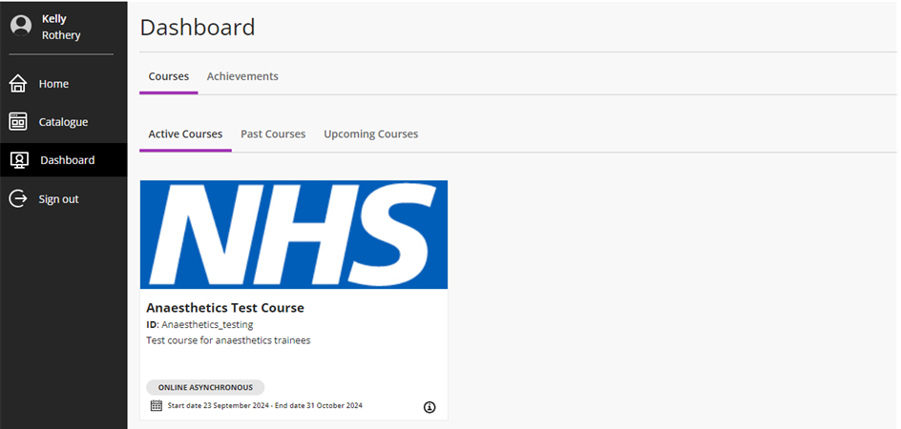

4.2 Click on the thumbnail for the course you wish to access and then click ‘Start Course,’ and this will redirect you to the main course page on Blackboard Learn.
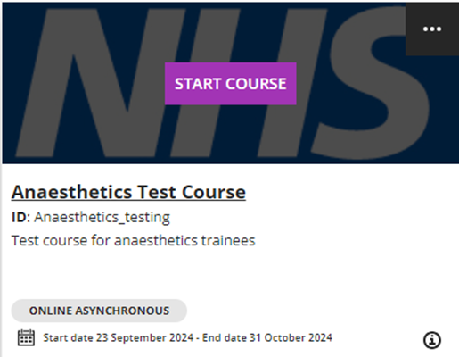

4.3 Once you are in the course page, you can interact with the course in the usual ways relevant to your teaching programme’s requirements.

Part 5: Downloading course certificates
5.1 In order to download your certificates you will need to launch TDM v2 (as per the instructions in Part 1) and click on Dashboard in the left-hand menu.
5.2 Once in your Dashboard, click on ‘Achievements,’ select ‘Certificates’ and then select ‘Achieved’
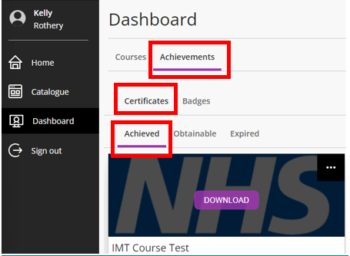

5.3 Click the purple ‘Download’ button to download your certificate. This will download a PDF certificate to the default download location on your device.
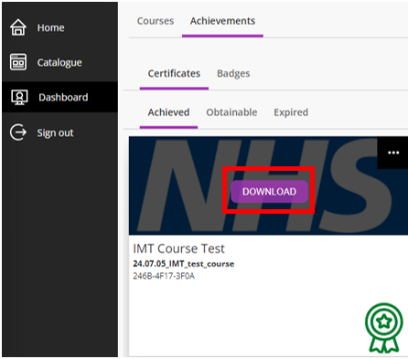

If you select ‘Obtainable,’ this will show you certificates that you can obtain once all the course requirements are met.
If you select ‘Expired’ this will show you historic certificates. Please note the course certificates we issue do not expire, so there should be nothing to see in this last area.

Part 6: Unenrolling from a course
6.1 In your dashboard, (see Part 1) hover your cursor over the course you wish to unenroll from
3 dots appear in the top right-hand corner of the thumbnail.
- Click the three dots,
- A small menu will open, select to unenroll from the course.
- Once you have done this, you will receive an email notification of the unenrolled from the course.

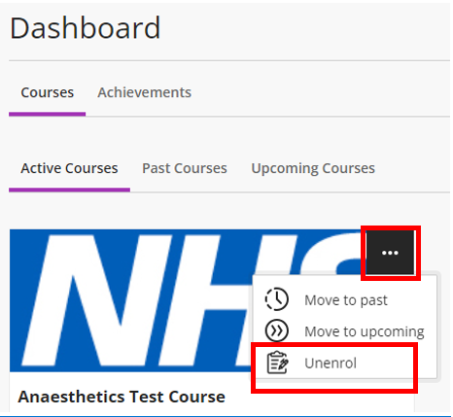

Part 7: Joining a course waiting list (where available)
7.1 If waiting lists are enabled by your School, and a course is fully booked, rather than having an ‘Enrol Now’ button, there will be an ‘Add to Waitlist’ button (see image below) on the course once you have opened it from the catalogue
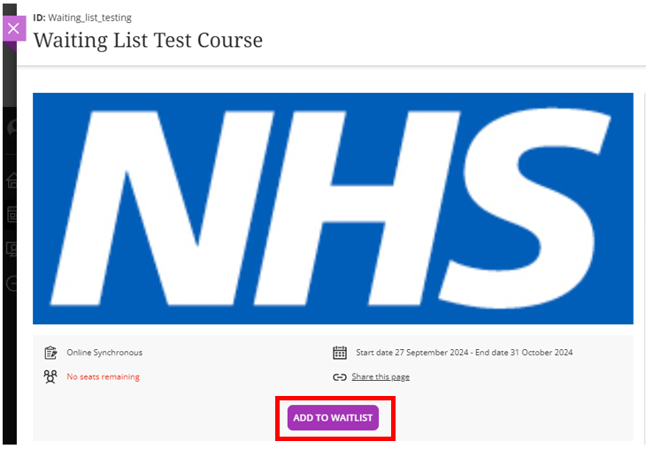

7.2 If you wish to add yourself to the waiting list, please click ‘Add to Waitlist.’ You should then receive an email advising that you have been added to the list for that course.
7.3 If a place becomes available on a course with a waiting list, we will allocate the place on a first come, first served basis from the waiting list.
7.4 If you are subsequently allocated a place, you will receive an email advising that you have been enrolled onto the course and will be asked to unenroll if you are no longer able to take the place.

Part 8: Updating your profile
8.1 Each time your training grade changes, you will be required to update your account information to ensure that you can see the courses relevant to your grade in the catalogue. To do this, launch TDM v2 in either of the ways outlined in Part 2 of this document, then please click on your name in the top left-hand corner of your screen.
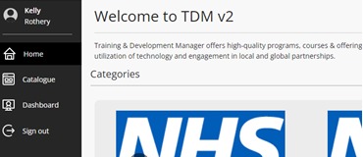
N.B. Please ensure that you are doing this on TDM v2 and not the main Blackboard Learn page.
8.2 This will open your account details. You will need to update the following information:
- Training Grade
- Trust name if applicable.
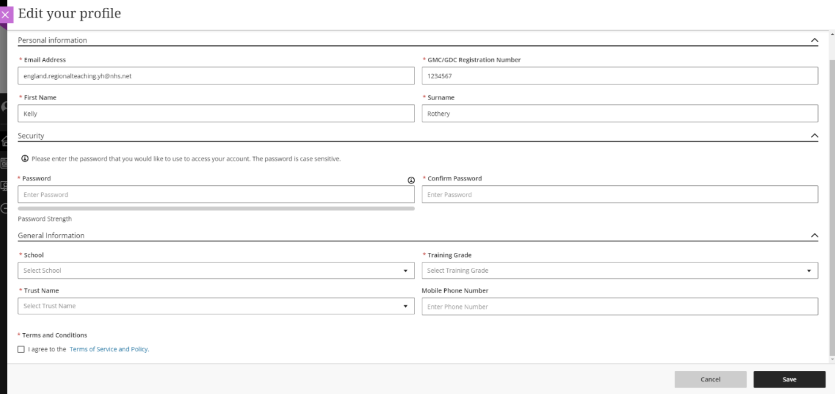

8.3 Once you have updated this information, click save in the bottom right corner of your screen.

