Trainee Forum Standard Operating Procedure
Yorkshire and the Humber Deanery
Yorkshire and Humber, NHS England



Name of Document |  | Trainee Forum (TEF)
Category |  | Standard Operating Procedure (SOP)
Audience |  | Yorkshire and the Humber postgraduate doctors and dentists in training
Purpose |  | This document sets out the guidance and terms of reference for the Yorkshire and the Humber Trainee Forum
Authorised by |  | NHS England - Yorkshire and Humber  SOP Delivery and Development Group
Date Authorised
Implementation Date (current version)
Next Review Date |  | SOP to be reviewed annually OR if there any significant changes to the Trainee Forum.
Document Author/Reviewers |  | Sium Ghebru, Immediate Past Trainee Forum Chair  Shrita Lakhani, Incumbent Trainee Forum Chair.  Andrew Brennan, Associate Dean NHSE YH.  Katie Cobb, Head of Training Programme Management, NHSE YH  Jon Cooper, Post Graduate Dean NHSE YH.
Version | Date |  | Author/Reviewer | Notes  Reason for Change, what has changed, etc
1 | February 2025 |  | Shrita Lakhani / Andrew Brennan / Katie Cobb / Jon Cooper | New guidance

Document Status

This is a controlled document. Whilst this document may be printed, the electronic version posted on the SharePoint site is the controlled copy. Any printed copies of this document are not controlled.
This document is not intended to be interpreted as a policy statement. This is a local guidance document for faculty and staff in the Yorkshire and Humber Deanery to enable consistency of application; it is recognised there may be exceptional circumstances when deviation from this guidance may be required.

Contents
Document status | 3
- Introduction | 4
- Trainee Executive Forum | 5
- Wider Forum | 8
- Meetings | 9
- Communications | 11
- Responsibilities of Trainee Forum Representatives | 13
- Development opportunities and portfolio | 15
- Accountability | 15
- Review | 15
- Appendices | 16

- Introduction

The Standard Operating Procedures (SOP) articulate the working practice of the Trainee Forum (TF) including the composition, working patterns and development opportunities of the Trainee Executive and Wider Forum. It is to be used in conjunction with the Terms of Reference.

  - What is the Trainee Forum?

The TF, established in 2020, is a group of postgraduate doctors and dentists in training from GP, specialty and foundation medical and dental training programmes in Yorkshire and the Humber (YH). The TF is chaired and run by postgraduate doctors and dentists in training for postgraduate doctors and dentists in training.
It is an essential space for NHSE WTE YH and postgraduate doctors and dentists in training to interact in a positive and productive way. It provides a format to ensure postgraduate doctor and dentist in training representation and input at all levels within NHSE. Through the Forum, postgraduate doctors and dentists in training can offer feedback or ideas and raise any concerns regarding any aspect of their education and training.

It is anticipated that the TF will also consider local employment issues and concerns and use their position as representatives of the postgraduate doctors and dentists in training to advocate for change in trusts where necessary. However, NHSE WTE are not the employer of YH postgraduate doctors and dentists in training and therefore cannot take unilateral action on employment issues.

The TF is divided into the Executive Forum and the Wider Forum, each with a difference in emphasis on responsibility of tasks (see appendix 1).
  - Equality statement

NHSE YH Trainee Forum is proud to represent all of our region’s postgraduate doctors and dentists in training. Celebrating diversity, equity and inclusion are essential for cultivating excellent working environments with safe team cultures, supportive educational environments and high-quality patient care. The differences that each individual postgraduate doctor and dentist in training possesses and the different lived experience that they have is recognised by the Trainee Forum as a valuable asset to our region. These differences bring a richness of culture and experience that can lead to innovative solutions to tricky problems, exciting enterprises to improve education and care and wonderful opportunities for us all to see the world through a wider lens.
The Trainee Forum understands that inclusion is about the choices we make, the words we use and the actions that we take every day. Our postgraduate doctors and dentists in training live their lives in a myriad of specific, unique ways, they come from all walks of life, and from all around the world; therefore, as a forum we will ensure diversity within our ranks in order to represent all postgraduate doctors and dentists fairly. It is essential that Trainee Forum members are open to, respectful of, and inquisitive about ideas, perspectives and outlooks different from their own. The Trainee Forum expects all members, and colleagues with whom we work, to uphold these values in their work with the Trainee Forum and into their lives beyond.
- Trainee Executive Forum
  - Membership for the Trainee Executive Forum (TEF) is currently by competitive process.
  - An Executive Committee will be selected biennially and roles will be established and designed to optimise the function of the TEF. These roles may be reviewed and evolve as necessary to promote a well-functioning TEF. Ad hoc selections will be held for roles becoming vacant during the 2-year tenure.
  - To deliver complete representation of postgraduate doctors and dentists in training in YH and sustain optimal function, the Executive Forum’s roles will be defined to reflect the needs of those it represents in the Yorkshire and the Humber region. These roles may be adapted or re-branded as required to map evolving needs of the region. It will always include the roles of Chair, Vice Chair and Secretary.
  - It is currently comprised of the roles of a Chairperson, Vice Chairperson, Secretary, Quality Lead, Employers Lead, Wider Forum Lead, 1 3 x Locality Leads, 2 Equality Diversity and Inclusion Leads, 2 x Less Than Full Time (LTFT) Leads, Communications and Engagement Lead and Wellbeing and Support Lead.
  - Advertisement of vacant TEF positions should be given at least 2 weeks prior to the closing date for applications.
  - Notice must be given electronically to all forum members but may also be announced at meetings.
  - Application requirements for vacant TEF executive positions have previously included submission of a CV, poster and video. Applications will be scored and decided upon by NHSE representatives, such as an Associate Dean and business manager, and current members of Trainee Executive Forum, including the Chair/Vice chair.
  - Application Tenure for a seat on the TEF will be 2 years.
  - It is acceptable to remain on the TEF for a maximum of 2 consecutive terms. If an Executive Forum member wishes to continue for a second term, a re-election process with support from the majority of the acting Executive Forum must occur.
  - Tenure will automatically end should a postgraduate doctor or dentist in training cease to be a NHSE YH postgraduate doctor or dentist in training for any reason, including gaining an outcome 4 or 6 and being released from training.
  - Postgraduate doctors and dentists in training on Out Of Programme (OOP) periods can hold their seat on the Executive Forum provided the doctor/dentist in training is residing within YH for a maximum of 1 year. After 1 year, it is expected that they will return to training or relinquish their seat.
  - A postgraduate doctor or dentist in training serving as member of the TEF taking periods of parental or other statutory leave or sick leave may be deputised for during their absence. This pauses their tenure which resumes on their return from leave.
  - It is recognised that the nature of postgraduate medical and dental training involves changes in work placements and localities. This may reduce a member’s flexibility and availability to be involved in the Executive Forum functions. If a postgraduate doctor or dentist in training wishes to be released from their role on the TEF they should give written notice to the Chair of the Trainee Forum giving 3 month’s notice. In exceptional circumstances a shorter notice period can be negotiated. A minimum of 1 year commitment to the Executive Forum roles is highly encouraged.
  - If a specific representative role on the TEF, such as any future roles, would benefit from a shortened tenure duration, then the 2-year tenure may be reviewed.
  - TEF members will have 2 periods of study leave per month to complete Trainee Forum work and attend Executive Forum meetings plus a further session per quarter to attend the Wider Forum quarterly meetings (one half day per meeting, therefore maximum 2 days per year). This leave is in addition to the standard 30 days PGDiT have for clinical training and the study leave allowance on Accent Leave Manager (ALM) will be increased to 44 days for TEF members. A period of study leave is classified as the normal time for PA allocation as for a consultant.
  - The 14 additional days are to be used solely for the purpose of TEF related activities. This is the same requirement for both full time and less than full time postgraduate doctors and dentists (i.e. is not calculated pro-rata) in order to allow sufficient time to complete duties and attend meetings.
  - It is the role of the chair to inform the NHSE YH Study Leave team on the appointment and leavers for TEF members, to enable the allowance on ALM to be amended as required. TEF members are however, responsible for requesting leave for themselves.
  - A supporting letter (Appendix 2) can be provided to the TEF members' TPD and rota co-ordinator
  - Additional meetings beyond this will need to be accommodated in the individuals’ study leave allowance.
  - Leave for the two Maxcourses ‘Transforming Meetings’ and ‘NHS Structure and Power Dynamics’, which are offered to members of the TEF, will be taken from the postgraduate doctors’ and dentists’ usual study leave allowance, and this is classed as continuing professional development.
  - Maxcourse access will be granted by the Future Leaders Programme (FLP) administration team upon appointment to a TEF position
  - The TEF may appoint sub committees or representatives to lead specific areas of work.
  - Additional members may be invited to attend the forum on an ad hoc basis to contribute to discussion about specific agenda items or lead work in their area of expertise.

- Trainee Wider Forum

  - Membership for the Trainee Wider Forum is currently by non-competitive application.
  - Membership to the Wider Forum is via a registration form.
  - If multiple members from the same specialty, rotation, or school wish to attend Wider Forum meetings and this impacts service delivery, local resolution should follow this process:
3.3.1 First Meeting: The newest Wider Forum members have priority to attend the first meeting they are eligible for.
3.3.2 Subsequent Meetings: Attendance is determined by a rota, ensuring all members from the same specialty, rotation, or school have an opportunity to attend.
3.3.3 Information Sharing: Attendees are responsible for relaying key information to their colleagues within the same specialty, rotation, or school.
3.3.4 Implementation: It is the collective responsibility of Wider Forum members within the same specialty, rotation, or school to implement the agreed local resolution.
  - Application process to the Trainee Wider Forum will be reviewed on a minimum yearly basis, depending on numbers and spread of applicants.
  - Trainee Wider Forum members can apply for 1 session of professional leave per month, where possible, to complete TF work where required.

3.5.1 This is additional to study leave and should not be deducted from the postgraduate doctors’ and dentists’ normal study leave allowance

3.5.2 This is the same entitlement for both full time and less than full time postgraduate doctors and dentists (i.e. is not calculated pro-rata) in order to allow sufficient time to complete duties and attend meetings.
  - Professional leave is to be granted for the quarterly meetings (one half day per meeting, therefore maximum 2 days per year). If professional leave is not possible, then study leave may be considered to attend these meetings. Additional meetings beyond this will need to be accommodated in the individuals’ study leave allowance. Leave is subject to usual approval processes.

- Meetings
  - Trainee Forum meetings and email communications will facilitate the collection, collation and dissemination of the views of postgraduate doctors and dentists in training on matters pertaining to training and professional needs.
  - The Trainee Executive Forum will meet monthly, unless extraordinary circumstances require additional meetings.
  - Meeting dates will be agreed by selection of the date and time when most Executive Forum members are able to attend.
  - Dates of upcoming meetings should be agreed with at least 6 weeks’ notice.
  - At the monthly meetings with the TEF, an invited attendance from the PGD, or Deputy Dean or Associate Dean, or NHSE Business Manager (i.e. Senior management from NHSE) is recommended. There will be an expected minimum quarterly attendance for part of the meeting, from a NHSE representative.
  - The Chair and/or Vice Chair of the TEF will also aim to meet monthly with the Postgraduate Dean (PGD), outside of the monthly Trainee Executive Forum meetings. If this is not feasible, a quarterly basis is the minimum required.
  - The Trainee Wider Forum will meet quarterly, unless extraordinary circumstances require additional meetings.

4.7.1 Meeting dates will be agreed for each training year (August to August) and ideally circulated 3 months in advance of each meeting, unless changed due to unforeseen circumstances.

4.7.2 Quarterly meetings with the Trainee Wider Forum with invited attendance for part of the meeting from PGD, or Deputy Dean or Associate Dean, or NHSE Business Manager (i.e. Senior management from NHSE) is recommended
  - The secretary will request agenda items from members two weeks in advance of the meeting. They will work with the Chair, or Vice-Chair if the Chair is unavailable, to agree the agenda and electronically circulate the agenda and meeting papers at least one week in advance of meetings.
  - The Postgraduate Dean or a NHSE management/faculty representative will attend Trainee Forum meetings to update the Forum on developments, answer questions and report back on progress made on issues previously raised by the Forum. They will provide appropriate support, guidance and accountability. It is expected that this will be a minimum of quarterly.
  - Trainee Wider Forum meetings will consist of an open section and a closed section. The open section will allow NHSE YH faculty/management and other interested parties to attend to feed into the TF functions. The closed part of the meeting will include only Trainee Forum members.

The Executive Forum and Wider Forum meetings will usually last around 3 hours depending on the agenda items.
  - Some sub committees may be formed and require additional meetings.
  - Sub committees must be approved by the Chair of the Trainee Forum Executive (or the Vice Chair in their absence).
  - The Forum will be quorate if the Chair or Vice Chair plus at least three additional Executive Forum members and three Wider Forum members attend, for the Executive Forum and Wider Forum respectively.
  - Records of attendance and apologies will be kept, which may be requested by NHSE YH.
  - A Trainee Executive Forum member will be expected to attend a minimum of 50% of monthly meetings and should send an update in advance of the meeting date if they are unable to attend.
  - For Trainee Wider Forum members, active engagement is encouraged. Proactive involvement may be more helpful than mandated frequency and poor engagement. There is therefore no minimum attendance to maintain Wider Forum membership.
  - Trainee Forum members are expected to send apologies when they cannot attend scheduled meetings. Apologies should be sent to the Secretary and/or Chair of the Forum.
  - The use of technology (e.g. teleconferencing) to encourage participation will be facilitated.
  - It is expected that the majority of Trainee Forum meetings will be held virtually in order to maximise participation. Face to face meetings will be arranged at the discretion of the Chair/ViceChair if safe to do so.
  - Face to face meetings must occur in accessible buildings which cater to the needs of all Trainee Forum members.
  - Expenses for travel to and from meetings will be reimbursed through the standard process via each Postgraduate doctor or dentist in training’s local postgraduate medical education centre.
  - The Secretary will ensure minutes and action notes are recorded at meetings, or will nominate a deputy to do so.

4.22.1 Minutes and action notes from meetings will be circulated to the Trainee Forum membership within 14 days of the meeting.

4.22.2. Finalised Minutes of the Trainee Forum meetings will be public documents that will be published on the NHSE YH Trainee Forum webpage.

- Communications
  - A specific Trainee Forum account will be used to circulate and receive Forum communications. The Chair, Vice Chair, Secretary and Dean’s Office will be able to access the email account.
  - Information about the Trainee Forum, including the Executive and Wider Forum, will be available on the NHSE YH website following consent from individual members. Members of the Trainee Executive Forum will have access to website training and editing rights for these webpages, to ensure this information is up to date, relevant and informative.
  - The Postgraduate Dean and Heads of Schools will ensure that NHSE YH postgraduate doctors and dentists in training are aware of the Trainee Forum either through direct communication or by allowing the Trainee Forum to cascade communications through their contact lists.
  - Postgraduate doctors and dentists in training in the Yorkshire and the Humber region will be able to contact the Trainee Forum directly via the Forum email address (england.traineeforum.yh@nhs.net) to raise issues and make enquiries. Postgraduate doctors and dentists in training will also be able to contact the Trainee Forum through an anonymised form, accessed via the NHSE YH website here.
  - The Trainee Forum will not deal with potentially sensitive or serious issues relating to individual postgraduate doctors or dentists. In cases such as this, that are referred to the Trainee Forum, the postgraduate doctor or dentist will be signposted to appropriate sources of help or support.
  - In the event of a serious disclosure to the Trainee Forum (such as a life threatening situation or workplace bullying/harassment) the Trainee Forum reserve the right to escalate this to the appropriate body/bodies.
  - Information specific to individual training programmes will be communicated directly from the relevant School’s coordinator or administrator and is not the remit of the Trainee Forum.
  - All communications will comply with NHSE Comms regulations. Specifically, Arial fonts and appropriate letter head and/or document templates should be used.
- Responsibilities of Trainee Forum Representatives
  - Postgraduate doctors and dentists in training who are members of the Trainee Executive Forum and Trainee Wider Forum are required to:

6.1.1 Recognise and celebrate the beautiful differences that we all possess and be open, respectful and inquisitive about opposing viewpoints and different experiences.

6.1.2 Attend and participate in Trainee Forum Meetings and engage with the work of the Trainee Forum in order to receive acknowledgment of Trainee Forum membership.
  - Send apologies and an appropriate update for meetings they are not able to attend to the Secretary and/or Chair of the Forum.
  - Prepare for and read papers for any meeting they attend and have access to them during the meeting.
  - Ensure they have the capacity to meet the requirements of the role.
  - Disseminate information and outcomes of the Trainee Forum to postgraduate doctor and dentist in training colleagues as and when directed by the Chair.
  - Seek opinions and present the views of all postgraduate doctors and dentists in training in the Yorkshire and the Humber region. This may include, but is not limited to, meeting with Junior Doctor Forum representatives, School or Specialty representatives, BMA representatives, arranging open access meetings for local postgraduate doctors and dentists in training and other local Trainee Engagement Forums.
  - Contribute and suggest items for the Trainee Forum agendas.
  - Be a point of contact for postgraduate doctors and dentists in training wishing to raise issues and/or signpost as appropriate.
  - Develop links with Schools/Directorates and other groups and committees as appropriate.
  - Organise a handover for incoming Trainee Forum representatives including carrying out a comprehensive handover to the applicable successor.
  - Work towards continuous improvement and sharing of good practice.
  - Attend and participate in other meetings and events where postgraduate doctor or dentist in training involvement is required and at the request of the Postgraduate Dean.
  - Promote and help raise awareness of Trainee Forum amongst postgraduate doctors and dentists in training.
  - Maintain full confidentiality to postgraduate doctors and dentists in training raising issues with the Trainee Forum. All members will be required to adhere to professional standards of confidentiality should any sensitive matters arise as part of the Trainee Forum business. All Trainee Forum members should declare any conflicts of interest when/if they become apparent during the course of their tenure or prior to taking up the post. There will be a requirement that information governance training has been undertaken. Appropriate modules taken by employing trusts are adequate.
  - Understand that NHSE YH is not the employer and although the Trainee Forum can campaign and collaborate to address employment issues locally, NHSE is unable to dictate employment conditions.

- Development opportunities and portfolio
  - All members of the Trainee Forum will be signposted to the ‘Leadership for Clinicians Early in their Careers’ course, for postgraduate doctors and dentists in training up to ST4 level. (ST5+ level have access to a three-day ‘Leadership and Management’ course as part of their generic skills offer on Maxcourse).
  - A letter of support for accessing the appropriate amount of leave will be provided upon appointment to the TEF and at the request of Wider Forum Members.

7.2.1 The letter of support is viewable in the Appendices
  - An annual certificate and/or letter of contribution/confirmation of attendance will be issued (electronically unless otherwise requested) acknowledging meeting attendance and thanking Trainee Forum members for their engagement, work and support.
  - In addition to the above, members of the Trainee Executive Forum will have the opportunity to attend 2 courses during their tenure funded by NHSE YH. These are:

7. 4.1 Transforming meetings

7.4.2 NHS structure and power dynamics
  - Members of the Trainee Executive Forum will also have the opportunity to complete the healthcare leadership 360 appraisal during their 2-year tenure.

- Accountability
  - The Trainee Forum is accountable to the Postgraduate Dean.

- Review
  - These Standard Operating Procedures will be reviewed annually.

- Appendices

Appendix 1: Trainee Forum; Executive and Wider Forum key features

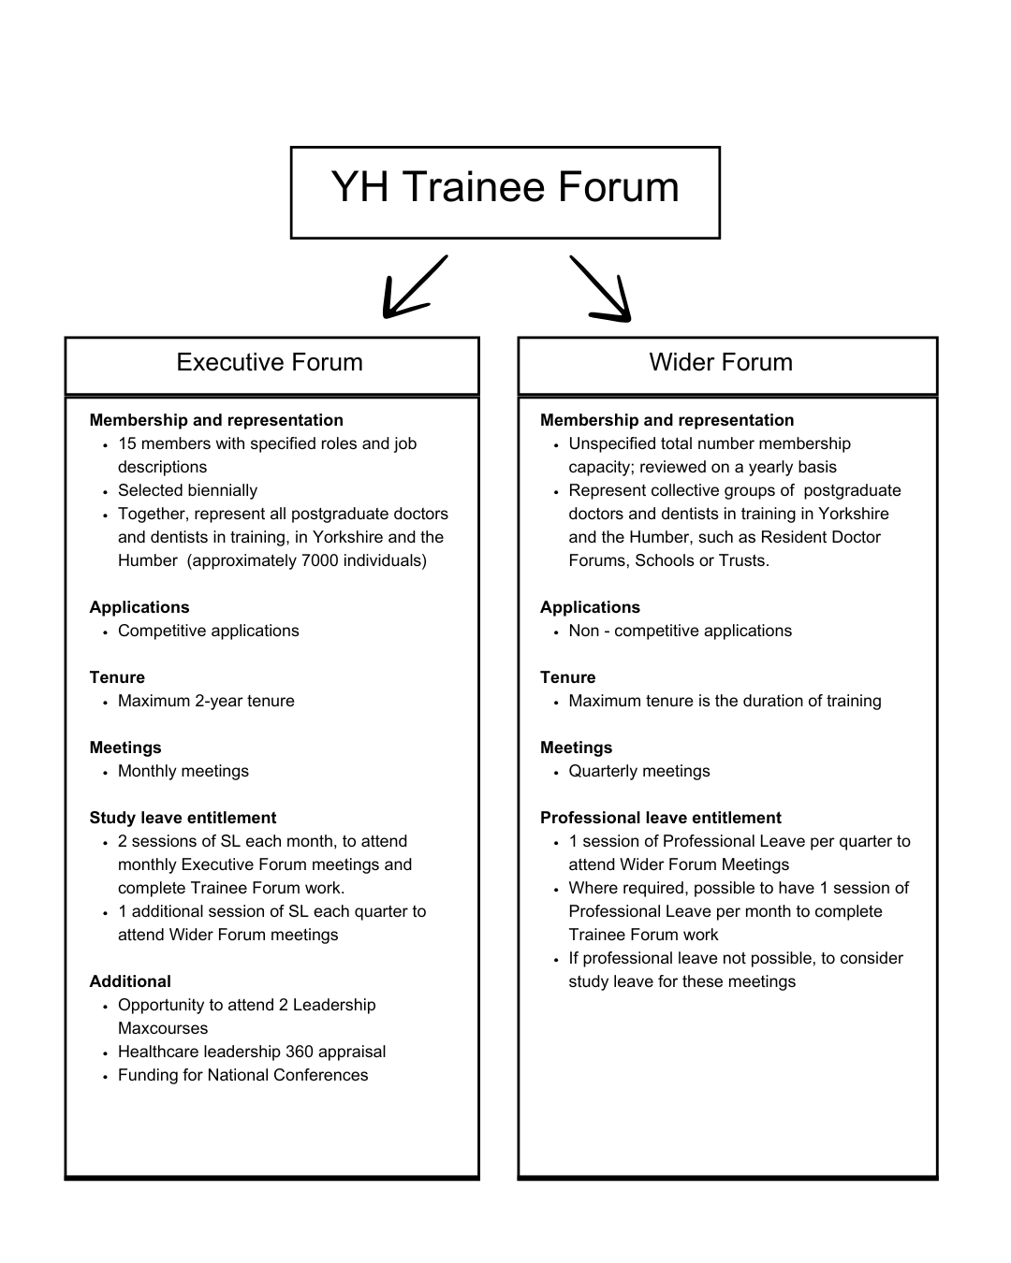

Appendix 2: Letter of Support

Dear colleague,

My name is Shrita Lakhani and I am writing in my role as Chair of the Yorkshire and the Humber (YH) Trainee Forum to support [Insert Name] request for study leave to carry out their duties as a member of the Trainee Executive Forum (TEF).

While I appreciate that we are in tough times in healthcare, I am looking at ways to support this initiative.

The TEF is a relatively new component of the Deanery structure within the new Workforce, Training and Education (WTE) structure (formerly HEE) to champion and develop trainee experience within the region.

The workings and arrangements of the TEF are under direct supervision of Andrew Brennan (Associate Dean) and supported by the Postgraduate Dean, Jon Cooper. When TEF members are appointed to the role, they are expected to attend two sessions (equivalent to 1 day) of study leave per calendar month to complete TEF work and attend TEF meetings with an additional session every quarter for a Wider Trainee Forum meeting. This equates to 14 days of additional study leave, which has been allocated to [Insert Name] study leave allowance on Accent Leave Manger.

The additional 14 days is solely for the purpose of TEF related activities. This includes carry out the tasks of the Forum by participating in a monthly meeting as well as active engagement with local and regional improvement projects as agreed from TEF meetings. In addition to this, there are ad-hoc opportunities to attend conferences, which are funded by the trainee forum and are in addition to the 14 day study leave allowance.

These sessions are deemed as professional work and so the idea is that these are developmental in the role and not taken out of self-directed learning or personal time. It is the same requirement for those in both full time and less than full time posts in order to deliver the work (that is it is not pro-rata).

Dr Andrew Brennan is designated as a first point of contact to provide any clarifications needed. He can be contacted via email at andrew.brennan9@nhs.net

Once again, thanks for helping with this so we can make a sustained improvement to training postgraduate doctors and dentists in training in our region.
Yours faithfully,
Shrita Lakhani
Future Leaders Programme Fellow in Trainee Engagement - NHSE WTE Directorate YH
Chair of the Trainee Executive Forum (TEF) for Yorkshire & The Humber

Supported with the oversight and help of,
Dr Jon Cooper
Postgraduate Dean, NHS England, Education Yorkshire and Humber

This may include but is not restricted to the following roles: BMA representation, HR/Employer representatives, College representatives, People with appropriate specialist knowledge, postgraduate doctors and dentists in training invited to support the TF work but not elected onto the TF, Quality/Business Managers, School Faculty representation, Directors of Medical Education/ Medical Education Managers, Post Graduate Dean and/or their nominated representative.

