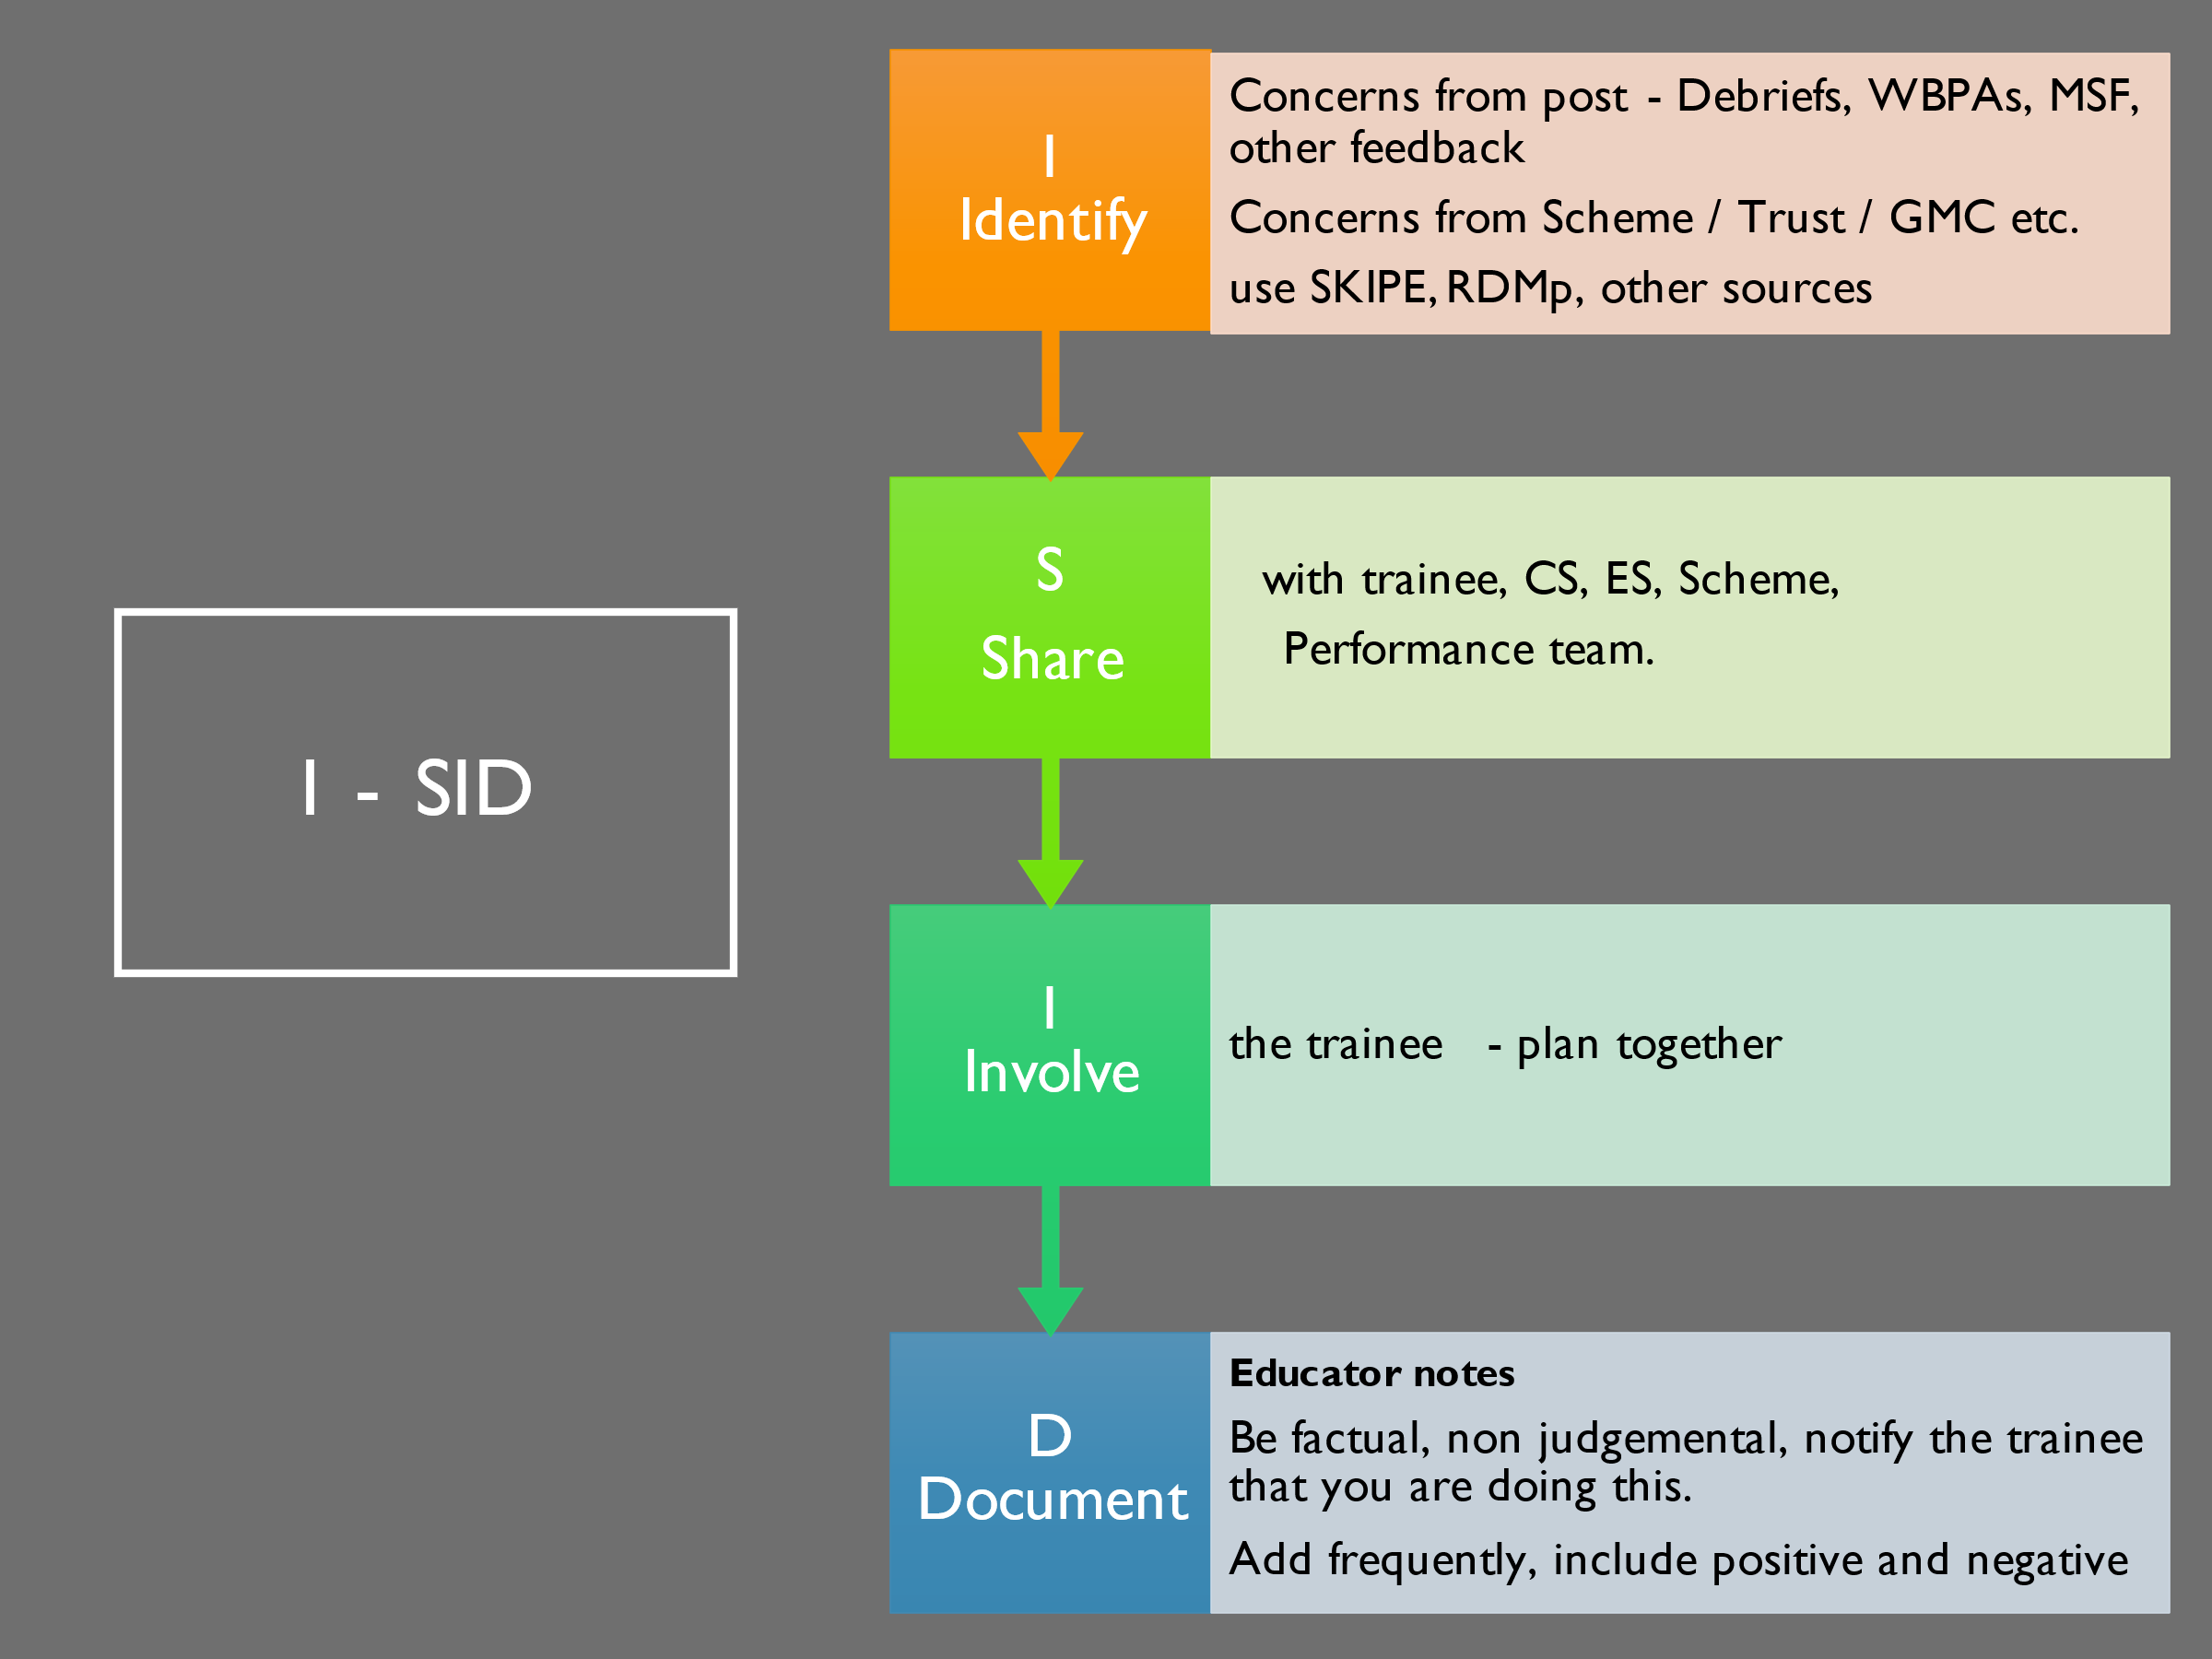
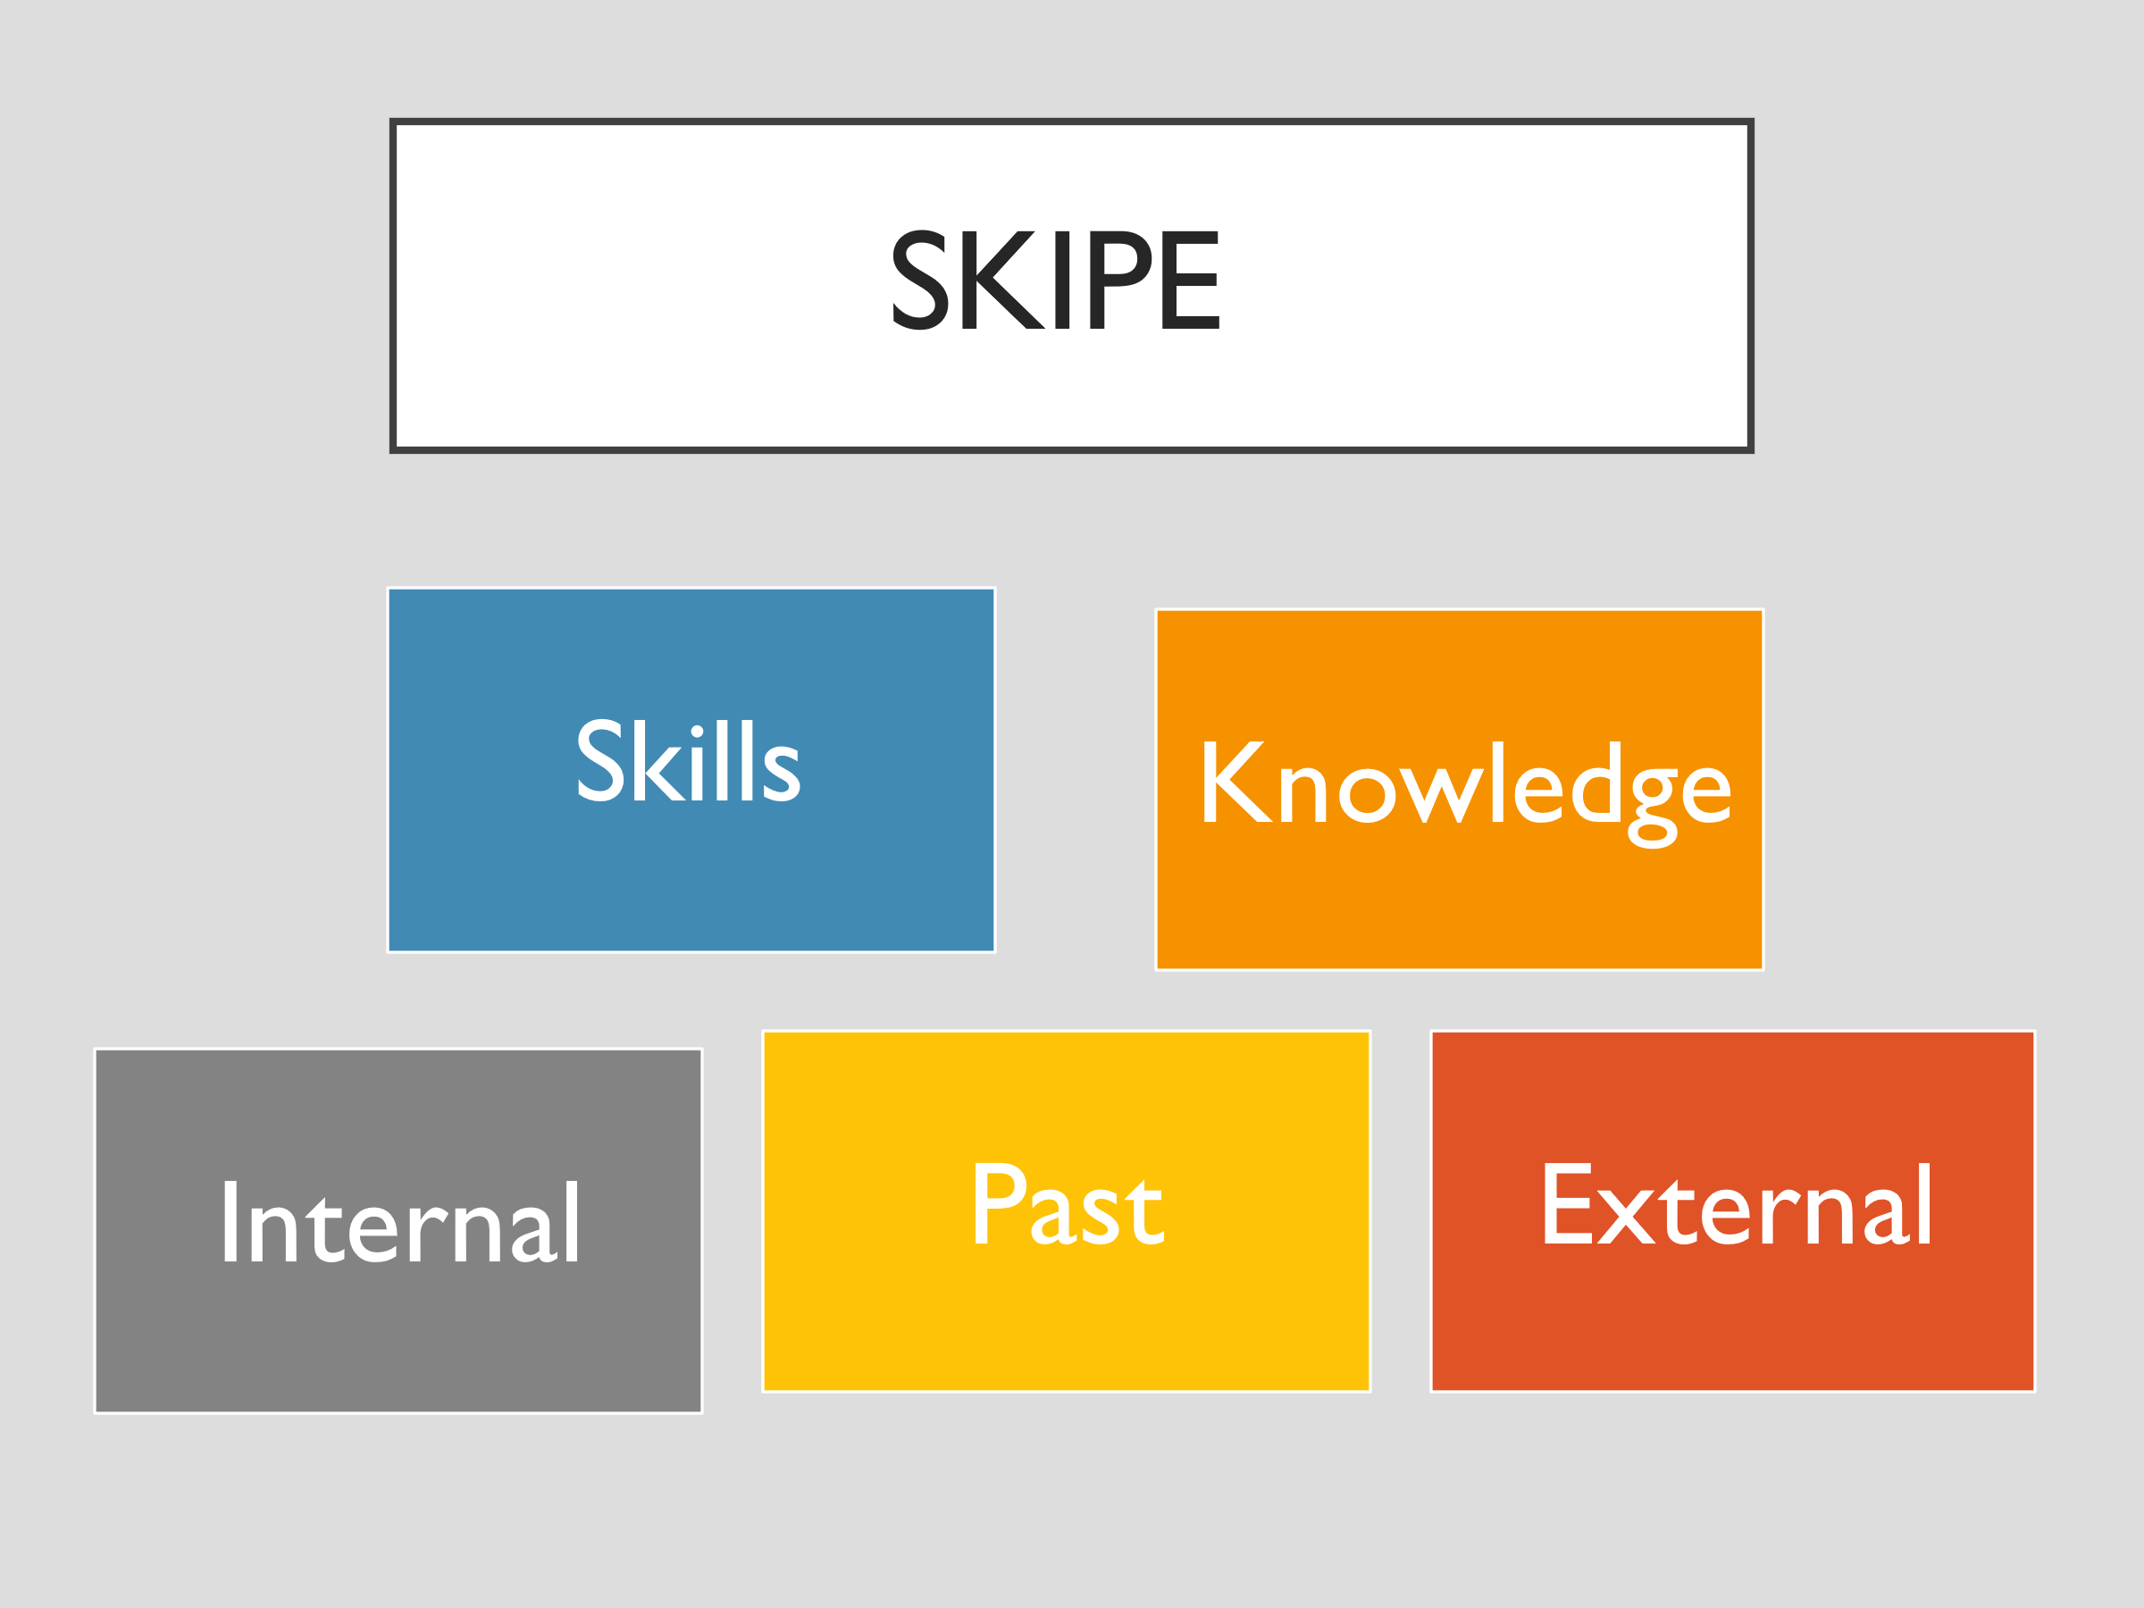
SKIPE
Lack of skills
Knowledge gaps
Internal factors – personality, health issues, organizational concerns, neurodiversity, attitudes
Past factors – different medical training, doctor centred training, didactic teaching experience etc
External factors – long commutes, inability to drive, family illness and bereavement, childcare

