WELCOME TO THE TRAINEE FORUM – WHO WE ARE….
Annabelle Carter – Forum Chair  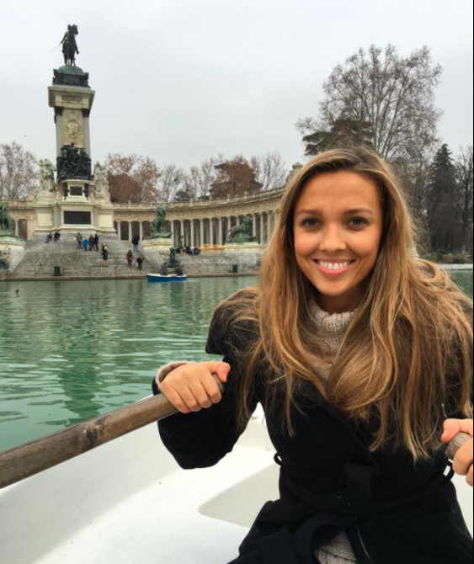 | Hi I’m Annabelle. I am currently a fellow on the future leaders 12 month programme with an interest in pursuing better trainee engagement. I am a senior registrar in Paediatric Dentistry based at the Leeds Dental Institute and Bradford Community Dental Services. I spent my early years in training in Manchester and Bristol. As chair of the trainee forum, I am keen to help shape the forum to be a place for trainees to have their voice heard, share ideas, facilitate open lines of communication between HEE and trainees: all for a positive and supportive training experience in Yorkshire.
Alexandra Damazer - East Locality Lead  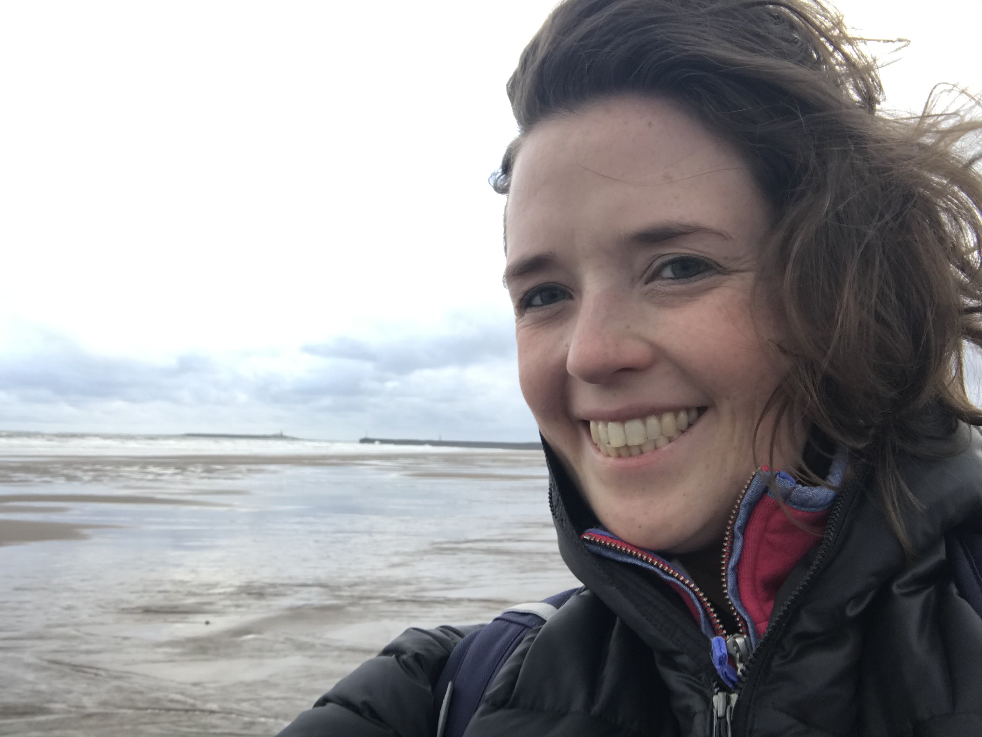 | I’m Alex and I am a Paediatric ST7 and have been based in York throughout paediatric training.  As locality lead of the forum I am passionate about trainee wellbeing, inclusivity and flexible training (including less than full time working), and advocating for trainees across the region. My leadership project as part of the leadership fellow year I undertook last year has allowed me to focus on flexible training at foundation level and I am particularly keen to ensure that trainees at all levels, including those just starting their careers, have a voice within the forum.  Outside of work I am a very keen baker (all meetings are better with cake!) and enjoy outdoor swimming whenever possible.
Lauren Harkin - Less Than Full Time Lead  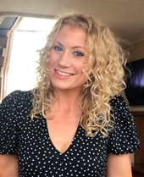 | I’m Lauren, an Acute Medicine Registrar in West Yorkshire. Originally from a wee place called Donegal in Ireland- I came to the UK in 2005 for medical school and have been training in Yorkshire since 2012. I have had two amazing children during my training and now work less than full time (LTFT). I have a special interest in medical education- especially postgraduate training and I have completed the postgraduate diploma in medical education. I am a huge advocate for simulation and human factors training.  I joined the forum to highlight the role of HEE to trainees and to improve communication between both parties so they can work together to improve the training experience and make our region the best place to work and train. I am the LTFT lead and feel passionate about being a voice for LTFT trainees so they can offer feedback or ideas and raise concerns about their education and training.  Outside of medicine I enjoy running, skiing, holidays, shopping and getting back to Ireland when I can.
Lucy McCabe - Quality Lead  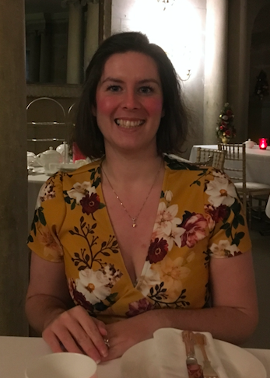 | I’m an ST5 in Obstetrics and Gynaecology, working within West Yorkshire. I have an interest in Quality Improvement and patient safety and I am the Quality Lead for the Forum. I have previously been involved with projects to improve Junior Doctor engagement and well-being at a Trust level and am passionate about ensuring that we’re able to achieve our potential within our training programmes. I joined the Trainee Forum to help establish a two-way conversation between trainees and HEE to overall improve our experience and training.
Nick Weatherley - South Locality Lead (til November 2021)  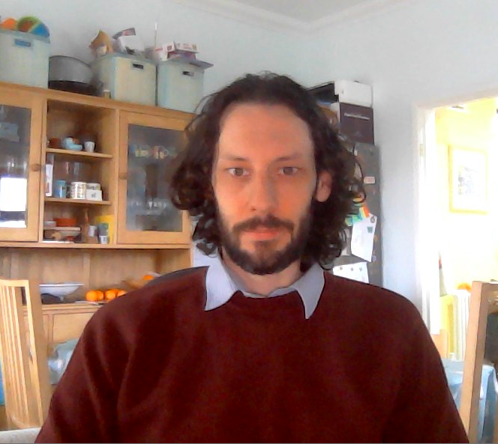 | I am a NIHR Academic Clinical Lecturer in Respiratory Medicine and Honorary Specialist Registrar. I have lived and worked in Sheffield since 2003, training and working in the Yorkshire and Humber region throughout. I am the South Yorkshire locality representative on the HEE Trainee Forum Executive. I am keen to use my role on the forum to improve communication and links between HEE and trainees and in the process give trainees more of a voice in how their training is organised.
Opeoluwa Adeniran - Equality and Diversity Lead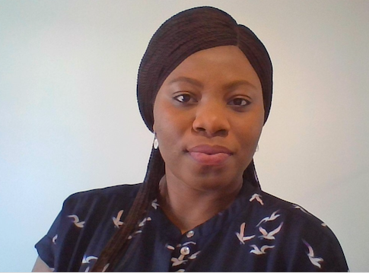 | My name is Opeoluwa A. Adeniran and I am currently a CT3 in Psychiatry, Leeds and York Partnership NHS foundation trust and based in Leeds. I have experienced a supportive and progressive training environment and it’s amazing the depth of character forged in psychiatry. I am one of two equality and diversity reps with the HEE Y&H forum and I joined this forum because I was drawn to the opportunity to know more about HEE from the “inside”, explore what HEE has to offer and be a part of a platform that helps others also do the same.
Pete Webster - Academic Lead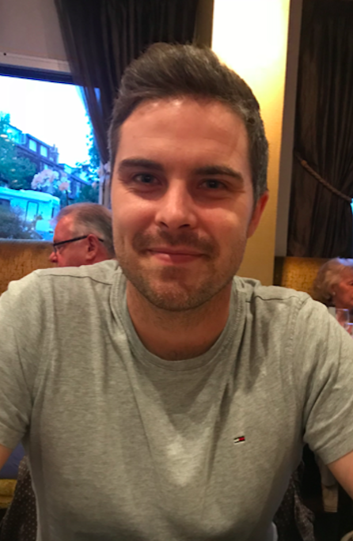 | I am a General Surgery Registrar currently working at Doncaster Royal Infirmary. “Yorkshire born and bred”, I have rotated through the majority of hospitals within the Yorkshire deanery during my training. I have also completed a lab-based PhD during a formal “out of program research” period. As the Academic Lead on the Trainee Forum I am keen to address the issues that academic trainees face whilst also encouraging and promoting research within the region.
Rammina Yassaie - Employers Lead  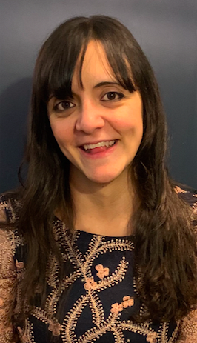 | I am a GPST2 on the Harrogate VTS Scheme having also previously worked as a Paediatric trainee in West Yorkshire. I joined the Trainee Executive Forum as the Employers Lead as I have been a longstanding advocate for improving working conditions for junior doctors. I am very familiar with the pressing issues that trainees face in their workplaces having worked as a Local Negotiating Committee BMA Representative for over a decade across various hospital trusts in Yorkshire. I am also the North Representative for the Faculty of Medical Leadership and Management’s Trainee Steering Group and in turn passionately champion the improvement of leadership opportunities for doctors in training.
Sidra Chaudhry - Equality and Diversity Lead  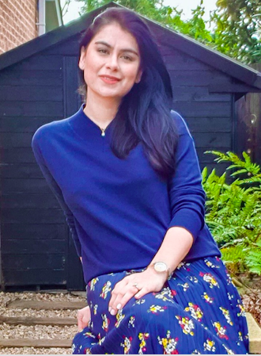 | Hi, I’m Sidra. I’m a dual specialty General Adult and Old Age Psychiatry registrar training in South Yorkshire. As a third culture kid and an international medical graduate, I take pride in my background and am passionate about making the training experience inclusive and empowering for trainees across the Yorkshire and Humber region.  Joining the Trainee Executive Committee as Equality and Diversity Representative has given me the wonderful opportunity to become a small building block in the bridge connecting the HEE with trainees. It has also allowed me to network with amazing trainees from other disciplines to brainstorm ways to make the training experience more fulfilling. When not working, I enjoy photography and creative writing. And this may seem strange, but I’m not a great fan of tea or coffee!
Stuart Stokes - Incoming South Locality Lead
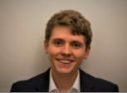
Sanah Sajawal- West Locality Lead

Maria Crouch - Forum Secretary

Sana Fatima – Health & Wellbeing Lead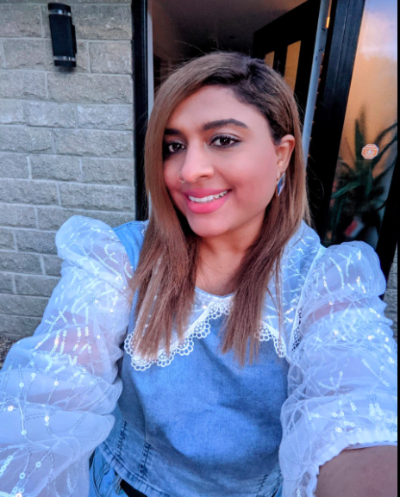 | I am a Higher Trainee in General Adult Psychiatry based in North and West Yorkshire. Having worked extensively in the region developing Wellbeing Programs for Foundation Trusts, I joined TEF as Trainee Health and Wellbeing Lead. In my current Leadership Fellowship with HEEYH, I am leading the project developing Professional and Wellbeing Support (PAWS) for doctors and dentists in training in Yorkshire and Humber. My journey thorough countries and cultures, having experienced peaks and trough of being almost a citizen of the world, being affiliated with several international healthcare set ups continues to further my vision and perspective, and helped me develop a unique and in-depth sensitivity to miscellany & multiplicity of people and presentations. I am keen to apply this to wider considerations around intricate trainee health and wellbeing needs as we strive to endorse authentic equality, equity, and inclusivity.  My passion for workforce h&wb is paralleled by my interest in medical education and learning, through experiences, interactions, and storytelling and have recently completed my PG Diploma in Med Ed. I am a mother to a very demanding 3-year-old, and recently discovered I am a celiac so l am on a perpetual prowl for gluten free recipes and restaurants
Hussain Sarwar – Vice Chair | Information to Follow
Sara Page – Vice Chair 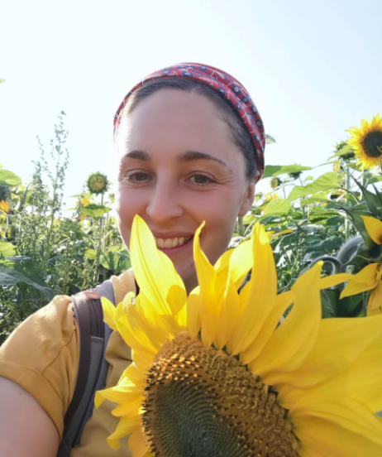 | Information to follow

